 |  | Doc. SE7(17)116R1
SE7 meeting
ECO, Copenhagen 27-29 November 2017
Date issued: | 23 November 2017
Source: | Communications Regulatory Authority of the Republic of Lithuania
Subject: | Compatibility between RAS and LTE (aggregated) in 400 MHz frequency band
Group membership required to read? (Y/N)
N
Summary:
SE7 is studying compatibility between LTE and the incumbent services in the 400 MHz band. Different kinds of systems are evaluated in current draft report on Compatibility studies related to the introduction of LTE systems in the bands 410-430 MHz and 450-470 MHz.
This contribution provides two major updates for the studies on LTE compatibility with Radio Astronomy at 406.1-410 MHz.
- First update is related to the usage of propagation model ITU-R P.1546-5, version 5 was selected instead of version 4. In Annex 5, § 1.1 of this recommendation it is said that “this Recommendation is not reciprocal with respect to designations of the transmitting/base station and the receiver/mobile station/terminal. When this Recommendation is used to calculate the coverage of, or for the coordination of, broadcasting and/or base-to-mobile stations, then the actual transmitting/base station should be treated as the “transmitting/base”. In other cases where there is no a priori reason to consider either terminal as the transmitting/base, then the selection of which terminal to designate as the transmitting/base station for the purposes of this Recommendation can be as follows: a) if both terminals are at or below the levels of clutter in their respective vicinities, then the terminal with the greater height above ground should be treated as the transmitting/base station; b) if one terminal is in an open location or above the surrounding clutter, whereas the other terminal is at or below the level of clutter, then the open/uncluttered terminal should be treated as the transmitting/base station; c) if both terminals are open/uncluttered, then the terminal with the greater effective height should be treated as the transmitting/base station.”
LTE terminals are used as the transmitting stations in the studies addressing compatibility with Radio Astronomy. Therefore additionally option of SEAMCAT “Terminal designations (Annex 5, Par. 1.1): use options a), b) and c)” was disabled in the updated calculations.
- Second update is related to the correction of misinterpreted UE spurious emission used in the calculations, see figure 53.
Proposal:
Invites SE7 to consider and incorporate modifications into the draft ECC Report on Compatibility studies related to the introduction of LTE systems in the bands 410-430 MHz and 450-470 MHz. Document “SE7(17)081A1_Draft ECC Report on LTE in 400 MHz.docx” was taken for the changes to be made.
Background:
WGSE has tasked SE7 to perform sharing and compatibility studies for broadband PMR/PAMR and NB-IoT systems in the bands 410-430 and 450-470 MHz. WGSE also tasked to perform complementary compatibility and sharing studies for BB-PPDR systems operating in the frequency band 410-430 MHz. Therefore SE7 is drafting report on Compatibility studies related to the introduction of LTE systems in the bands 410-430 MHz and 450-470 MHz. This input proposes some updates in current draft report.

LTE Impact on Radio Astronomy at 406.1-410 MHz

Study parameters

MATLAB ANALYSIS

Compatibility studies with 1 MHz guard band

Effect of the guard band between LTE and RAS

SEAMCAT ANALYSIS

Introduction
ECC Decision (16)02‎[4]is addressing the harmonised conditions for the implementation of BB-PPDR radio systems. Paragraph 3 of Decides section of this Decision presents several frequency allocation options for introducing BB-PPDR in the band 450-470 MHz. This approach of several frequency allocation options could also be used for 410-430 MHz. Shifting the operating frequencies on LTE UE and LTE BS could reduce interference on RAS service operating in the band 406.1-410 MHz. Following studies were done in order to estimate the effect of the guard band between the RAS and possible LTE systems in the band 410-430 MHz.
In the studies, interference into RAS receiver (RAS Rx) from multiple LTE UE transmitters (UE Tx) and LTE BS transmitters (BS Tx) was evaluated. The studies were carried out for the maximum bandwidth (5 MHz) for both base stations and user equipment using SEAMCAT.

Study parameters
The LTE UE and BS (5 MHz) parameters, as well as RAS parameters used for these studies are listed in Table 52 UE density is 0.0342 km2.
BS deployment density for RAS scenario is defined as 0.0057 km2. This leads to an area of 175.857 km2 occupied by one BS. In SEAMCAT, Tri-sector hexagon type was chosen. Following equation is used to calculate Cell range - 2R. (In SEAMCAT, this R is defined as “Cell radius”. Cell range = 2R):
$Deployment density= \frac{1}{Cell area}= \frac{1}{3(\frac{3\sqrt{3}}{2}R^{2})}$ . (1)
It follows from equation (1) that R = 4.75 km.
According to the ECC Report 240, average density of active UE is 0.027 km2 for RAS scenario, while deployment density of BS is 0.0057 km2. This leads to the average of 4 UE per BS. For the studies, Tri-sector BSs were taken and UEs density was increased to 6 UE per BS or 2 UE per 1 sector. Therefore, UE density in the study was increased to 0.0341 km2.
Usually LTE networks are not fully loaded, so 10 resource blocks (RB) were taken per UE. UE emission mask was based on 3GPP TS 36.101 V9.2.0 and adjusted using approach described in ECC Report 240 (Table 62) to correspond with 2 UE per sector using 10 RB.

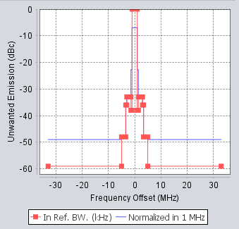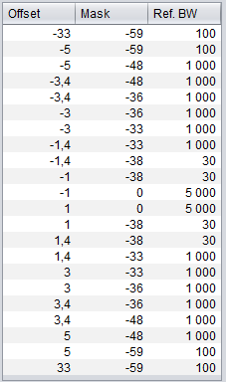

Figure 53: Emission mask of UE in SEAMCAT
BS emission mask is based on 3GPP TS 36.104. Spurious emission level is adjusted to -139 so that it corresponds to the BS spurious power equal to -96 dBm/100 kHz and BS transmitting power as in Table 21.

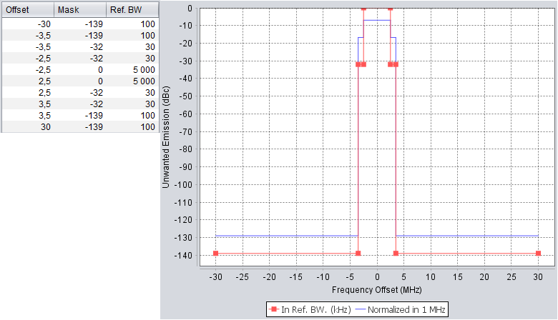
Figure 54: Emission mask of BS in SEAMCAT

Simulation Method
A "static" model, also referred to as a "snapshot" Monte-Carlo model, was employed by means of SEAMCAT. This model sets up a random distribution of users based on one time instant correspondent with a network configuration and considered service characteristics. A set of statistics which accurately reflects these scenarios is derived by simulating several such snapshots. Investigation of the coexistence of an LTE based BB-PPDR network with Radio Astronomy Station (RAS) was performed by using SEAMCAT v.5.1.1.
During the simulations, unwanted signal levels from all BSs and UEs were included and then compared with the protection level of RAS. RAS protection level used in this study is -173 dBm as in Recommendation ITU-R RA.769-2 with time percentage of 2 %. Propagation models described in Recommendations ITU-R P.1546-5 and P.452-16 were used in the studies.
A cellular environment (hexagonal cluster) was used for modelling in SEAMCAT consisting of 19 cells (2-tiers tri-sector 3GPP layout) and wrap-around technique to reduce the number of cells required in the simulations of endless network and consequently to enable faster simulation run times. The geographical separation of the victim receiver and interferer LTE network was modelled by specifying the modelled cellular cell as laying at the edge of the network and thus as if the cellular system extending to one side only. For this simulation right-hand side network was applied. This is illustrated in the Figure 55, where DE is RAS distance from the network edge, DC is distance from hexagonal cluster centre, RC is cluster maximum range, and α is central (network visibility) angle.
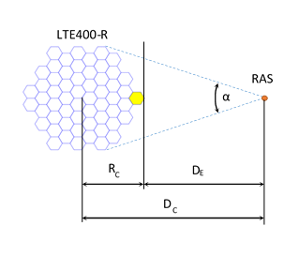
Figure 55: Layout used in Monte Carlo simulation
The set of simulations was done using UE power control settings showed in Figure 56.
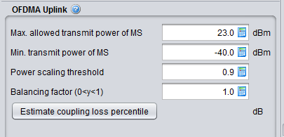
Figure 56: UE power settings for the simulations
The simulation was performed using 100000 snapshots in each scenario. Interference probability dependence on the distance from the network edge for various values of guard band is presented in Figure 57 and Figure 58. Interference criterion I/N was applied for the victim receiver.
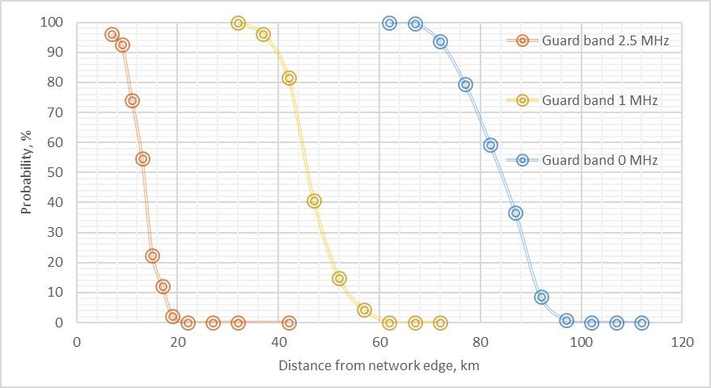
Figure 57: Interference probability dependence on distance from the LTE network edge using ITU-R P.1546-5

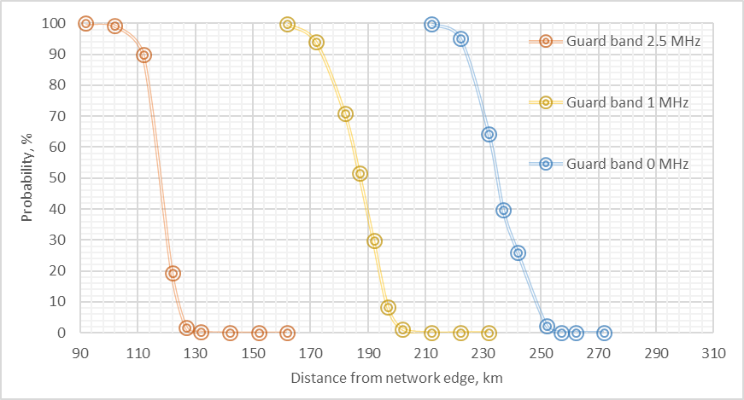
Figure 58: Interference probability dependence on distance from the LTE network edge using ITU-R P.452-16

The SEAMCAT translation mode was used, to calculate the probability of interference as a function of the total output power of interferer transmitters. The 5 % interference probability level as a trigger was chosen to evaluate the power supplied value to victim receiver at various RAS distances from the interferer LTE network edge. The results are presented in Figure 59 and Figure 60.

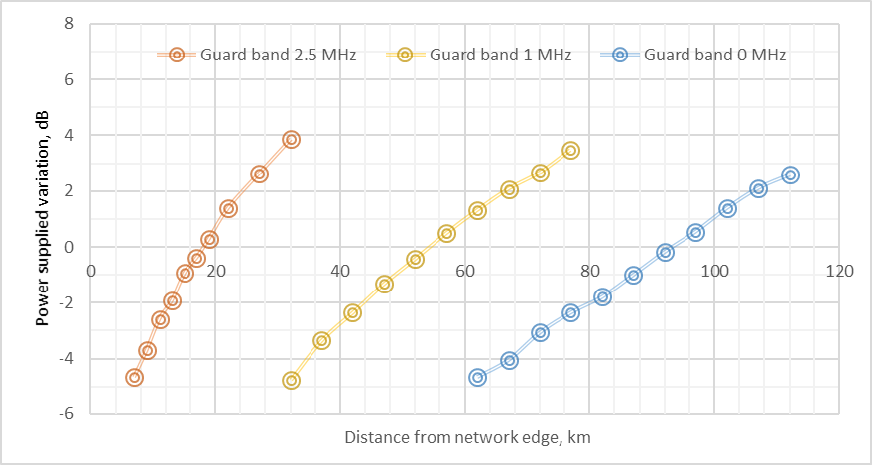
Figure 59: Power supplied dependence on RAS distance from the interferer LTE network edge for various guard bands to keep 5 % interference probability using ITU-R P.1546-5

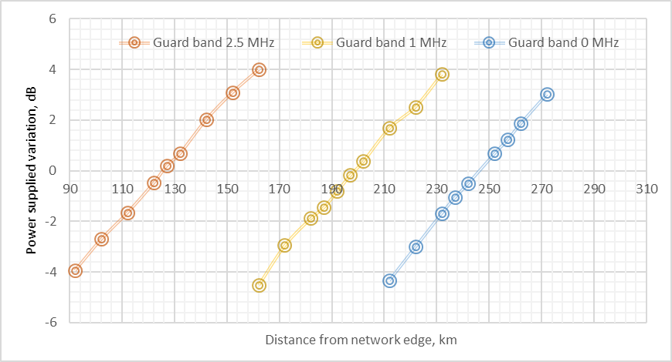
Figure 60: Power supplied dependence on RAS distance from the interferer LTE network edge for various guard bands to keep 5 % interference probability using ITU-R P.452-16

The increase of power supplied at bigger distances means that the interfering signal probability at victim receiver is less than the 5 % level, and therefore, the number of interferers can be increased to keep the same 5 % probability level of interference. And on the contrary, the less distances can be assured by decreasing the interferers number.
This way, the number of interferers (114 UE + 19 BS) used in SEAMCAT simulations can be easily recalculated to another number by introducing the effective cluster of interferers in the form of the part of the circular ring of the same width as the hexagonal cluster dimensions 2Rc and having the same area, interferers number (density) and the distance from the RAS receiver to the ring centre Dc, Figure 61.
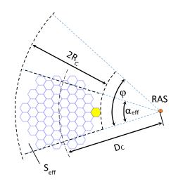
Figure 61: Effective area of part of ring to generate the same interfering signal at RAS receiver

Formulas for the recalculations are as follows:
, (2)
, (3)
, (4)

where K is the interferer signal power gain factor, φ is required central (network visibility) angle.

For example, given guard band value 2.5 MHz, one right-hand side cluster area Seff = 3341.288 km2, cluster range RC = 38 km, the distance from RAS receiver to cluster centre D_{C} = 56 km (distance from cluster edge DE = DC – RC = 18 km), interference probability 5 % and for required angle φ = 360 deg (closed circular ring around the RAS placed in the ring centre) the power gain factor is K = 9.033 dB. In case of the closed circular ring the correction factor is introduced to keep the same BS and UE transmitters density in the ring area:
. (5)
Finding the intersection point x = D_{rec} of two curves, one is the correction factor dependence on distance plus power gain factor, G(x) + K, and another is a propagation model losses dependence on distance, L(x) – L(D_{C}), x > D_{C}, by means of numerical solving a system of two equations, gives the recalculated distance D_{E} = (D_{rec} - R_{C}) from the interferer network edge that is increased to about 116.4 km to keep the same 5 % interference probability. The weighted average of the propagation model losses in numerical calculations is taken with weighted coefficients proportional to the distance from the RAS receiver to the corresponding cluster point.
It should be noted that the simulation of interference in SEAMCAT is not confined to the case of one LTE cluster. Number of clusters, their sizes, distances from the victim's receiver, guard bands and propagation models could be different.

SEAMCAT results using different guard bands
The interference from all LTE BSs and LTE UEs Tx into RAS Rx station was calculated. RAS stations operate in the band 406.1-410 MHz . Therefore, the guard band was estimated from the 410 MHz edge. LTE UE 412.5 MHz centre frequency is considered to use 0 MHz guard band. LTE BS 422.5 MHz centre frequency is shifted 10 MHz away from the UE frequency.
Separation distance is considered to be the inner radius of the ring, equal to D_{c} – R_{c}. The results of the compatibility studies are summarised in Table 55 and Table 56.

Table 55: Separation distances needed to protect RAS station at the 5 % interference level.
Guard band between LTE UE and RAS, MHz | Number of hexagon-clusters | Number of interfering BS | Number of interfering UE | Separation distance, km |  | Effective network visibility angle, deg
 |  |  |  | P.1546-5 | P.452-16 | P.1546-5 | P.452-16
0 | 1 | 19 | 114 | 93.5 | 245.6 | 19.2 | 8.9
1 | 1 | 19 | 114 | 54.8 | 197.8 | 27.1 | 10.7
2.5 | 1 | 19 | 114 | 18.0 | 126.3 | 45.0 | 15.3
0 | 2 | 38 | 228 | 113.2 | 268.5 | 33.3 | 16.4
1 | 2 | 38 | 228 | 70.4 | 220.2 | 46.5 | 19.5
2.5 | 2 | 38 | 228 | 27.5 | 151.0 | 76.9 | 26.7

Table 56: Separation distances needed to protect RAS station
given its full circular environment

Guard band between LTE and RAS, MHz | Power Gain factor, dB | Transmitter density correction factor, dB | Number of interfering BS | Number of interfering UE | Separation distance, km
P.1546-5
0 | 12.740 | 3.266 | 758 | 4543 | 241.0
1 | 11.226 | 3.794 | 604 | 3621 | 184.4
2.5 | 9.033 | 4.407 | 419 | 2514 | 116.4
P.452-16
0 | 16.078 | 1.488 | 1084 | 6502 | 361.3
1 | 15.276 | 1.820 | 974 | 5840 | 320.7
2.5 | 13.707 | 2.592 | 810 | 4859 | 260.6

Conclusion on SEAMCAT analysis
In this report, several options of the guard bands between aggregated impact from LTE based BB-PPDR UEs and BSs into RAS stations were analysed. Performed calculations showed that the separation distances needed to protect RAS station given its full circular environment are as follows for ITU-R P.1546-5:

- at least 117 km using 2.5 MHz guard band;
- at least 185 km using 1 MHz guard band;
- at least 241 km using 0 MHz guard band.
for ITU-R P.452-16

- at least 261 km using 2.5 MHz guard band;
- at least 321 km using 1 MHz guard band;
- at least 362 km using 0 MHz guard band.
The calculated separation distance from one LTE hexagonal cluster consisting of 19 cells are as follows for ITU-R P.1546-5:

- at least 18 km using 2.5 MHz guard band;
- at least 55 km using 1 MHz guard band;
- at least 94 km using 0 MHz guard band.
for ITU-R P.452-16

- at least 127 km using 2.5 MHz guard band;
- at least 198 km using 1 MHz guard band;
- at least 246 km using 0 MHz guard band.
Studies were done in rural environment with land propagation model described in Recommendations ITU-R P.1546-5 and P.452-16. In real life situations, separation distances could be lower because of the specifics of the propagation environment, e.g. terrain constraints, clutter obstacles.

Comparison of propagation models on real terrain
A difference between propagation models ITU-R P.1546 and ITU-R P.452 was evaluated. For this purpose LTE network of 114 UEs was taken. UEs were randomly placed within a rectangular area of 3356 km2 (76x44.158 km2) in the territory of Lithuania. A global interfering signal from all 114 UEs was calculated at points placed at every 25-km beginning from the closest edge of the rectangular network. The receiver parameters were taken the same as the RAS station (table 28). Propagation loss was evaluated as the difference between the total signal of all UE transmitters and the received signal at the RAS receiver. Calculated propagation losses together with actual ground profile are presented in Figure 41. Propagation model ITU-R P.452 requires the use of terrain profile in order to obtain accurate propagation losses. In case of not using terrain profile propagation losses may be overestimated. A statistical assessment of exclusion zones around RAS sites could be obtained by applying ITU-R P.1546. For more precise exclusion zone ITU-R P.452 might be applied with real terrain data.
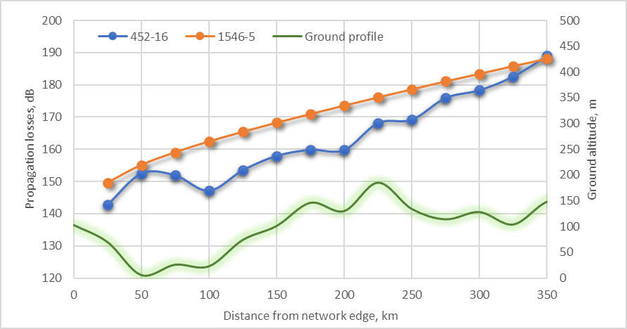
Figure 62Figure XX: Comparison between P.1546-5 and P.452-16 propagation models.

Conclusion
Two studies by using different statistical calculation methods were used for evaluation of interference from LTE based BB-PPDR systems operating in the band 410-430 MHz into radio astronomy stations in the band 406.1-410 MHz. One study was done by using SEAMCAT and propagation model described in Recommendations ITU-R P.1546-5 and P.452-16 with different network layout when aggregated effect of BSs and UEs were taken into account; another one - using MATLAB program and propagation model described in Recommendation ITU-R P.452-16. The previous methodology used in ECC Report 240 involved simplified propagation model described in Recommendation ITU-R P.452-14. The new study with MATLAB also considered a guard band of 1 MHz for base stations and larger guard bands of up to 5 MHz for user equipment, both indoor and outdoor usage.
Generic compatibility calculations for LTE systems in the 410-430 MHz band and radio astronomy operating in the band 406.1-410 MHz showed that compatibility may be achievable by implementing emission-free zones around RAS stations.
Analysis by using SEAMCAT showed that for LTE PPDR network completely surrounding RAS station, exclusion zone extended up to 241 km with Recommendation ITU-R P.1546-5 and 362 km with Recommendation ITU-R P.452-16 around RAS when no guard band was used. Exclusion zone extended up to up to 117 km with Recommendation ITU-R P.1546-5 and 261 km with Recommendation ITU-R P.542-16 when 2.5 MHz guard band was used. Separation distances became smaller when LTE network’s layout comprises a part of the ring placed on one side of RAS. They shrank down to 94 km with Recommendation ITU-R P.1546-5 and 246 km with Recommendation ITU-R P.542-16 when no guard band was used between systems. And they shrank to 18 km with Recommendation ITU-R P.1546-5 and 127 km with Recommendation ITU-R P.452-16 when 2.5 MHz guard band was used. Such case could be met when coordination of different systems between two countries occurs.
It is a difference between results for different propagation models Recommendation ITU-R P.1546-5 and Recommendation ITU-R P.452-16. Protection of investigated services could be insured by applying distances given by using ITU-R P.1546, for more precise exclusion zone ITU-R P.452 might be applied with real terrain data.
Analysis by using MATLAB with Recommendation ITU-R P.452-16 for the outdoor UE, considering a 1 MHz guard band, the separation distances for single emitter and aggregate cases become 78 km and 326 km, respectively. For indoor usage and additional wall attenuation of 11 dB the separation distances for single emitter and aggregate cases are reduced to 34 km and 190 km, respectively. The separation distances decrease with larger guard bands; for example, with a guard band of 5 MHz the separation distances for single emitter and aggregate cases of outdoor UE become 41 km and 261km, respectively. Moreover if the BS filter is applied to the UE frequency range and not further, the elevated spurious emissions of -26 dBm/MHz in the RAS band will result in increased separation distances of more than 500 km between a RAS station and the base stations.List of RAS stations in Europe operating in the 400 MHz band

Table 57: RAS stations in Europe operating in the 400 MHz band
Observatory | Administration | Coordinates | Elevation  (m AMSL)
e-callisto solar network | Germany, Italy, Belgium, Ireland, Finland, Czech Republic
Lustbühel | Austria | 47°04’03” N, 15°29’34” E | 483
Humain | Belgium | 50°11’31” N, 05°15’19” E | 293
Metsähovi | Finland | 60°13’04” N, 24°23’35” E | 61
Nançay | France | 47°23’00” N, 02°12’00” E | 150
Effelsberg | Germany | 50°31’32” N, 06°53’00” E | 369
Thermopiles | Greece | 38°49’00’’ N, 22°41’00” E
Medicina | Italy | 44°31’14” N, 11°38’49” E | 28
Noto | Italy | 36°52’33” N, 14°59’20” E | 90
Sardinia | Italy | 39°29’34” N, 09°14’42” E | 600
Westerbork | Netherlands | 52°55’01” N, 06°36’15” E | 16
Bleien | Switzerland | 47°20’26” N, 08°06’44” E | 469
Kayseri | Turkey | 38°42′37″ N, 35°32′43″ E | 1054
Cambridge | United Kingdom | 52°09’59” N, 00°02’20” E | 24
Jodrell Bank | United Kingdom | 53°14’10” N , -02°18’26” E | 78

Conclusion

LTE impact on narrowband PMR

LPWAN compatibility with LTE

LTE impact on DTT above 470 MHz

LTE impact on radars

LTE impact on radio astronomy
Two studies by using different statistical calculation methods were used for evaluation of interference from LTE based BB-PPDR systems operating in the band 410-430 MHz into radio astronomy stations in the band 406.1-410 MHz. One study was done by using SEAMCAT and propagation model described in Recommendation ITU-R P.1546-5 and ITU-R P.452-16 with different network layout when aggregated effect of BSs and UEs were taken into account; another one - using MATLAB program and the propagation model described in Recommendation ITU-R P.452-16.
Generic compatibility calculations for LTE systems in the band 410-430 MHz and radio astronomy operating in the 406.1-410 MHz band showed that compatibility may be achievable by implementing emission-free zones around RAS stations.
Analysis by using SEAMCAT showed that for LTE PPDR network completely surrounding RAS station, exclusion zone extended up to 241 km with Recommendation ITU-R P.1546-5 and 362 km with Recommendation ITU-R P.452-16 around RAS when no guard band was used. Exclusion zone extended up to up to 117 km with Recommendation ITU-R P.1546-5 and 261 km with Recommendation ITU-R P.452-16 when 2.5 MHz guard band was used. Separation distances became smaller when LTE network’s layout comprises a part of the ring placed on one side of RAS. They shrank down to 94 km with Recommendation ITU-R P.1546-5 and 246 km with Recommendation ITU-R P.452-16 when no guard band was used between systems. And they shrank to 18 km with Recommendation ITU-R P.1546-5 and 127 km with Recommendation ITU-R P.452-16 when 2.5 MHz guard band was used. Such case could be met when coordination of different systems between two countries occurs.
It is a difference between results for different propagation models Recommendation ITU-R P.1546-5 and Recommendation ITU-R P.452-16. Protection of investigated services could be insured by applying distances given by using ITU-R P.1546, for more precise exclusion zone ITU-R P.452 might be applied with real terrain data.
Analysis by using MATLAB with Recommendation ITU-R P.452-16 for the outdoor UE, considering a 1 MHz guard band, the separation distances for single emitter and aggregate cases become 78 km and 326 km, respectively. For indoor usage and additional wall attenuation of 11 dB the separation distances for single emitter and aggregate cases are reduced to 34 km and 190 km, respectively. The separation distances decrease with larger guard bands; for example, with a guard band of 5 MHz the separation distances for single emitter and aggregate cases of outdoor UE become 41 km and 261 km, respectively.

