WGSE PT45 meeting |  | Doc. SE45(18)113R1
Bonn, Germany, 10–12 December 2018
Date issued: | 3 December 2018
Source: | Lithuania
Subject: | Bandwidth factor estimation in RLAN to FSS aggregate interference studies
Group membership required to read? (Y/N)
N
Summary:
This contribution proposes a method for estimation of interference from RLAN to FSS using statistical means of bandwidth factor (BF) divided into two parts, namely, overlap probability and bandwidth correction. The method allows accurate estimation of mean I/N ratio of the aggregate interference.
Proposal:
Invites SE45 Group to consider this material and reflect in draft report as appropriate.
Background:
In the previous ECC draft report SE45(18)096A1R1 several studies of RLAN to FSS interference addressed the question of bandwidth overlap and bandwidth correction based on RLAN bandwidth distribution and channelization plan with respect to FSS/RLAN channel overlap. The channel overlap probability allows to reduce total number of active RLAN devices in Monte Carlo simulations to the number of interfering RLANs. The two constituent parts of bandwidth factor represent random dependent variables, therefore the product of their expectation values should take into account the covariance in order to reach accurate estimate of the final bandwidth factor value. The proposal includes the table of statistical distributions used for modelling bandwidth factor and Monte Carlo simulation results applied to Intelsat-22 satellite.

Introduction
For sufficiently large numbers of RLAN points used in Monte Carlo simulations the expectation value of aggregate interference level for FSS service can be approximated using the product of statistical means of power budget components assuming they are independent random variables. As already has been reported in Section 8.1.4 of ECC report SE45(18)096A1R1 [1], link budgets for some satellites obtained using average loss values match detailed Monte Carlo simulations within 1 or 2 dB accuracy. I/N power budget depends on path losses such as free space loss, building penetration, clutter loss, polarization mismatch, body loss, etc., which are calculated deterministically or generated using statistical probabilities over sufficiently large population sets and can be represented by their mean values equal to expectation values over multiple Monte Carlo runs. For most of the path loss components statistical independence of their distributions holds true. However, when the bandwidth factor ${\text{L}}_{\text{BF}}$ is divided into two interrelated parts, the overlap probability ${\text{L}}_{\text{BW,ovrl}}$ and bandwidth correction ${\text{L}}_{\text{BW,corr}}$, these parts are not statistically independent. We still can continue working with mean values of each random variable $E \left[{\text{L}}_{\text{BW,ovrl}}\right]$ and $E \left[{\text{L}}_{\text{BW,corr}}\right]$, but have to take into account the covariance $\text{Cov }\left[L_{\text{BW,ovrl}}\text{, }{ L}_{\text{BW,corr}}\right]$ when estimating expectation value of the product $E \left[L_{\text{BW,ovrl}}\text{ × }L_{\text{BW,corr}}\right]$:
$$E\left[L_{BF}\right]=E\left[L_{BW,ovrl}×L_{BW,corr}\right]=E\left[L_{BW,ovrl}\right]×E\left[L_{BW,corr}\right]+Cov\left[L_{BW,ovrl},L_{BW,corr}\right]$$
Such division of bandwidth factor ${\text{L}}_{\text{BF}}$ into two separate parts is especially advantageous in large scale Monte Carlo simulations where statistics of only overlapping points has to be considered. In this case substantially smaller amounts of RLAN points are generated and processed, as in the current simulation example the overlap probability results in about 1/5 of all active RLAN devices.

Bandwidth overlap and correction factors
Statistical estimation of mean values for bandwidth factor based on probability distributions following ECC report SE45(18)096A1R1 data is given in Table 1. Here the mean values of bandwidth factor and its parts are calculated according to RLAN distribution probabilities over different bandwidths. In this case, RLAN and FSS spectrum overlap probabilities and bandwidth correction factors are estimated for FSS 40 MHz channel.
Table 1: Statistical estimation of mean values for bandwidth factor as a product of overlap probability and bandwidth correction
Bandwidth (MHz) | 20 | 40 | 80 | 160 | Mean | Mean (dB)
Probability | 0.1 | 0.1 | 0.5 | 0.3
Overlap probability LBW,ovrl | 1/8=0.125 | 1/6=0.167 | 1/6=0.167 | 1/3=0.333 | 0.212 | -6.73
Bandwidth correction LBW,corr | 0.667 | 0.5 | 0.5 | 0.25 | 0.442 | -3.55
Total bandwidth factor LBF | 0.083 | 0.083 | 0.083 | 0.083 | 0.083 | -10.79
Product of the mean values of Bandwidth overlap and correction | $$E\left[L_{BW,ovrl}\right]×E\left[L_{BW,corr}\right]$$ |  |  |  | 0.0939 | -10.28
Covariance between bandwidth overlap and correction | $$E\left[L_{BF}\right]-E\left[L_{BW,ovrl}\right]×E\left[L_{BW,corr}\right]$$ |  |  |  | -0.0105
Difference in power budget due to covariance | $$\frac{E\left[L_{BF}\right]}{E\left[L_{BW,ovrl}\right]×E\left[L_{BW,corr}\right]}$$ |  |  |  | 0.8879 | -0.52
Covariance between bandwidth overlap and correction obtained statistically from Monte Carlo simulations in the following example with 4228696 RLAN points averaged over 10 snapshots is -0.010512 which is rather close to value -0.0105 resulting from statistical probabilities shown in Table 1 and derived as$Cov\left[L_{BW,ovrl},L_{BW,corr}\right]=E\left[L_{BF}\right]-E\left[L_{BW,ovrl}\right]×E\left[L_{BW,corr}\right].$Correcting the bandwidth factor product by including covariance for the current distribution probabilities gives 0.52 dB difference to the overall interference power budget. Although such error is not large compared to power budget estimation accuracy it is a systematic error and cannot be averaged out by increasing the number of Monte Carlo snapshots. In the following extra factor of 0.52 dB will be added to the interference power budget in case of separately estimating bandwidth overlap ${\text{L}}_{\text{BW,ovrl}}$ and bandwidth correction ${\text{L}}_{\text{BW,corr}}$ factors.

Monte Carlo simulations of the aggregate RLAN to FSS interference
The method of bandwidth factor division into two parts has been applied to Monte Carlo simulations for Intelsat-22 satellite covering European, African and Middle East countries. We used in total population 2465.7 million from the 133 countries within satellite West Hemi beam footprint zone up to 0 deg elevation over the horizon and limited by -10 dB level beam contour as shown in Figure 1.
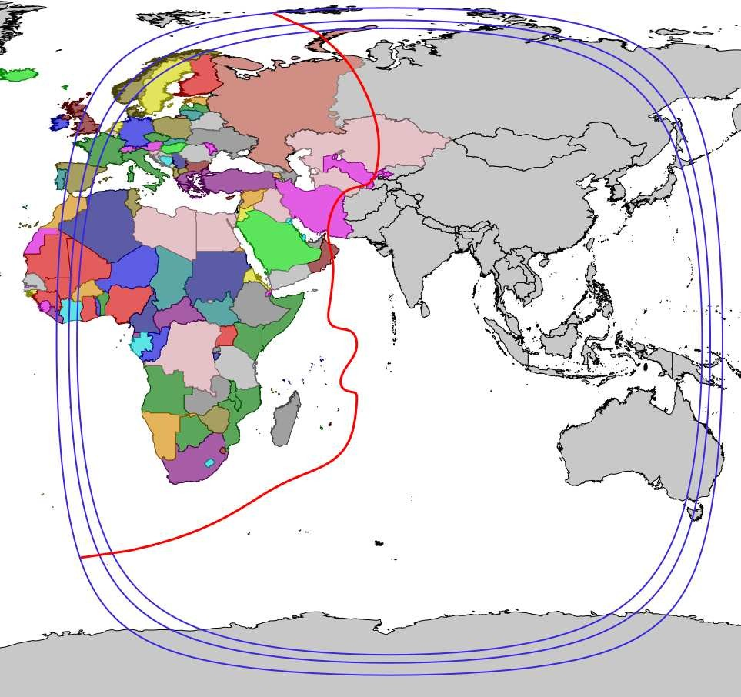
Figure 1: Geometry of satellite Intelsat 22 West Hemi beam footprint: -10 dB level antenna gain contour (red line), 0°, 3° and 5° elevation angles (blue contours) and countries included into analysis shown by coloured areas
For estimating covered population the multinational Gridded Population of the World data Version 4 (GPWv4) [2, 3] based on historical census data and extrapolated to year 2020 has been used. Following the method suggested in ECC report SE45(18)096A1R1, the RLAN device density factor of 0.001715 has been obtained assuming duty cycle of 1.97% and the rest parameters according to Table 2. These population and RLAN device densities results in 4228696 active simultaneously transmitting RLAN devices within satellite footprint zone.
Table 2: Parameters for generating RLAN device density according to draft CEPT report
Parameter | Value
Devices per person | 10
License exempt factor | 0.9
Busy hour factor | 0.627
6 GHz market adoption | 0.32
6 GHz spectrum loading | 0.4817
Duty cycle (high act.) | 0.0197
Duty cycle (low act.) | 2.2e-06
Device density factor | 0.001715
Four different potential use cases of bandwidth factor is studied next. The results are compared to similar RLAN to FSS interference studies presented in ECC draft report SE45(18)096A1R1. Despite some variations in populations covered by each of the satellite under analysis, another key factor influencing I/N interference results is bandwidth factor. The difference in bandwidth factor definitions in RLAN to FSS interference case studies may cause differences in resulting I/N levels:
- Using total bandwidth factor. If using a single bandwidth factor its value can be estimated as a fraction of FSS channel bandwidth over total RLAN 6 GHz bandwidth which is
$${\text{L}}_{\text{BF}}\text{=}\frac{\text{40}}{\text{480}}\text{=0.0833=-10.79 dB}$$
for satellite channel bandwidth of 40 MHz. In this case only channel correction factor is used, the spectrum overlap is considered 100%. A similar approach has been used in Study A of ECC draft SE45(18)096A1R1 report (see e.g. Table 37 in [1]) where bandwidth factor corresponding to 36 MHz FSS channel has been applied as ${\text{L}}_{\text{BF}}$ = 36/480 = 0.075.
- Using bandwidth overlap only. Spectrum overlap probability which is 0.212 in our case will result in about 6.73 dB reduction of interference power budget. A similar study in ECC draft SE45(18)096A1R1 report, Study B (see Table 46) in [1] employs spectrum overlapping factor of 0.2125. Bandwidth correction factor due to different RLAN and FSS channel bandwidths is referenced in equation in Section 8.2.2 of [1], but no further results of bandwidth correction is reflected in the following interference level tables.
The same channel overlap factor of 21.2% is derived in Appendix A5.1 of Study C [1]. This overlap factor is then used in Tables 74–81 of Annex A5.2 [1].
- Using bandwidth correction only. As another alternative, bandwidth correction alone can be used for interference estimation reducing the power budget about 3.55 dB. Bandwidth correction distribution over RLAN channel bandwidths is used as bandwidth factor in Study C of ECC draft SE45(18)096A1R1 report as detailed in Section 8.3.4 and Annex A5.3 in [1]. Although it is not clearly visible from the analysis results in Tables 83 and 84, we may assume channel overlap equal to 1.0 in this case.

- Using product of bandwidth overlap and correction. In the current analysis we used method detailed in Annex 2 of ECC SE45(18)096A1R1 report [1], which uses a product of both channel overlap factor (Table 67 in [1]) and bandwidth correction factor (Table 68 in [1]).
The results of Monte Carlo simulations for RLAN interference to FSS satellite Intelsat-22 using bandwidth factor estimated using four different approaches is compared in Table 3. The results in the last column represent the case of using product of bandwidth overlap and correction which matches exactly the case of using the total bandwidth factor estimated using mean values. When calculating BF by parts, extra term of 0.52 dB has been added due to covariance between bandwidth overlap and bandwidth correction. The main advantage of using BF division into parts is that the same result is reached using 898597 RLAN points instead of 4228696 points in the total BF case. When using only one single component of BF, either bandwidth overlap probability or bandwidth correction, significantly higher interference levels are obtained with the same average power budget values as displayed in the middle two columns.
Table 3: Four use cases of bandwidth factor application for I/N power budget estimation
Parameter | Total BF | BW overlap only | BW corr. Only | Prod. Of BW overlap and corr.
EIRP mean value per single RLAN (dBm) | 15.03
Number of active RLAN devices | 4228696
Bandwidth overlap fraction $E \left[{\text{L}}_{\text{BW,ovrl}}\right]$ | 1.0 | 0.2125 | 1.0 | 0.2125
Number of overlapping RLAN devices | 4228696 | 898597 | 4228696 | 898597
Bandwidth correction (dB) $E \left[{\text{L}}_{\text{BW,corr}}\right]$ | 10.79 | 0.00 | 3.55 | 3.55
Covariance term (dB) |  |  |  | 0.52
Total bandwidth factor (dB) $E \left[{\text{L}}_{\text{BF}}\right]$ | 10.79 | 6.73 | 3.55 | 10.79
FSPL (dB) | 199.83
Building penetration (dB) | 15.83
Clutter loss (dB) | 0.56
Polarization loss (dB) | 3.0
Body loss (dB) | 0.76
Estimated mean I/N (dB) | -22.61 | -18.54 | -15.36 | -22.61
MC simulated I/N (dB) | -22.05 | -18.01 | -14.77 | -22.52
As the results of interference values I/N presented in Table 3 suggest, using mean values of total bandwidth factor as a whole or divided into ${\text{L}}_{\text{BW,ovrl}}$, ${\text{L}}_{\text{BW,}\text{corr}}$ parts could be used as good estimators of aggregate interference values for a given population numbers.

References
- ECC, “Draft Report RLAN6. Sharing and compatibility studies related to Wireless Access Systems including Radio Local Area Networks (WAS/RLAN) in the frequency band 5 925 – 6 425 MHz,” ECC, Tech. Rep. SE45(18)096A1R1, Oct. 2018
- C. T. Lloyd, A. Sorichetta, and A. J. Tatem, “High resolution global gridded data for use in population studies,” Scientific Data, vol. 4, p. 170001, Jan. 2017. [Online]. Available: https://www.nature.com/articles/sdata20171
- Center For International Earth Science Information Network-CIESIN-Columbia University, “Gridded Population of the World, Version 4 (GPWv4): Population Density, Revision 10,” 2017, dOI: 10.7927/H4DZ068D. [Online]. Available: http://sedac.ciesin.columbia.edu/data/set/gpw-v4-population-density-rev10

