CPG PT D |  | Doc. PTD(18)105
7th meeting of CPG19 Project team D
Kyiv, Ukraine
25 – 28 September 2018
Date issued: | 17 September 2018
Source: | Lithuania
Subject: | Position on WRC-19 Agenda item 1.1 and proposal for sharing with Broadcasting service
Group membership required to read? (Y/N)
N
Summary:
During the last CPG meeting, it was approved the preliminary position that CEPT supports an allocation of 2 MHz in the frequency range 50-52 MHz to the amateur service in Region 1 on a secondary basis. Furthermore, the meeting noted the position expressed by Lithuanian administration to address the section 3.2 of the CEPT Brief on agenda item 1.1 on sharing with Broadcasting service issue in the next PTD meetings as at the 6th PTD meeting held at Tallinn (Estonia), the meeting could not reach final agreement. It shall be noted the change of the Preliminary CEPT position considering the frequency band allocated to Amateur service limited to 2 MHz in the frequency range 50-52 MHz instead of initial 4 MHz.
The present document provides in the Annex the position of Lithuanian administration on the protection requirements for the stations of Broadcasting service.
Proposal:
CPG/PTD is asked to consider the proposal in the Annex for inclusion in the draft CEPT Brief on WRC-19 agenda item 1.1

Noting:
- some countries border with a miniature radius service area of potentially operational analogue broadcasting station pertinent to the framework of the Stockholm 1961 Agreement (Rev. RRC-06) (ST61) of neighbouring country (i.e. service area diameter 10 km vs 254 km border length in the Kaliningrad region) or doesn’t border this service area overall;
- protection for the operational stations of Broadcasting service that had been coordinated within the framework of the ST61 Agreement shall be continued of the same level as it was when all European countries operated stations of analogue TV broadcasting;
- any other new use of spectrum within the framework of the ST61 Agreement shall be protected at the same level as analogue TV stations.
- any other use of spectrum outside the framework of the ST61 Agreement must be coordinated under the provisions of Chapter III RR or may be maintained on a basis of Article 4.4 RR on non-protected non-interference basis only;
- number of analogue TV stations still listed in MIFR may be not in actual use;
- ITU RR introduces framework to protect stations and their service areas, but not national borders.

Background:
Frequency band 50-52 MHz was covered by the ST61 Agreement and still in use for analogue television (TV) broadcasting in some countries.

It shall be noted that Broadcasting is allocated as a primary service according to Article 5 of the Radio Regulations on a non-exclusive basis along with other radio services allocated within the same band.
Electromagnetic compatibility (EMC) between stations of Amateur service in the 50-52 MHz band and analogue TV stations of Broadcasting service can be assessed on a basis of Recommendation ITU-R SM.851-1 "Sharing between the broadcasting service and the fixed and/or mobile services in the VHF and UHF bands" and Recommendation ITU-R P.1546 "Method for point-to-area predictions for terrestrial services in the frequency range 30 MHz to 3 000 MHz".

Calculations didn’t consider co-channels interferences created by these stations to each other to indicate maximum possible size of service area of each station in case the neighbouring stations are closed.
Graphical display of the calculations of the service areas of analogue TV broadcasting sites in the Baltic region, based on MIFR entries RUS-NTFD_RR-096016857, RUS-NTFD_RR-097006798, RUS-NTFD_RR-097006792 and RUS-NTFD_RR-104035589.
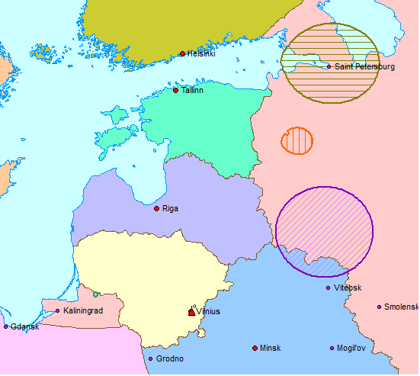
Graphical illustration of the calculation of the service area of d = 10 km width of analogue TV broadcasting site based on MIFR entry RUS-NTFD_RR-104035589.
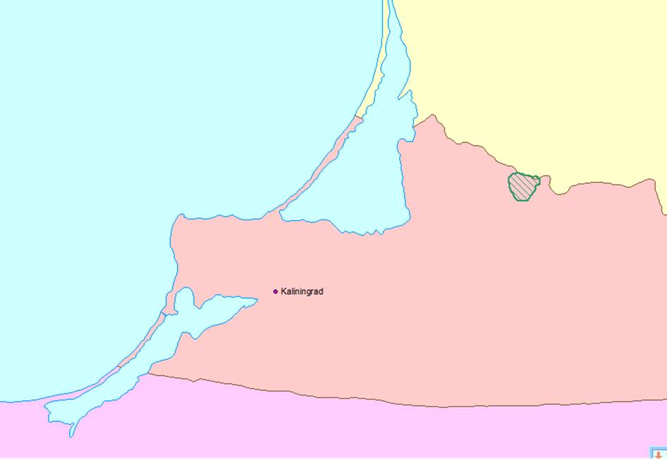

The assumptions used:
Recommendation ITU-R P.1546-5 "Method for point-to-area predictions for terrestrial services in the frequency range 30 MHz to 3 000 MHz". Minimum wanted field strength of analogue TV transmitter on the boundary of the coverage area (in 50% of the locations, 90% of the time) – 46 dBμV/m at a height of 10 meters.

The nominal frequency of analogue TV station – 52,5 MHz, vision carrier frequency 49,75 MHz.
Value of the protection ratio, required to protect analogue TV channel, differs by 6 dB in the band 50–52 MHz, so it creates space for an increase of the limit of the field strength created by the Amateur service station in a part of the band still ensuring sharing with the Broadcasting service.
It shall be noted that other than analogue TV uses of spectrum may require even less protection in comparison to vulnerable analogue technologies (i.e. DVB-T, Europe and Asia practices), protection ratio around 20 dB.

…/…

Annex
Proposal for the Sharing with Broadcasting Service section 3.2 of the CEPT Brief on on WRC-19 agenda item 1.1

…/…

3.2 SHARING WITH BROADCASTING SERVICE

Protection of the broadcasting service requires that the amateur service stations’ field strength values do not exceed 6 dBμV/m within 50-51,25 MHz band and 12 dBμV/m within 51,25-52 MHz band for more than 10% of time at any point inside the service area (within the 46 dBμV/m boundary in 50% of the locations, 90% of the time for each station) of a broadcasting station in operation, measured at a height of 10 m above ground.
Administrations shall be required to assess and if necessary to coordinate the usage of the band by the amateur service.
This provision does not apply to countries listed in No 5.169.

…/…

