 |  | FM22(21)08
Project Team FM22
55rd Meeting of FM22
Web Meeting, 20 – 23 April 2021
Date issued: | 12 April 2021
Source: | Lithuania
Subject: | Antenna radiation pattern measurement with drones
Group membership required to read? (Y/N)
N
Summary:
RRT conducted experimental measurement of DVB-T antenna radiation pattern using a drone, obtained results are presented.
Proposal:
FM22 is invited to study the material and possibly provide feedback that may serve to improve the measurement technique.
Background:
.

Introduction and background
The Communications regulatory authority of the Republic of Lithuania (abbreviated RRT) occasionally needs to measure the radiation patterns of the transmitting antennas of broadcasting stations. It is now possible to carry out such measurements using a drone. Moreover, measurements are usually ordered from some company that specializes in this area. In this case, measurements are taken rather quickly at a good professional level, but the price of such a service is usually high. Less often, organizations that need such measurements purchase the necessary equipment and independently carry out radiation pattern measurements. In the long term, this approach may be justified, but several additional difficulties accompany its implementation. So, in addition to assembling and setting up systems that ensure the flight of the drone along a strictly specified route and at the same time measuring the field strength, it is necessary to train the pilot to control the drone, it is necessary to take care of insurance in case of an accident during the flight, and so on.
RRT chose a compromise. The professional service company provided the drone and conducted its flights. RRT provided the field strength measurement system that the drone carried and took the actual measurements.

DronE
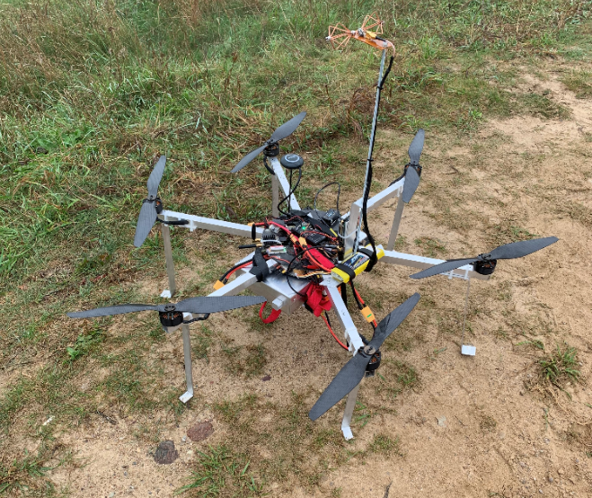
Drones come in a variety of designs. In our case, the experimental hexacopter with Pixhawk autopilot controller was used (Figure 1). The flight time with 2 kg payload is about 20 min.

Figure 2: Drone (hexacopter) for measurements of antenna radiation pattern
The position of drone is controlled by means of internal compass and GPS with a metrical accuracy. As a ground control station for drone Mission Planner was used. This application allows to plan autonomous mission and load it into autopilot, monitor drone status while in operation, analyze autopilot and telemetry logs after the flight. Fig. 2 shows a screenshot of the Mission Planer with a drone setup to fly in a circle around the test antenna.
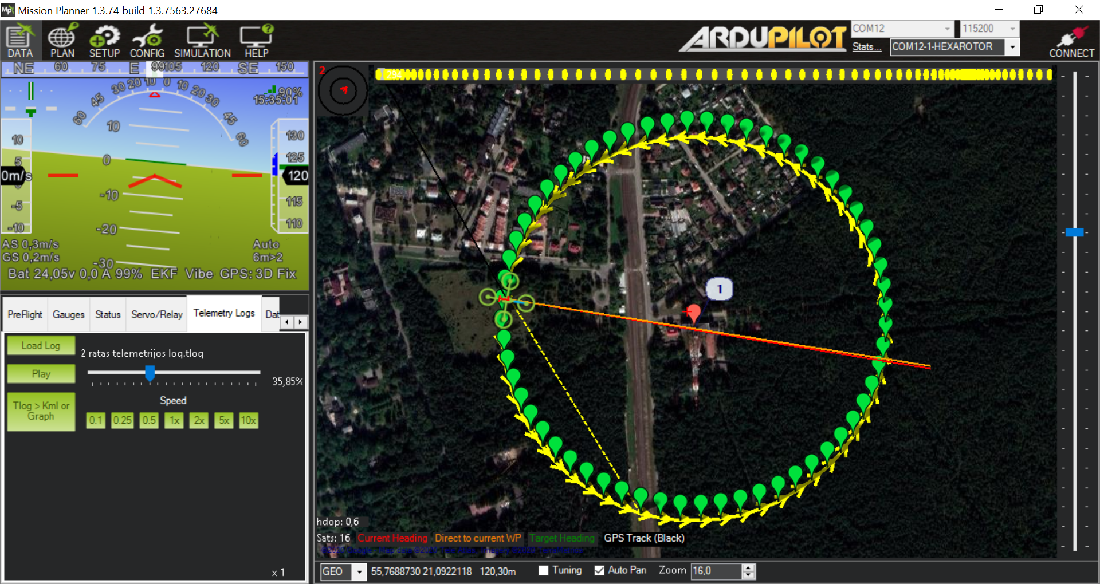
Figure 2: Screenshot of the Mission Planer

The fiEld strength measurement system
The system for field strength measurement is a complete receiving system, including an antenna, spectrum analyzer and logging (host) computer. The main element of the system is the real time spectrum analyzer Signal Hound BB60C (weight 500 grams), operated and is powered by connecting to a host PC through a USB 3.0 cable. As mentioned above, the system (unit) was produced by RRT staff. Fig. 3 shows its functional diagram.
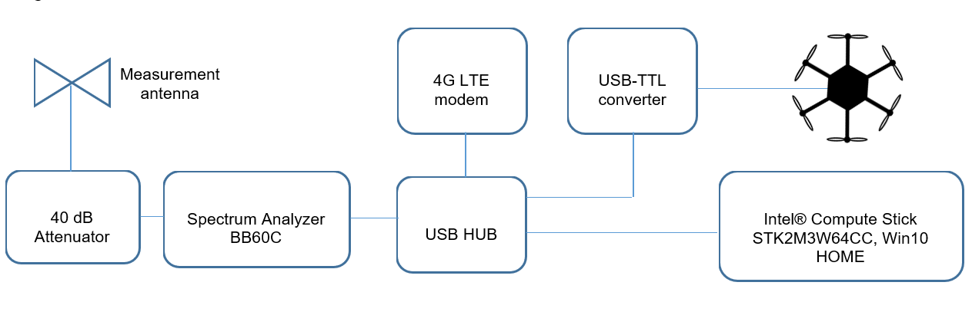Figure 3: The functional diagram of the measuring system

The Spike Signal Hound Spectrum Analyzer software allows to record spectrum data. Channel power of up to nine channels can be logged simultaneously together with time stamp, as well as complete spectrum trace can be recorded for later analysis. Fig. 4 shows the screenshot when the spectrum analyzer is configured to measure seven channels simultaneously.
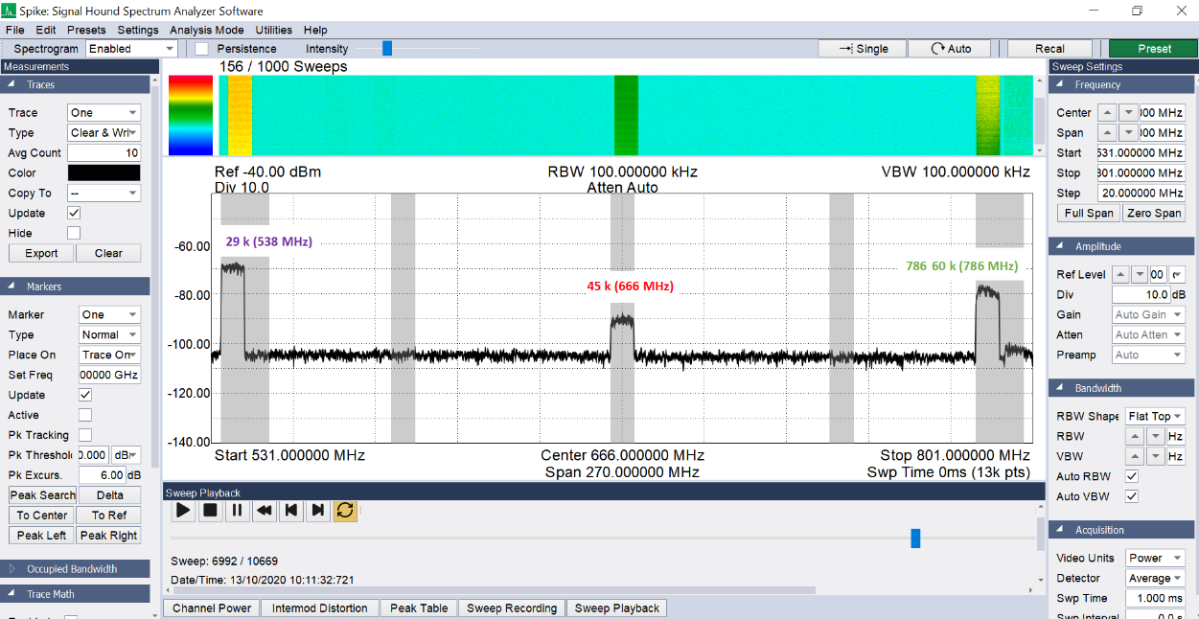
Figure 4: Spike Signal Hound Spectrum Analyzer screenshot
Example of logged channel power data is presented in Fig. 5. Although Spike spectrum analyzer software allows to connect external GNSS receiver for a location data, the channel power values are logged with time stamp only.
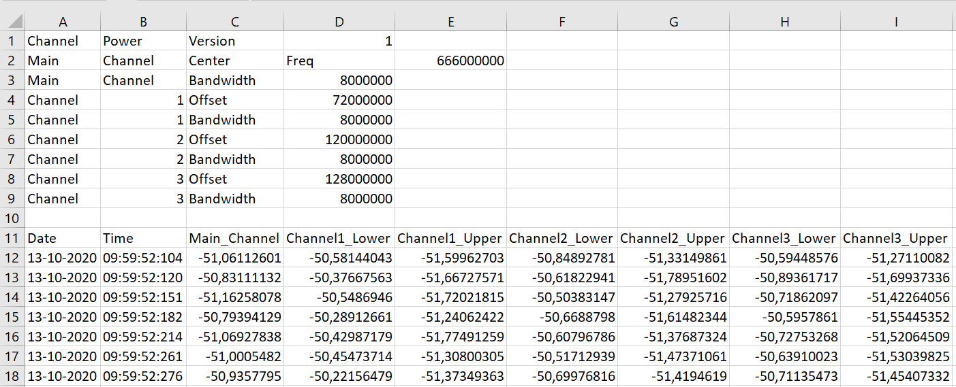
Figure 5: Example of logged channel power data
For antenna radiation pattern we need to know location data for each channel power value. For this in parallel GNSS data, received from drone controller using NMEA protocol, was also recorded with time stamp (Fig. 6).
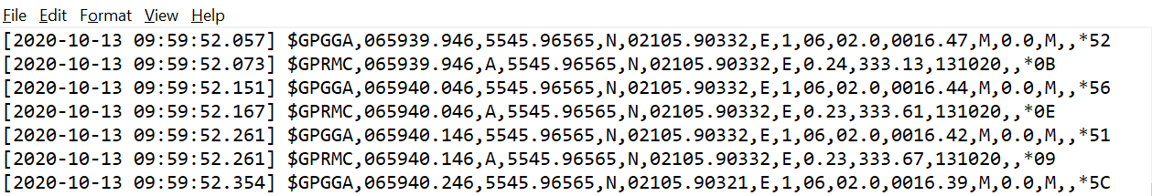
Figure 6: Example of logged GNSS data
RRT created an automatic tool “Log data analyzer”, which automatically merges GNSS and channel power log files and draws a polar diagram. The merged data can be also exported to MS Excel file for later analysis.
As a measurement antenna we used a small-sized, 40 g weight homemade bi-conical antenna, which operates from 80 MHz to 1,000 MHz and covers all TV channels, FM and GSM. The measuring system (except for the antenna) was placed in an aluminum box (see Fig. 7).
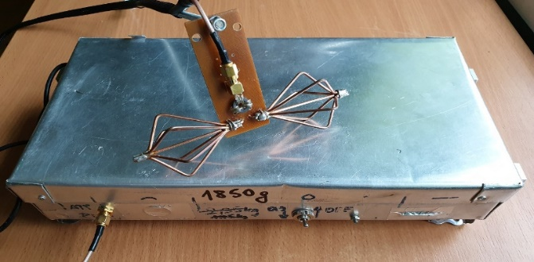

Figure 7: The field strength measurement system

Setting up an experiment
The test transmitter was located on the coast of the Baltic Sea near the port city Klaipeda in a wooded area and the measurement of antenna patterns is possible only by using a drone. The main parameters of the transmitter are given in Table 1.
Parameter
Coordinates | N55°46’7.4” / E22°05’48.4”
Antenna location height above mean see level | 21.4 m
Tx antenna center height above ground | 198 m
Antenna vertical size D | 8.7 m
Number of bays | 8
Panel per bay | 3
Vertical pattern beam tilt | -0.8°
Maximum ERP (29 channel) | 44.8 dBW
Maximum ERP (45 channel) | 29.79 dBW
Maximum ERP (60 channel) | 42.7 dBW
Table 1: Key data for measured DVB-T transmitters

General view of the DVB-T antenna installation is shown in Fig.8.
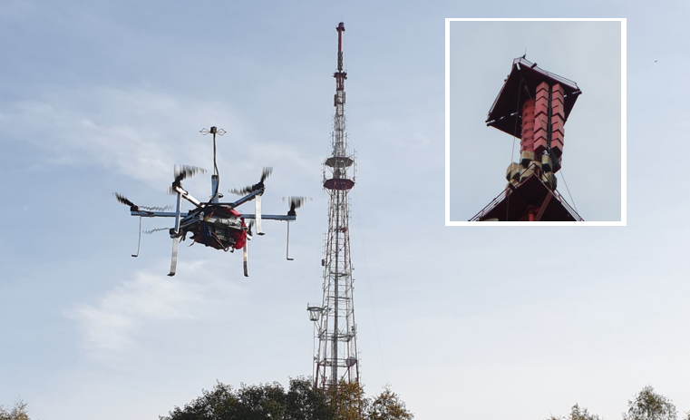
Figure 8: DVB-T antenna installation

Before real measurements on-site, using the shown above parameters of the transmitter, the conditions of the experiment were simulated. First, the flight radius of the drone around the antenna was determined. For this purpose, the distance from the measured antenna to the far field zone was calculated. For channel 29, this distance is:
$L=\frac{2*D^{2}}{λ}=\frac{2*{8.7}^{2}*538}{300}=271 m$.
For channel 60, this distance is 396 m. Taking into account the limitations on the flight time of the drone, a compromise value of the radius of 300 m was chosen.
Then the total peak power at the input of spectrum analyzer (which should not exceed +20 dBm) was calculated. Besides 3 television channels, we additionally need to take into account also 8 FM channels, transmitted from the same tower. The calculation showed that the maximum power could reach more than +10 dBm. Based on this, it was decided to use a 40 dB attenuator at the input of the spectrum analyzer.
The measurements were carried out in 2 stages. Initially, the drone took off strictly vertically to a height of about 220 m above the ground and descended vertically. During the flight, the signal power of each of the three channels was recorded. From the data obtained, the radiation patterns in the vertical plane were calculated and the height H_{s} (above mean sea level) corresponding to the maximum signal power was determined.
During the second stage, the drone automatically flew around the antenna under test, strictly maintaining a distance of 300 m from it and the height of H_{s}. While flying in a circle, the drone was constantly turning so that its measuring antenna was always pointed at the antenna under test. As before, during this flight the signal power of each of the three channels was recorded.

results of the radiation pattern measurements
Fig. 9 represents the measured radiation patterns in vertical plane.
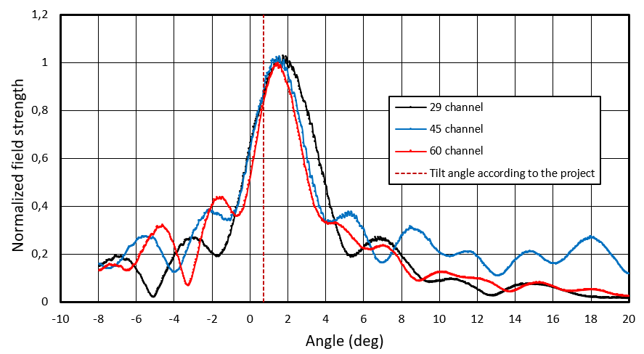
Figure 9: Measured radiation pattern in vertical plane
It shows that the width of the main lobe increases with decreasing channel number (and, hence, frequency). Moreover, as can be seen from the data in Table 3, the data from the project are in good agreement with the measured ones.

Channel number | Project data | Measured data
29 | 4.52° | 4.33°
45 | 3.29° | 3.62°
60 | 2.84° | 3.07°

Table 2: Main lobe width at -6 dB
Fig. 9 also shows that the beam tilt differs significantly from the design (project) value, which is 0.8 degrees. The height measurement was done only using a simple non-RTK GNSS receiver, so height error of several meters would affect beam tilt determination significantly. Moreover, it is difficult to accurately determine the beam tilt value directly from the measured data due to signal fluctuations, possibly caused by the signal reflected from the ground. These fluctuations are clearly visible in Fig. 10. Use of an antenna with vertical directivity can minimize the impact of signals bouncing up from the ground.
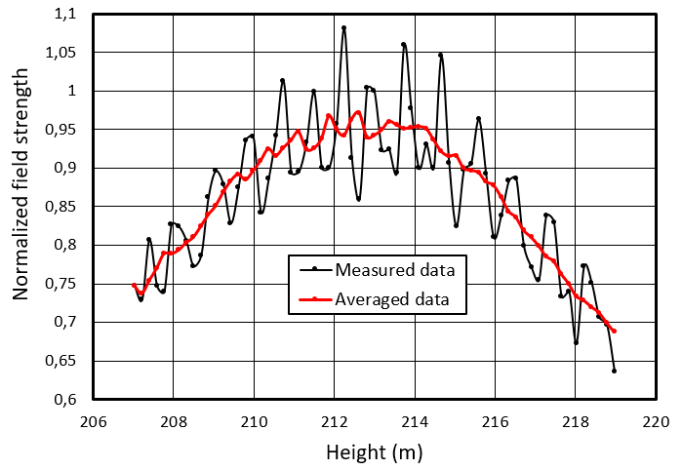
Figure 10: Dependence of the field strength of the 29th channel near the beam on the height above mean see level
Using averaged field strength data, it is much more accurate to determine the height where the field strength reaches its maximum. Knowing this height, the horizontal distance to the transmitting antenna and the height of the antenna above mean sea level, the beam tilt is easily calculated. For 29 channel, its value is 1.45 degrees and with increasing frequency, it decreases, reaching 1.3 degrees for 60 channel.
Horizontal radiation patterns were measured by conducting two flights in a circle around the measurement antenna. Measurement results and comparison with project data are presented in Fig. 11-13.

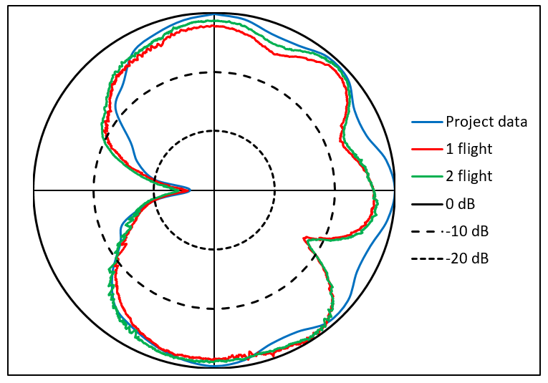
Figure 11: Measured horizontal radiation pattern compared to project data for channel 29
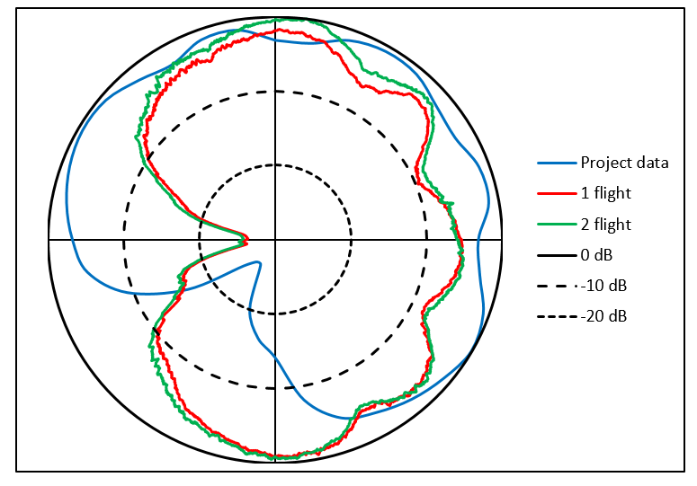
Figure 12: Measured horizontal radiation pattern compared to project data for channel 45
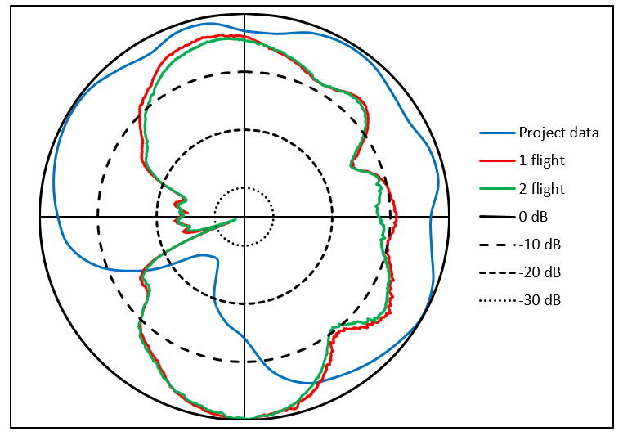
Figure 13: Measured horizontal radiation pattern compared to project data for channel 60
Measurement results for the first and the second flights repeated well pretty well, measured values overlap within 2 dB. Radiation pattern for channel 29 is close to project data with exception of couple minimums at about 70 and 120 degrees. Radiation patterns of channels 45 and 60 clearly show that antenna orientation differs from project data for about 60 degrees.

CONCLUSIONS
Measurements have shown that a drone with a simple GNSS receiver could be used only for basic horizontal radiation pattern measurements and antenna direction determination, where distance and height measurements with the accuracy of several meters is not critical. Vertical radiation pattern measurements require much better positioning accuracy, so the drone should be positioned using RTK GNSS receiver.

