FM22(17)48Annex

ECC Recommendation (12)03

Determination of the radiated power through field
strength measurements in the frequency range
from 87.5 MHz to 6000 MHz
Approved DD Month YYYY

introduction
The radiated power of a transmitter is one of the most important parameters which characterise a transmitter and its emissions. Usually it is not possible to measure the radiated power directly. However, there are two different methods to determine the radiated power indirectly. The first method would measure the transmitter output power and calculate the radiated power by taking into account cable losses and antenna gain (equivalent to an isotropic radiator). The second method measures the field strength and calculates the radiated power by taking into account the measurement distance and the propagation loss.
The purpose of this Recommendation is to provide two remote measurement (over-the-air) methods which will enable CEPT administrations to determine the radiated power of a transmitter in the frequency range from 87.5 MHz to 6000 MHz from field strength measurements reducing as much as possible the uncertainty of the measurement.
ECC recommendation (12)03 of XX YY on determination of radiated power through field strength measurements in the frequency range from 87.5 MHz to 6000 MHz
“The European Conference of Postal and Telecommunications Administrations,
considering
- that the limitation of the radiated power of a transmitter is essential for the limitation of co-channel re-use distances and for interference mitigation in neighboring channels,
- that radiated power is one of the parameters which is specified in authorisations,
- that the verification of radio stations emissions for compliance with the authorisation conditions is an important task of the radio monitoring or inspection services,
- that radiated power determination through measurements at the transmitter output are often impossible due to access problems or lacking test output,
- that these measurements can be substituted by field strength measurements with subsequent conversion to radiated power under certain conditions,
- that a radiated power determination through measurement at the transmitter output generally can only be done with the agreement and thus with the knowing about measurement activities of the operator or the operating company,
- that the radiated power of some systems may vary in relation with many parameters such as traffic load of the network and/or downlink power control,
recommends
that the height scan measurement method, described in Annex 3, which is technically simpler than route scan measurement method described in Annex 4, should be used to determine the radiated power of a transmitter in the frequency range from 87.5 MHz to 6000 MHz. The route scan measurement method should be used in those cases when measurements are not possible according to the height scan method.

- radio propagation over the ground
  - Abbreviations and symbols
- Abbreviations and symbols
Abbreviation & symbol | Explanation
c | Velocity of light in free space
d | Horizontal distance from transmitting antenna position to the measurement antenna position
dB | Decibel
dBW | Decibel watt
d_{n} | Normalized distance (the distance derived from H*h*f/c)
d_{max} | Maximum distance from transmitting antenna position to the measurement antenna position at which still is possible to obtain one minimum and one maximum of field strength during a height scan
d_{min} | Minimum distance from transmitting antenna position to the measurement antenna position at which with sufficient accuracy can be taken into account the decrease in the field strength due to the directivity of the antenna in the vertical plane
E | Field strength (RMS value)
e.i.r.p. | Equivalent isotropically radiated power
f | Frequency
F(θ) | Directivity of the transmitting antenna in vertical plane
E_{D} | Magnitude of direct wave
E_{R} | Magnitude of reflected wave
E_{H} | Horizontal field strength component
E_{V} | Vertical field strength component
E_{FS} | Field strength of direct wave (free space)
E_{max} | Maximum field strength obtained during a height scan
E_{min} | Minimum field strength obtained during a height scan
h | Height of the measuring antenna above the ground
h_{max} | Maximal height of the measuring antenna above the ground
h_{min} | Minimal height of the measuring antenna above the ground
H | Height of the transmitting antenna above the ground
L_{D} | Length of direct propagation path
L_{R} | Length of indirect propagation path due to ground reflection path
R | Magnitude of the ground reflection coefficient
RMS | Root Mean Square
Tx | Transmitter
θ_{max} | Elevation angle corresponding to distance d_{min}
θ_{min} | Elevation angle corresponding to distance d_{max}
θ_{D} | Elevation angle corresponding to direct propagation path
θ_{R} | Elevation angle corresponding to reflected propagation path
θ (-1dB) | Elevation angle corresponding to transmitting antenna’s vertical pattern at -1 dB
θ (-10 dB) | Elevation angle corresponding to transmitting antenna’s vertical pattern at -10 dB
DAB | Digital Audio Broadcasting
DVB-T | Digital Video Broadcasting — Terrestrial
FM | Frequency modulation
  - Two-ray ground reflection model for flat surface
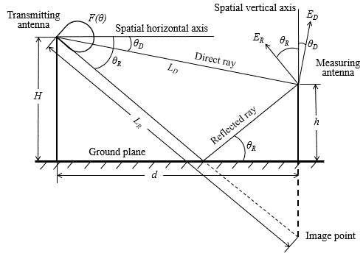
The two-ray model is an improved version of the free space propagation model. It considers both line-of-sight (direct) and ground reflection paths and is based on geometric optics. It is reasonably accurate for predicting the large-scale field strength at a distance of several tens kilometers.
Fig. 1: Graphical representation of the two-ray model applied for a vertically polarized wave.
Following the notations in Fig. 1, the length of direct propagation path can be geometrically derived to be
(1)
and the length of indirect due to ground reflection path derived to be
(2)
The elevation angle θ_{R} and angle θ_{D} can be derived to be
(3)
(4)
Based on the lengths L_{D} and L_{R}, on the equivalent isotropically radiated power e.i.r.p., on directivity of the transmitting antenna in vertical plane F(θ) and on the magnitude R and phase φ(θ) of the ground reflection coefficient, the direct wave can be expressed as
(5)
and the reflected wave can be expressed as
(6)
where f – the transmitting frequency; c – the velocity of light in free space.
When doing field strength calculations, the type of wave polarization should be taken into account. In case of horizontal polarization, the electric vector of direct wave is horizontal to the reflecting surface. The electric vector of reflected wave also is horizontal to the reflecting surface. So, these two vectors are parallel, and the total field strength can be calculated by adding the direct and the reflected waves accounting for difference of phases. As follows from the equations (5) and (6), the phase difference is
(7)
Therefore, for the total field strength we obtain [1]:
(8)
where
(9)
As follows from equations (8), the RMS value of the total field strength is equal:
(10)
In case of vertical polarization, the electric vectors of direct and reflected waves lay in the plane of incidence. The visualization of this situation is shown in Fig. 1. Therefore, the total field strength can be calculated by adding the direct and the reflected waves accounting for difference of directions and difference of phases.
Following the notations in Fig. 1 the vertical component of the total field strength is equal:
(11)
The difference of phases between and is given by equation (7). Finally, in the case of vertical polarization, for r.m.s value of the total field strength we obtain the expression similar to expression (10), but with different function K_{V} [1]:
(12)
(13)
It should be noted, that expressions (9) and (11) contain interference coefficient cos(ΔΦ), which magnitude and sign depends on the path difference of direct and reflected waves. Therefore, field strength fluctuations occur when the height h or distance d changes. Below, this question will be discussed in more detail.
When the distance d is very long relatively to the height of the transmitting antenna H and receiving antenna h, the angles θ_{D} and θ_{R} are nearly equal and close to zero (see Fig. 1) and the reflection coefficient of the ground (see Fig. 2) is close to 1, then the exact expression for the calculation of field strength transforms into simplified expression [2]:
(14)
The equation (14) is usually called the Vvedenskij’s interferential formula. According to paper [2], this formula can be applied under the following condition:
(15)
It is more convenient to introduce the normalized distance d_{n}=d/(Hhf/c) and (15) rewrite as:
(16)
The equations for total field strength (10), (12) and (14) are more useful when expressed logarithmically:
(17)
(18)
(19)
  - Computing of field strength
Data processing and computation may be carried out with Microsoft Excel or with another appropriate program. Directivity of the transmitting antenna in vertical plane F(θ) is generally available in paper form. Therefore, they should be described using approximating polynomial. As the main beam is symmetrical, it is enough to describe only one side of it. Usually the third order polynomial was used for its’ description. The coefficients of polynomial can be easily determined with MS Excel.
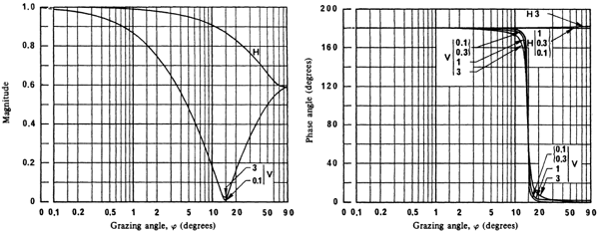
Fig. 2: Magnitude and phase of the reflection coefficient of a plane surface and medium dry ground as function of grazing (elevation) angle for vertical V and horizontal H polarizations [4] (the frequencies are given in GHz).
Dependencies of magnitude and phase of the reflection coefficient on grazing angle (it is equal to elevation angle) are taken from [3] and are presented in Fig. 3. It can be seen that for horizontal polarization the magnitude of a reflection coefficient changes smoothly with the change of a grazing angle, so it was precisely described using one polynomial of the sixth degree. For vertical polarization, the magnitude of a reflection coefficient has a sharp deep minimum at a grazing angle of 15 degrees (Brewster‘s angle). For that reason, the reflection coefficient may be described using two separate polynomials in the ranges from 0 to 15 degrees and from 15 to 90 degrees of grazing angle. As follows from [3], the phase of the reflection coefficient is equal to 180 degrees for horizontal polarization, and it decreases from 180 degrees to 0 degrees with the change of grazing angle from 10 to 20 degrees for vertical polarization. Because the magnitude of the reflection coefficient in this range is less than 0.2, without significant influence on calculations of the total field strength we can presume that the phase of reflection coefficient is equal to 180 degrees in the range of grazing angle from 0 degrees to 15 degrees, and it is equal to 0 in the range of grazing angle from 15 to 90 degrees.
Lithuanian administration used MS Excel templates for field strength calculation. The first type template has been created where fixed ground distance d varies from 100 m to 15000 m with a step of 10 m. After entering the heights of transmitting and measuring antennas, transmitting frequency and radiated power, the values of L_{D} and L_{R}, angles θ_{D} and θ_{R} and corresponding antenna directivity, reflection coefficient magnitude and phase values are calculated automatically for every distance value. As the final result, the values of the total field strength were calculated by formulas (10), (12) and (14) for each fixed distance value and represented graphically. The second type template has been created where fixed height h varies from 1 m to 15 m with step of 0.1 m. After entering the height of transmitting antenna and distance from it, transmitting frequency and radiated power, the values of the total field strength were calculated by formulas (10) and (12) for each fixed height value and represented graphically. Notice that the use of MS Excel is not enough comfortable, because for each antenna type a separate template must be prepared.
Field strength calculations, the results of which are presented below, were obtained using the above-mentioned MS Excel templates.
  - Field strength dependence on distance
As an example, the results of field strength calculation as a function on distance from the transmitting antenna position for two heights above the ground are presented in Fig. 3. We can see the field strength fluctuations around free space value at a distance of 18d_{N}. Their reason is the change in the phase difference between the direct and reflected waves as the distance from the transmitting antenna changes. Comparing the figures 3a and 3b, one can see that as the height increases, the distance between the maxima (and minima) of the field decreases.
- b)
Fig. 3: The field strength dependence on distance for isotropic antenna and height above the ground of 3 m (a) and 10 m (b). Initial calculation data: equivalent isotropically radiated power – 30 dBW; frequency – 100 MHz; transmitting antenna height above the ground – 100 m.
From Fig. 3 we also see, that at distances larger than 18d_{N} field strength decreases in proportion to ~d⁻² and calculation results according to Vvedenskij”s formula and initial formulas (10) and (12) are very close.
In order to determine the error of application of Vvedenskij’s formula, the field strength calculations according to it and the exact formulas (10) and (12), which include the dependence of the ground reflection coefficient on the grazing angle, were carried out. In calculations, it was assumed that the transmitting antenna’s normalized directivity in vertical and horizontal planes is constant and equal to 1 and measuring antenna’s height above the ground is 3 m (this height value may be considered as a practical value for field strength measurement along the route). Calculated results as a function of normalized distance d_{N} are shown in Fig. 4. It is seen that at the difference of 1 dB for horizontal polarization, Vedenskij’s formula can be applied starting from normalized distance equal to 10, and for vertical polarization – starting from 15. It is necessary to note that curves in this picture practically do not change when h=3 m and H varies within 50-200 m.
a) b)
Fig. 4: Dependence of the field strength difference between calculated in line with Vvedenskij’s formula and exact equations on normalized distance for horizontal (a) and vertical (b) polarizations for several frequencies. Initial calculation data: transmitting antenna height above the ground – 100 m, measuring antenna height – 3 m.
  - Field strength dependence on height
As an example, the results of field strength calculation as a function on height at two distances d from the transmitting antenna position are presented in Fig. 5. It can be seen that by varying the measuring antenna height the number of detected minimum and maximum values of the field strength is decreasing with increasing the distance d. Let’s determine the maximum horizontal separation distance d_{max} between the transmitting and the measuring antenna positions, at which by varying the receiving antenna height one minimum and one maximum value of the field strength is detected (this distance is useful to know, because the height scan method can be applied only if at least one minimum and one maximum value is detected).
a) b)
Fig. 5: The field strength dependence on height for isotropic antenna and distance of 250 m (a) and 1000 m (b). Initial calculation data: equivalent isotropically radiated power – 30 dBW; frequency – 100 MHz; transmitting antenna height above the ground – 100 m.
To calculate the distance d_{max} , let’s assume that the measuring antenna height h was changed from the lowest value h_{min} to the highest value h_{max}. Following the notations in Fig. 1, when the height of measuring antenna above the ground was minimal, the length of the direct propagation path L_{D,min} can be expressed as follows:
(20)
and the length of the indirect propagation path L_{R,min} due to the ground reflection will be:
(21)
In practice, the horizontal separation distance d between the transmitting and the measuring antenna positions is very large compared to and . Therefore, the expressions (20) and (21) simplifies:
(22)
(23)
In such a case, the path difference is
(24)
Similarly, when the height of the measuring antenna above the ground is maximal, the path difference will be:
(25)
So, if the height of the receiving antenna above the ground is increased from h_{min} to h_{max}, the change in path difference is
(26)
By varying the antenna height, at least one minimum and one maximum value of the measured field strength is always met if the change of the paths differences is
(27)
where λ – the wavelength of the transmitting signal.
It follows from equation (27) that the maximum horizontal separation distance d_{max} between transmitting and measuring antenna positions is given by:
(28)
where f is the transmitting frequency and c is the velocity of light in free space.
This equation is more useful when expressed in such a form:
(29)
We introduce an additional limitation for the distance d_{max} so that when the antenna is in the lower position the line-of-sight (LoS) propagation is yet fulfilled. According to the Recommendation ITU-R R.526 [4] line-of-sight (LoS) propagation is assumed, i.e. diffraction is negligible, if there is no obstacle within the first Fresnel ellipsoid. If you reduce the height of the receiving antenna even the Earth's surface may become an obstacle (see Fig. 6).
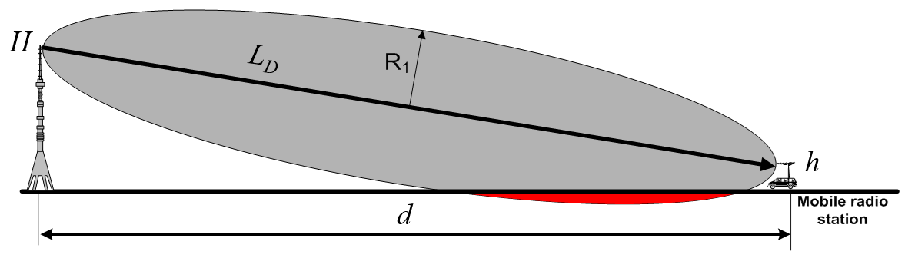
- The first Fresnel zone and the effect of the Earth's surface to the direct ray
The minimum height of the receiving antenna is determined by using digital maps. In the case of quasi-plane earth's surface, the first Fresnel ellipsoid should be above the ground and in marginal case can only touch the Earth's surface. In that case the minimum value of height h_{min} is [4]
(30)
Using expression (30) for the distance d_{max}, the system of equations (29) and (30) can be solved for d_{max} to obtain [5]
(31)
It follows from this equation that the maximum distance is linearly dependent on the maximum achievable measuring antenna height. Comparing the expressions (29) and (31), the height h_{min} can be expressed in terms of h_{max}:
(32)
It is interesting to note that the ratio (32) is very close to practically achieved heights when using retractable masts. For example, Lithuanian Communications Regulatory Authority uses three types of the mobile monitoring stations with GEROH retractable masts. The maximum lifting heights of antennas for these stations are 10.78, 10.26 and 11.7 m. The minimum height of the antennas for them is respectively 0.353 h_{max}, 0.321 h_{max} and 0.342 h_{max}.
It is obvious that for distances smaller than d_{max} the height h_{min} < (h_{max})/3. So, when using retractable masts at all distances not exceeding d_{max} the first Fresnel ellipsoid never touches the Earth's surface.
It is obvious that the maximum distance d_{max} corresponds to the minimum elevation angle θ_{min}. To calculate it we can use equation (31). It follows from this equation that for broadcast frequencies following inequality may be applied:
d_{max} >> H >> h. (33)
Therefore, elevation angles are very small and θ_{D} ≈ θ_{R} ≈ θ_{min}. Considering this fact, it follows from inequality (33) and equation (31) that the elevation angle at the distance d_{max} is
(34)
Note that angle θ_{min} is independent of transmitting antenna height above the ground H.
Note, that from equation (27) follows additional conclusion, that the height difference between two adjacent peaks of field strength is approximately given by
(35)
- typical radiation pattern parameters for several bays antenna arrays

  - Typical radiation pattern parameters for several bays antenna arrays
The accuracy and the applicability of the-over-the-air measurement methods highly depends on the transmitting antenna design. Therefore, it is useful to consider the typical vertical radiation patterns for broadcast antennas, consisting of several bays. The Table 2 and 3 below present elevation angles at which antenna gain is 1 dB and 10 dB less than the maximum gain (further they will be denoted as -1 dB elevation angle θ(-1dB) and -10 dB elevation angle θ(-10 dB)). These θ(-1 dB) and θ(-10 dB) angle values were obtained from the radiation patterns, given in Kathrein catalogue “Professional Broadcast Antennas and Combiners. The reason for use of these angles is the following. If the elevation angle at the measurement point is lower than -1 dB elevation angle the directivity of the antenna in vertical plane can be neglected, otherwise it must be taken into account. The influence of this directivity can be considered with sufficient accuracy if elevation angle at the measurement point is less than -10 dB elevation angle.
As it was shown in section A1.5., the height scan method can be applied only if the measurement is performed at elevation angle which is bigger or equal to minimum elevation angle θ_{min}. Therefore, in order to evaluate the possibility of applying the height scan method, the minimum elevation angle θ_{min} values are presented in the Tables 2 and 3. These angles were calculated using formula (34) when h_{max}=10 m.
It can be seen from Table 2 that in FM broadcast band (87.5-108 MHz) the directivity of an antenna in vertical plane can be neglected only for single bay antenna arrays. For 2 and 4-bays antenna arrays the directivity in vertical plane must be taken into account. In case of 6 and 8-bays the application of height scan method is not possible. At DAB broadcast band (174-240 MHz) the directivity of an antenna in vertical plane can be neglected for single and 2 bays antennas arrays. For antenna arrays with more bays the directivity in vertical plane must be taken into account.
- Typical vertical radiation pattern parameters for FM and DAB several bays antenna arrays
 | Without null fill |  |  |  |  | With null fill and beam tilt
Quantity of bays in antenna arrays | 1 | 2 | 4 | 6 | 8 | 1 | 2 | 4 | 6 | 8
Elevation angle at -1 dB level, deg | 17 | 8 | 3.5 | 2.6 | 2 | - | - | 5 | 3.9 | 3
Elevation angle at -10 dB level, deg | 60 | 24 | 11 | 7.5 | 5.5 | - | - | 12.6 | 9 | 7.2
Elevation angle θ_{min} in FM broadcast band, deg | 11.8-14.4
Elevation angle θ_{min} in DAB broadcast band, deg | 5,4-7,4

It can be seen from Table 3 that in at DAB broadcast band (174-240 MHz) the directivity of an antenna in vertical plane can be neglected for single and 2 bays antennas arrays. For antenna arrays with more bays, the directivity in vertical plane must be taken into account.

- Typical vertical radiation patterns parameters for DVB-T several bays antenna arrays
 | Without null fill |  |  |  |  | With null fill and beam tilt
Quantity of bays in antenna arrays | 2 | 4 | 8 | 12 | 16 | 2 | 4 | 8 | 12 | 16
Elevation angle at -1 dB level, deg | 3 | 1.6 | 0.6 | 0.4 | 0.3 | 7 | 2.6 | 1.2 | 1.1 | 0.9
Elevation angle at -10 dB level, deg | 9 | 4.4 | 2.1 | 1.4 | 0.9 | 13 | 6 | 2.8 | 2.1 | 1.7
Elevation angle θ_{min} in DVB-T broadcast band, deg | 1.5-2.7

It can be seen from Table 3 that in the lower part of the DVB-T broadcast band (470-862 MHz) the directivity of an antenna in vertical plane can be neglected only for 2 bays antenna arrays without null fill, and for 2 and 4 bays – with null fill and beam tilt. In case of 16 bays antenna arrays or more the application of height scan method, generally, is not possible.
- height scan method for determing the radiated power in the frequency range from 87.7 MHz to 6000 MHz
  - Abbreviations and symbols
- Abbreviations and symbols
Abbreviation & symbol | Explanation
D | Largest dimension of the transmitting antenna
E_{FS} | Field strength of direct wave (free space)
G_{RX} | Receiving antenna gain
k | Antenna factor, dB/m
m | Metre
P_{RX} | Measured receiver input power
Rx | Receiver
Tx | Transmitter
U_{max} | Maximal signal voltage level
U_{min} | Minimal signal voltage level
U_{RX} | Measured receiver input voltage
W | Watt
ΔE | Difference between the maximum and the adjacent minimum field strength
a_{k} | Cable loss
λ | Wavelength
n_{k} | Correction value
AV | Average
GNSS | Global Navigation Satellite System
RLAN | Radio Local Area Networks
RMS | Root Mean Square
TDMA | Time Division Multiple Access
∞ | Infinity

  - introduction
Field strength measurements are one of the basic tasks of all radio monitoring services. It is feasible to measure the field strength at a single location in the electromagnetic field but due to reflections and other propagation effects, the measured values may change extremely from one measurement location to the next. The following measurement method describes how these effects can be handled in order to retrieve reliable field strength values which may be used for the determination of the radiated power of a transmitter.
  - Scope of application and limitations
The measurement method relies on the correction of the influence of possible ground reflections from information gained through a height scan of the field strength at the location of reception which allows estimating the effective reflection coefficient. This method is basically frequency independent. However, there are many cautions to take into account in order to reduce external influence factors which may lead to errors in the measurement process.
The accuracy and the applicability of the recommended measurement method in FM and DAB broadcast bands highly depends on the transmit antenna design and can usually not be applied for antenna arrays with more than 4 bays. Even for simpler antenna designs, the applicability of the method may depend on an a priori knowledge of the vertical diagram.
Above about 3000 MHz the application of this method may be difficult because the maximum and the next minimum is very closely neighboured due to the small wavelength of the signal.
There are, however, even more constraints with regard to the applicability of the method. Field strength measurements have to be performed in the far field. The far field is usually defined as the range from 2D²/λ to ∞ with D being the largest dimension of the transmitting antenna. If D=1 m (typical base station antenna) and λ=0.1 m (3 GHz) the measurement distance between the transmitter and the receiving antenna has to be at least 20 m.
It has further to be taken into account that the actual location where the effective ground reflection occurs is different for different heights of the measurement antenna. A valid estimate of the reflection coefficient from a field strength height scan can thus be obtained under the provision only that locations of reflection for the “maximum” and the “minimum” reflection nearly coincide. This condition is more easily achieved with higher frequencies and closer measurement distances. In contrast, in the case of typical high-power broadcast transmitters, large transmitting antenna heights are prevailing. In addition, the radiation is confined to a vertically narrow lobe which meets the ground at distances of several kilometres from the transmitter only. This forces the measurements to be done at large distances from the transmitter and locations of reflections may be 50 or 100 metres apart under these circumstances.
The measurement method assumes free space propagation, i.e. a 20 dB path loss per decade of distance. Hence the method loses accuracy if this condition is not fulfilled.
Finally, it should be mentioned that measurement errors due to the aforementioned effects usually result in undervalued field strength or radiated power levels and not in increased levels.
This procedure may not be suitable for systems using advanced radio technology as such dynamic beam forming.
Moreover, it is crucial to perform a spectrum overview at the measurement location in order to avoid overloading the measurement chain and to take into account power contributions from different sources.
  - APPLICABILITY OF THE MEASUREMENT METHOD
The applicability of the measurement method depends on several technical and practical conditions. The following flow chart provides guidance on the decision making whether the method, from the technical point of view, is applicable for a particular transmitter. Details and background information on the individual steps are provided in the Table 2: and following sections. From the practical point of view, the applicability of this measurement method may be restricted by lack of access to a suitable measurement location.
Collect available technical information about transmitter (Tx)
Is this -10-dB angle bigger than minimal elevation angle?
Is the Tx antenna pattern available?
Measurements are possible according to this method
Measurements are not possible according to this method
Inspect the Tx antenna installation on-site
Apply typical antenna pattern, corresponding to the antenna installation
Is this -1-dB angle bigger than minimal elevation angle?

Yes
No
Yes
No
Determine the elevation angle of the typical antenna pattern at -1 dB level
Apply available antenna pattern
Determine the elevation angle of the transmitting antenna at -10 dB level
Determine the elevation angle of the transmitting antenna at -1 dB level
Is this -1-dB angle bigger than minimal elevation angle?
Calculate minimal elevation angle θ_{min}
1
2
3
4
5
6
7
8
9
10
11
12
13
14
No
Yes
No
Yes
- Decision making flow chart
- Explanations for decision making flow chart elements
Element number | Explanation
 | Obtain information about transmitter (Tx) antenna design and pattern. Determine of how many bays the antenna array consists.
 | Inspect the Tx antenna installation on-site to determine if the declared Tx antenna pattern corresponds to the real installation. Height and down tilt of the Tx antenna should be determined.
 | According to equation (34) calculate minimal elevation angle θ_{min}.
 | In case the declared Tx antenna pattern is available decide if they correspond to the real installation.
 | For further calculations apply Tx antenna pattern which was declared.
 | Determine the elevation angle of the Tx antenna at -1 dB level
 | Compare the elevation angle of the Tx antenna at -1 dB level and minimal elevation angle θ_{min}.
 | Determine the elevation angle of the Tx antenna at -10 dB level.
 | Compare the elevation angle of the Tx antenna at -10 dB level and minimal elevation angle θ_{min}.
 | For further calculations apply a typical antenna pattern, corresponding to the antenna installation. Typical antenna patterns can be obtained from manufacturer catalogues or other appropriate literature.
 | Determine the elevation angle of the typical antenna pattern at -1 dB level.
 | Compare the elevation angle of the typical antenna pattern at -1 dB level and minimal elevation angle θ_{min}.
 | If decision making process ends at this point, then measurements are not possible according to this method.
 | If decision making process ends at this point, then measurements are possible according to this method. The maximal elevation angle θ_{max} (-1 dB level or -10 dB level) at which the measurements are possible is identified.
  - Conversion from receiver input level to field strength
The field strength E is generally calculated from RF level measurements. The subsequent sections assume that field strengths are measured in the far field region under free space conditions using receiving antennas with known antenna factors, cables with known losses, with adequate receiver bandwidth and sufficient signal to noise ratio. The formulas further assume an antenna load resistance of 50 Ω.
For determination of the field strength, the following relationship has to be used:
(36)
where:
E - field strength at receiving location in dBµV/m;
U_{RX} – measured receiver input voltage in dBµV;
k – antenna factor in dB/m;
α_{k} – cable loss in dB.
The e.i.r.p. is calculated from free space field strength by using formula
(37)
where:

e.i.r.p. - effective radiated power in dBW relative to an isotropic antenna;
E_{FS} – free space field strength in dBμV/m;
L_{D} – length of direct propagation path in m;
G/G_{max} – ratio of the transmitting antenna gain in the direction of the measuring antenna to the maximum gain in the direction of the main beam axis in dB.
The length of path L_{D} depends on horizontal separation distance between the transmitting and measuring antenna position, antennas height above the ground (see Fig. 6) and is calculated by formula (2). In most cases the height of the measurement place not coincide with the height of the place where the transmitting antenna is located. This might be dealt with the introduction of the effective height of the transmitting antenna, which is the height of the transmitting antenna above the measurement place. The effective height of the transmitting antenna is detemined by using digital map with terrain heights.
Recommendation ITU-R P.525-2 [4] as well as sections 6.3 and 6.4 of the ITU Handbook on Spectrum Monitoring [6] may be consulted for more detailed explanations on the calculation of free-space attenuation and conversion formulae. Correct level measurement of digital signals and field strength measurements are specified in sections 4.3 and 4.4 of the ITU Handbook on Spectrum Monitoring [6]. Additional information on field strength measurements can also be found in Recommendation ERC/REC 74-02 [7] and Recommendation ITU-R SM.378-7 [8].

  - The impact of ground reflections
Reflections have a substantial influence on field strength measurements. In extreme cases, they may cause the total elimination of the signal or amplification by 6 dB depending on the amplitude and phase difference between direct and reflected wave. Field strength measurements for the calculation of radiated power assume a direct line-of-sight position of the receiving antenna to the transmitter and an unobstructed propagation path with no objects causing considerable reflections in the vicinity. However, ground reflections will always be present and have necessarily to be taken into account when the radiated power of a transmitter is calculated from the measured field strength.
Ground reflections can be detected by varying the antenna height h. Considerable ground reflections exist if at least one sharp minimum and one maximum of the measured field strength can be detected. This effect occurs more distinctive with horizontally polarized signals. An example of the dependency of the field strength on height is shown in Figure 8.

E_{min}
E_{max}
- Example of the dependency of the measured field strength on measuring antenna height
For the elimination of effects due to ground reflections, a correction value n_{k} has to be applied (see figure 8). It can be determined from the difference between the maximum field strength and the adjacent minimum field strength.
(38)
with ΔE, E_{max} and E_{min} in dBµV/m. The result can also be taken from Figure 9.
The free space field strength value E_{FS}, used in expression (37), is determined by the following formula:
. (39)

- Correction curve for n_{k}
  - Measurement procedure
The measurement procedure works as follows:
- Inspect the installation
The field strength measurement requires that the measuring antenna can be positioned in the main lobe of the transmitter and that the area between transmitter and monitoring antenna is unobstructed. Height, directivity and down tilt of the transmitter antenna have to be determined.
- Determination of the maximum measurement location distance
The maximum measurement location distance d_{max} is calculated from centre measuring frequency, height of the transmitting antenna and maximal height of the measuring antenna by using formula (31). The following Fig. 10 gives guidance on the determination of the maximum measurement location distance for a common height range.
- The maximum separation distance between transmitting and measuring antenna position as a function of transmitting antenna height at some frequencies
- Exception: expanded maximum measurement location distance
Common heights and designs of FM broadcast antennas often lead to maximum measurement distances that are still out of the vertical main lobe, resulting in an underestimation of the calculated e.r.p. In the exceptional case where the transmitter uses a 4-bay antenna array and its vertical diagram is not known, the measurement method described here may also be applied at distances up to about 13 times transmit antenna height where the height scan will provide only a maximum and no minimum. In these cases, a general correction for the ground reflection is applied to the maximum field strength value according to the following table:
- General correction for ground reflection
Polarisation | n_{k} for general ground reflection
Horizontal | -5 dB
Vertical | -2 dB

Note that the value, specified in Table 7, originate from multiple measurements.
- Determination of the minimum measurement location distance
In section A.3.4. the maximal elevation angle θ_{max} at which the measurements are possible according to this method has been identified. Knowing this angle, the minimum measurement location distance d_{min} can be calculated using trigonometric formulas, with the help of an electronic map that includes terrain height or field strength prognosis tools.
- Search a suitable measurement location
The measurement location must be chosen at a distance that is between minimum and maximum distances determined in steps 2-4. In most cases, to reduce the impact of the directivity of transmitting antenna in vertical plane, it is necessary to select the maximum possible distance. The measurement location within that area must have a line of sight to the transmitter. The measurement conditions applicable for field strength measurements as outlined in the relevant documents mentioned in section A.3.5 have also to be fulfilled. If directional transmitting antennas are used, the measuring antenna must be placed in the direction of the main lobe. The distance will usually be in the range of one to several thousand meters so that far field conditions apply.
- Measure the field strength at the predetermined location
Ensure that there are no other transmitters that are in close proximity or close in frequency that can impact the measurement. Using a directional measurement antenna mounted on a retractable mast on the measurement vehicle, first at roof height, to measure the field strength of the transmitter.
Usually the measurement has to be done with an RMS detector. For continuous emissions, the measurement time has to be long enough to equalize any changes due to traffic or propagation. For pulsed emissions (TDMA systems like RLAN), the average burst power has to be measured (this is the RMS power during the burst only). Some specific systems such as analogue TV require the use of the Peak detector.
The measurement bandwidth should be equal to or higher than the occupied bandwidth of the signal under investigation. The polarisation of the measurement antenna should be the same as used by the transmitter. In case of cross-polarized transmitter antennas the polarisation of the measurement antenna is not relevant. In this case, special care should be taken as in some situations the cross polarisation is used to transmit two different signals and both polarisations have to be addressed separately. Further details regarding field strength measurements may be found in section 4.4 of the ITU Handbook Spectrum Monitoring [6].
- Search for the location with the highest field strength
The location with the highest field strength is searched by moving the measurement vehicle a few meters back and forth. This is done to ensure that possible reflections at the measurement location do not have significant influence in cancelling out with the direct wave. Once a local maximum is found it is necessary to ensure there are no powerful echo signals from buildings or signals from other transmitters operating on the same frequency. To do this, the receiving directional antenna mounted at a height of 10 meters is rotated in a horizontal plane. If a local maximum of the echo signal does not exceed -15 dB compared to the direct ray, the individual contribution of one scattered ray to the overall power level of the beam will not exceed 0.2 dB.
Perform a height scan
This is done by permanently recording the receive field strength while the mast rises from minimum height (from car roof level) to 10 m above ground. The path difference of the direct and the reflected signals varies if the height of the receiving antenna is changed. The height difference between two adjacent peaks of the signal is approximately given by formula (35). Fig. 11 represents typical measurement scenario.
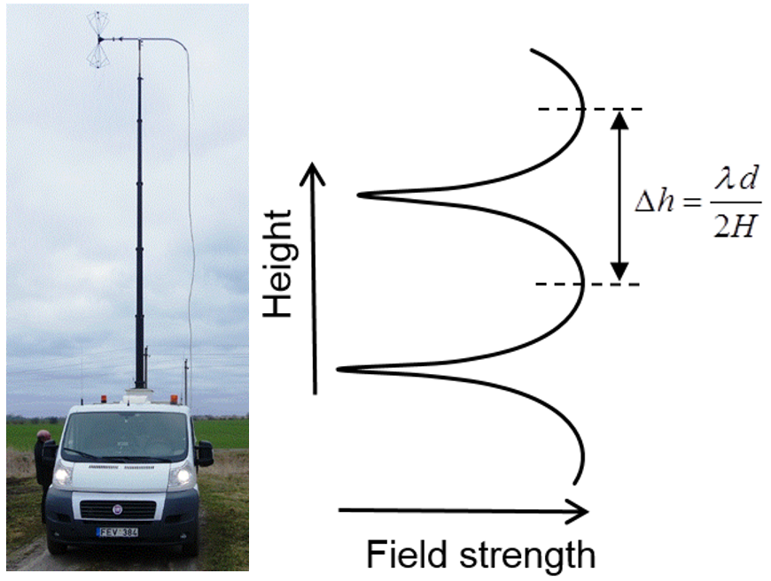
- The change of the field strength at change of height of the measuring antenna
To accurately determine the minimum and maximum of the received signal it is necessary to conduct the height scan with incremental steps of S << Δh, e.g.
S = Δh/10 = (λ * d) / (20 * H). (40)
Example: λ = 0.1 m (f = 3 GHz), d = 500 m, H = 50 m results in S = (0.1 * 500) / (20 * 50) = 0.05 m.
If a swept spectrum analyser is used for the measurements, the recommended settings are presented in Table 8:
- Recommended settings for a swept spectrum analyser
Parameter | Value
Centre frequency | corresponding measured signal working frequency in MHz
Resolution bandwidth (RBW) | equal to or higher than the occupied bandwidth of the measured signal
Video bandwidth (VBW) | 10RBW
Span | 0 Hz (Zero Span)
Sweep time | corresponding to approximate measurement antenna mast height change from 3 m to 10 m in seconds
Sweep mode | Single Sweep
Trace detector | RMS (root mean square) or AV (average)
Trace mode | Clear Write

- Determine the maximum field strength from the height scan
The maximum field strength is designated as E_{max}. Depending on reflections, especially from the ground, E_{max} must not necessarily be at the maximum antenna height.
- Determine the minimum field strength adjacent to the maximum field strength identified in Step 9
This local minimum is hereafter designated E_{min}. It is not the overall minimum of the complete height scan, but the minimum just next to the predetermined E_{max}. See also Fig. 8.
- Calculate the final magnitude of the free space field strength
The final magnitude of E is determined according to section A.3.6. This cancels out the effect of the ground reflections that may have influenced the measurement result.
- Determine the field strength decrease due to transmitting antenna directivity in vertical plane
If the measurement is performed at elevation angle where the vertical antenna gain differs more than 1 dB from the maximum gain, by using the antenna pattern the ratio G/G_{max} should be determined.
- Calculate the radiated power.
The radiated power is calculated by using the free space propagation formula according to section A.3.5. from the measured field strength E_{FS}, the measurement distance d and determined ratio G/G_{max} (if it was necessary to define).
- Calculate and report the measurement uncertainty
Methods used to calculate the uncertainty from the experimental observation and input data should be clearly described. All the uncertainty components and their assessment should be listed and documented.
  - Measurement equipment
A laser distance measuring device, a GNSS receiver, binoculars and a compass are usable tools for the visual inspection of the transmitter and the determination of the antenna height.
For the field strength measurement of many types of emissions a spectrum analyzer or measurement receiver may be used.
  - CONTRIBUTION of THE environment to the Measurement UNCERTAINTY
The described method assumes that the main contributor to the measurement uncertainty is caused by reflections, this is usually the case. Reflections from distant objects may be minimised by using a measurement antenna with high directivity or determining a horizontal field strength profile in addition to the vertical height scan as given in section A.3.7.
The accuracy of this method depends mainly on the local circumstances in between the transmitter to be tested and the measurement location. The accuracy of this method depends mainly on the local circumstances in between the transmitter to be tested and the measurement location. The following example may give an impression. Several 1000 measurements at base stations of mobile phone operators and verifications using test transmitters with known parameters have shown a maximum measurement uncertainty of 3 dB.
It is possible to verify the contribution of the spectrum environment (such as the impact of reflexions) on the error of the measurement. If the location of the transmitter antenna (roof, mast) is accessible, the general principle outlined as follows may be applied: A test transmitter with known parameters (power, antenna gain) is installed close to the antenna, operating on a free frequency close to the frequency of the transmitter to be measured. A height scan of the test transmitter at the predetermined measurement location is performed and its radiated power is calculated using the method described in this document. By comparing the result with the known true radiated power of the test transmitter the additional measurement error for the particular radio path can be determined. The calculated power of the transmitter to be measured can then be corrected by the magnitude of the error. Environmental effects may be assumed to be “zeroed out” this way. It should be noted that also this method may introduce uncertainties in the measurement result. For example, the used antenna may not be identical and the frequency is slightly different from those of the transmitter to be measured. The more such parameters are close to those of the transmitter to be measured, the more the uncertainty is negligible.
  - Measurement UNCERTAINTY CALCULATION
To ensure the reliability of the measurement, the uncertainty should be calculated. Keeping the previous chapter in mind a single calculation for the specific test set used is sufficient in many cases. This is called the typical measurement uncertainty of the test set.
Typical measurement uncertainty
For determining the typical measurement uncertainty all uncertainty sources that are normally present in the measurement system and during the measurement are identified and estimated and an overall uncertainty calculation is made. A typical measurement uncertainty between 1.5 dB and 2.5 dB for a 95% confidence interval can be considered a good achievement for a field strength measurement system but can only be achieved when all main contributing error sources are minimized and when the measurement is conducted very precisely.
Actual measurement uncertainty
For measurements where the procedure in A.3.9. cannot be applied completely, an individual measurement uncertainty calculation must be made, taking specific circumstances as they occur during the actual measurements into account. A good way to do this is to start with the typical measurement accuracy calculation examining all values in that calculation and correcting them for the specific circumstances that occurred during the measurement. An analysis of the measurement data in the height and horizontal profiles gives important input to this process. The value calculated this way is called the actual measurement uncertainty, and is unique for every measurement. This figure has to be mentioned in the measurement report, not the typical value.
Methodology
The measurement uncertainty calculation should be performed and presented conforming to applicable international standards, e.g. ISO “Guide to the Expression of Uncertainty in Measurements” [9]. When using this method, each measurement is described first, followed by the mathematical formula with which the end result is calculated from the individual variables involved. Then all these variables are described with their uncertainties and their weighting factors of their influence on the final result is established. When the source variables are expressed logarithmically, they first have to be converted to linear values. With this information, the uncertainty of the end result is calculated and is presented in the standardised form. Also, the main contributors to the overall uncertainty are identified.
Example of a measurement uncertainty calculation
In this section, a practical example is given of an actual uncertainty calculation for radiated power measurement. The example illustrates the influence of different error sources, and is meant to assist the making of one’s own measurement uncertainty analysis. The spread sheet with calculations is incorporated in this Recommendation.
The values used in this example are typical for a particular setup and could in practice be worse or better depending on the effort made to optimize the design.
The example describes a radiated power measurement system. The power P_{RX} is measured at a distance R from the transmit antenna. This is done using a measurement antenna with antenna gain G_{RX} and a measurement receiver.

transmit antenna
P_{rad}
radiated power

transmitter
G_{RX}
measurement
antenna

distance R
P_{RX}
measured power

- Radiated power measurement
The calculation as given before is
With the additional parameter A_{ref} representing reflections = interference of direct and reflected waves;
The measurement uncertainty of P_{rad.} is a result of the measurement uncertainty of the input parameters. Some of these parameters again have multiple error sources creating their uncertainty. The error sources relevant in this example are discussed hereafter.

Frequency The frequency f used in the formula is that of the carrier frequency. In reality not all the power components measured are on that frequency due to the modulation of the transmitter. Assuming that most of the power is concentrated within known boundaries from the carrier, the relative uncertainty Δf is about 0.1%. The error distribution is assumed uniform.
Distance The uncertainty of the distance is caused by the measurement uncertainty of the position of the transmit antenna and of the measurement antenna.
Antenna gain The uncertainty of the antenna gain is caused by the calibration uncertainty of the antenna, the RF cables, the residual polarization mismatch, and the horizontal and vertical misalignment of the antenna.
In formula:
This also includes possible misalignment in cases where a down-tilted base station antenna is used.

RX power The uncertainty of the received power is caused by the calibration uncertainty of the receiver, mismatch between antenna and receiver, IF filter losses due to excess bandwidth of the transmitter and leakage of adjacent channel transmitters.
In formula:
Reflections One of the main contributors to the overall measurement uncertainty are reflections. The relative amplitude of the reflections depends on the reflectivity of the ground and the objects built on it. The reflection is attenuated by the relative path length difference between direct wave and reflected wave and by the vertical pattern of transmit antenna and receive antenna. The amount of reflections in this example has been derived from analysis of the actual measurements as described in section A.1.8, which is 1.7 dB in this case.

The calculation of the total measurement uncertainty in this example is shown in the Table below.
Table 2: Calculation of the total measurement uncertainty
A calculator containing the table is also incorporated in this report and may be used as the basis for someone’s own application.
Administrations implementing this recommendation should evaluate and express uncertainties of their individual measurement equipment according to ETSI TR 100 028-1 and TR 100 028-2 [10], Uncertainties in the measurement of mobile radio equipment characteristics (Parts 1 and 2 - version 1.4.1).

- route SCAN METHOD FOR DETERMING THE RADIATED POWER IN THE FREQUENCY RANGE FROM 87.7 MHz TO
  - Terms, Definitions, Abbreviations and symbols

Table 1: Abbreviations
Abbreviation | Explanation
c | The velocity of light in free space, m/s
d | Horizontal distance from transmitting antenna position to the measuring antenna position
E | Field strength, dBμV/m
F(θ) | The directivity of the transmitting antenna in vertical plane
f | The transmitting frequency, Hz
H | Height of the transmitting antenna above the ground
h | Height of the measuring antenna above the ground
P | Equivalent isotropically radiated power
R | The magnitude of the ground reflection
r.m.s. | Root Mean Square
s | Second
φ_{R} | The phase of the ground reflection
λ | Wavelength, m
m | Metre
dB | Decibel
dBW | Decibel watt
W | Watt

  - introduction
Field strength measurements are one of the basic tasks of all radio monitoring services. It is feasible to measure the field strength along the route but due to reflections and other propagation effects, the measured values may differ extremely from calculated. The following measurement method describes how these measured and calculated values can be handled in order to determine the radiated power of a transmitter.
  - Scope of application and limitations
The measurement method relies on the comparison of field strength values measured along a route with the calculated field strength values. This method is basically frequency independent. However, application of this method in a hilly terrain can be difficult.
The accuracy of the recommended measurement method depends on the radio propagation model used for the field strength calculation. The most suitable model is the two-ray interference model. In case the field strength measurement route is far enough from the transmitting antenna, easy applicable Vedenskij’s formula can be used.
In many cases this method does not require knowing radiation patterns of the transmitting antenna. However, a-priori knowledge of these patterns may ease the selection of appropriate route.
  - DESCRIPTION OF THE METHOD
This method is based on postulation that the difference between the measured and the calculated field strength values along the route occurs only because of the radiated power value used in the model. The radiated power value used in calculations is being adjusted in such a way that the minimum of the fitting error between theoretically calculated and experimentally measured data curves is achieved (Fig. 13). The best-fit radiated power value P_{bf} obtained by using this method is the measured radiated power P_{m}. When Root-Mean-Square Error (RMSE) is used for data fitting, it is possible to show that when the best-fit radiated power P_{bf} was used in the model, then the arithmetic mean of all measured values along the route is equal to the arithmetic mean of all calculated values.
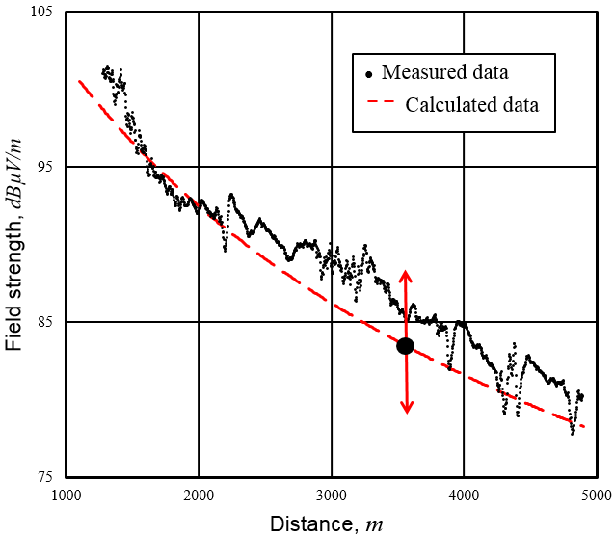
- Adjustment of radiated power value used in calculations
The above-mentioned fact allows simplifying the procedure for determination of radiated power of a transmitter and performing it in several stages:
- Around the transmitting station a suitable route is selected;
- the field strength as function on a distance to transmitting station is calculated, considering that station’s radiated power is equal to authorized radiated power P_{a};
- for the selected route, an arithmetic mean of the field strength is calculated;
- the field strength along the route is measured and its arithmetic mean is calculated;
- transmitter’s radiated power P_{m} is calculated according to the expression:
(41)
  - Measurement procedure
The measurement procedure works as follows:
- Inspection of the installation (radio station checks on-site)
Transmitter frequency, antenna height above ground, polarisation, directivity, maximum or minimum emission azimuth, and transmitter location geographical coordinates must be checked before measurements.
- Selection of suitable route
First, the route should be selected about across the radial line from the transmitting antenna. There are some reasons for this. The first reason is that in such case there is no need to change the position of the measuring antenna related to the car. The second reason is that the retractable masts are usually mounted at the rear of vehicle. Thus, when the car moves along radial line away from transmitting antenna the vehicle body has minimal influence on measurement results. The third reason is that it is easy to evaluate the transmitting antenna directivity in horizontal plane if needed. Of course, it is preferable that the route was selected within the direction of the main horizontal lobe.
Secondly, the route should be selected in the rural area. In this case the reflections from tall buildings, big structures etc. will be avoided. Moreover, this helps to ensure that a line of sight to the transmitting antenna is fulfilled along the route.
Route selection starts from selection of suitable country road around radio station, and satellite maps help with this task a lot. Only a suitable section of the road may be used for measurements along the route.
- Selection of the starting point of a route
It is important to select the starting point of a route d_{s} at a correct distance from the transmitting antenna. It is convenient to take this distance so that the Vvedenskij’s formula can be used to calculate the field strength. As it follows from section A1.2, for horizontal polarization it is equal to:
(42)
For vertical polarization it should be 1.5 times greater, but practical measurements has shown, that it also can be calculated according to (42).
- Selection of the length of measurement route
The measurement accuracy generally gets higher as the distance driven increases. The minimum length of the measurement route depends on the start distance. A practical value for the term length/start distance seems to be 1, which means the route should have about the same length as the distance where the measurement is started (driving away from the transmitter is assumed).
- Impact of non-ideal route evaluation
In most cases the surface of the measurement is is not completely flat, and its height does not coincide with the area where broadcast station transmitting antenna mast is built. This might be dealt with the introduction of effective transmitting antenna height H_{ef}. Using digital map with terrain heights, the height of antenna mast area above the sea level H_{A} is determined. The selected route terrain heights should be also checked, and the average route height above the sea level should be determined. H_{av}. Practically in most cases it is sufficient to take the average of the highest and the lowest points of the route. Then the effective antenna height H_{ef} is calculated as follows:
(43)
The effective antenna height is used for field strength calculations using expressions (17) – (19).
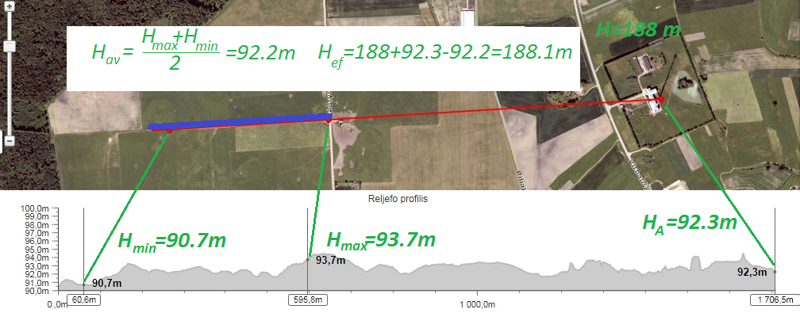
Figure 14: Example of effective height calculation.
  - Inspection of the installation (Radio station check on-site)
Transmitter frequency, antenna height above ground, polarisation, directivity, maximum or minimum emission azimuth, and transmitter location geographical coordinates must be checked before measurements.
  - Measurement equipment
A laser distance measuring device, a GNSS receiver, binoculars and a compass are usable tools for the visual inspection of the transmitter and the determination of the antenna height.
For the field strength measurement, a spectrum analyzer or measurement receiver with appropriate calibrated measurement antennas may be used.
  - Measurement UNCERTAINTY
Practical measurements of several conveniently located FM broadcasting radio transmitters with known technical parameters were done according to this recommendation. In practice, measurement results matched to theoretically calculated FM broadcasting transmitter effective radiated power within ± 2 dB interval.
Even though exists theoretical measurement uncertainty calculation methods, applicability of such methods are difficult or even impossible in context of this recommendation due to several unknown factors which affects total measurement uncertainty and cannot be objectively evaluated. Thereby uncertainty of 2-3 dB, which was obtained in practical measurements, has to be applied

- list of references
- G. E. Leontjev, Determination of the Radiated Power of Radio Station Through Field Strength Measurement Along a Route, Proc. 2016 International Symposium on Electromagnetic Compatibility (EMC Europa 2016), September 5-9, Wroclaw, Poland, pp. 347-352.
- A.И. Kaлинин, Е.Л. Черенкова, Распространение радиоволн и работа радиолиний, издательство “Связь”, Москва, 1971, с.38.
- ITU Report R-REP.P1008-1 “Reflection from surface of the Earth”.
- Recommendation ITU-R P.526-12: Propagation by diffraction.
- G. Leontjev. Over-the-air methods for determining the radiated power of radio station. Proc. 2017 International Symposium on Electromagnetic Compatibility (EMC Europa 2017), September 4-8, Angers, France, pp. XX-YY.
- ITU Handbook on Spectrum Monitoring, Edition 2011.
- Recommendation ERC/REC 74-02: Method of measuring the field strength at fixed points in the frequency range 29.7 – 960 MHz.
- Recommendation ITU-R SM.378-7: Field-strength measurements at monitoring stations.
- JCGM 100:2008: Evaluation of measurement data - Guide to the expression of uncertainty in measurement.
- ETSI TR 100 028-1 and TR 100 028-2: Electromagnetic and Radio Spectrum Matters (ERM); Uncertainties in the measurement of mobile radio equipment characteristics (Parts 1 and 2 - version 1.4.1.)
- ITU Recommendation ITU-R SM.1708-1 “Field-strength measurements along a route with geographical coordinate registrations”
- G. Leontjev. Over-the-air methods for determining the radiated power of radio station. Proc. 2017 International Symposium on Electromagnetic Compatibility (EMC Europa 2017), September 4-8, Angers, France, pp.
- Recommendation ITU-R P.525-2: Calculation of Free-Space Attenuation
- ITU Handbook Spectrum Monitoring Edition 2011
- Recommendation ERC/REC 74-02: Method of measuring the field strength at fixed points in the frequency range 29.7 – 960 MHz
- Recommendation ITU-R SM.378-7: Field-strength measurements at monitoring stations
- Recommendation ITU-R P.526-12: Propagation by diffraction
- ETSI TR 100 028-1 and TR 100 028-2: Electromagnetic and Radio Spectrum Matters (ERM); Uncertainties in the measurement of mobile radio equipment characteristics (Parts 1 and 2 - version 1.4.1)
- JCGM 100:2008: Evaluation of measurement data - Guide to the expression of uncertainty in measurement
- ECC Recommendation (12)03 “Determination of the radiated power through field strength measurements in the frequency range from 400 MHz to 6000 MHz”
- ITU Recommendation ITU-R SM.1708-1 “Field-strength measurements along a route with geographical coordinate registrations”

