Project Team FM22
47st Meeting of FM22  Copenhagen, 4 – 7 April 2017 | FM22(17)19

Date issued: 03 April 2017

Source: Lithuania

Subject: The influence of measurement route’s length on FM-BC ERP measurements results
N
Password protection required? (Y/N) *

Summary

Document presents simple method for modeling of measurement error dependency on the length of measurement route. The analysis has shown that in order to get reliable results, the route length should be no shorter than 1 km. In principle, good results can be obtained and for shorter routes of 200-300 m if they are selected correctly in flat and open areas. But it is more reliable to choose the measurement route as long as possible.

Proposal
FM22 members are invited to contribute to further development of proposed method. With the information gained it is proposed to start a work on a new recommendation on e.r.p. determination from field strength measurements along a route or integrating the measurement method into the existing ECC Recommendation (12)03.

Background
FM22 work programme

Introduction
At previous meeting of FM22 in Budapest there was presented a method to determine the radiated power of transmitters by field strength measurements along a route (document FM22(16)14). This method is based on the comparison the average of field strength values measured along a route with the average of calculated field strength values. Field strength fluctuations, caused by additional reflections (from trees and buildings near the route), compensate each other. Therefore, it is understandable that radiated power measurement error depends on the route’s road.
This paper presents analysis of measurement error dependence on the route’s length. The analysis has shown that in order to get reliable results, the route length should be no shorter than 1 km.

Analysis methodology
Analysis is done is several stages. Initially the field strength is measured along a route, the values of measured field strength and parameters (geographical coordinates, terrain height) of every measurement point are recorded. Then from the recorded data two data series are formed: measured field strength and the distance to the transmitter. Later, using parameters of the transmitting station, the theoretical field strength values are calculated for every measurement point. From these three data series (for each measurement point along a route: distance to the transmitter, measured field strength value and calculated field strength value) you can choose different lengths of route segments freely and calculate the measurement error for them. These analysis steps are described in more detail further.
  - Measurement data processing
Field strength measurements on-the-go with geographical coordinate registration were made using the mobile monitoring station. It is equipped with a measurement system which, during the moving, records the data of time, field strength level, latitude, longitude, direction to transmitting antenna mast and line-of-sight distance away from this mast. The measurement system was described quite in detail in document FM22(16)14. After the measurement is completed, all data is recorded to MS Excel file, example of the data structure is presented is Fig. 1. Every row describes one measurement point.

Fig. 1. Graphical representation of the Excel-sheet with measured data
Further Excel file processing depends whether the direction of the route does match the exact direction of the antenna beam axis or not. If not, the transmitting antenna's pattern in H plan should be considered. The most reliable way to do this manually is by taking H-plane pattern values (from the chart or table) for angle range, corresponding the route, inputting them into MS Excel and calculating the approximating polynomial. Then all measured field strength values should be recalculated to correspond the transmitting antenna beam axis by applying the antenna correction for each measurement point, taking account its position in respect to the transmitting antenna.
The theoretical field strength values for the route were calculated with a step of 10 m as it was shown in paper FM22(16)14. In order to compare the theoretical and experimental data, we need to calculate the average measured field strength value for each 10 of the route. So all the measured field strength data should be transformed into a new data series, averaged for each 10 m.
  - Calculation of field strength
For the purpose of field strength calculations separate Excel templates were created for several often used types of broadcast transmitting antennas. Excel template was created where horizontal distance from transmitting antenna position to the measurement antenna position ranges from 100 m to 15,000 m with a step of 10 m. After entering the heights of transmitting and receiving antennas, transmitting frequency and radiated power, the values of the field strength for horizontal and vertical polarization were automatically calculated for every distance value. Together the length of direct and reflected propagation path, the grazing angles and the corresponding antenna directivity, reflection coefficient magnitude and phase values were calculated for every distance value. As the final result, after inputting the distances from the transmitting antenna’s position to the beginning and the end of the route, the mean value of the field strength was calculated. All formulas, used for field strength calculations, are presented in paper FM22(16)14.
The theoretical field strength calculations for measured stations were performed using the actual values of the radiated power, which were determined by the on-site inspection.

  - Analyses procedure
For analysis, we use Excel sheet (see Fig. 2) with measured field strength values, averaged for each 10 m along the route (column B) and theoretically calculated field strength values (column C). Column A contains the distance to the transmitting antenna position. In column D we calculate the cumulative moving average of measured (exper) field strength data. In this cumulative moving average (CMA), the field strength data arrive in an ordered distance stream, and we get the unweighted mean of all of the data up until the current distance point. As it is shown in Fig. 2., in cell D8 the average field strength value for the route segment from 940 m to 1000 m. is calculated. Cell D9 contains the average field strength value for the route segment from 940 m to 1010 m, and so on.
Fig. 2. Graphical representation of the Excel-sheet with input data
and analysis results data
Column F contains the difference between corresponding cells in columns D and E. In example the value, calculated in cell F8, shows the difference between the average measured and calculated field strength values for the route segment from 940 m to 1000 m. This difference, analyzed in the scope of the radiated power measurement methodology logics, is nothing else but the radiated power measurement error. In such a way the data in column F represent the dependency of measurement error on the route’s (with fixed starting point) length that is cumulative moving error of radiated power measurement.
In column G the moving average MA (it is also called a rolling or average mean) of the measured (exper) field strength data is calculated. A moving average is calculation by creating series of averages of different subsets of the full field strength data. Given a series of numbers and a fixed subset size, the first element of the moving average is obtained by taking the average of the initial fixed subset of the number series. Then the subset is modified by "shifting forward"; that is, excluding the first number of the series and including the next value in the subset. In Fig. 2 the initial subset for the measured field strength data is B2:B12. In cell G12 the mean of this subset is calculated, that is the average value of the field strength, measured in the route segment from 940 m to 1000 m. Cell G13 correspondingly contains the average value of the field strength, measured in the route segment from 950 m to 1010 m and so on. In such a way column G contains the average values of the field strength, measured within fixed segments of 60 m with “moving” starting point. Analogically in column H is calculated the moving average of calculated field strength data.
Column I contain differences between corresponding cells in columns G and H. For example, the value calculated in cell I15 shows the difference between the average calculated and measured field strength for the route segment from 970 m to 1070 m, cell I16 – route segment from 980 m to 1080 m, etc. As it was already mentioned above, this difference is the radiated power measurement error. In such a way the data in column I represent the radiated power measurement error dependency on the distance from transmitting antenna position to the starting point of a route’s segment with a fixed length that is moving error of radiated power measurement.
- The measurement and analysis results
During approval of this radiated power measurement method in 2015-2017 there were made measurements in six measurement places. The results were similar in all measurement places. Therefore, this section presents the measurement results for FM broadcast stations, located only in two places Juragiai and Bubiai. It should be noted, that analysis was possible because reliable data on the station’s antennas radiation patterns, the height above the ground, authorized radiated power and the transmitter’s authorized power were available.
  - Juragiai
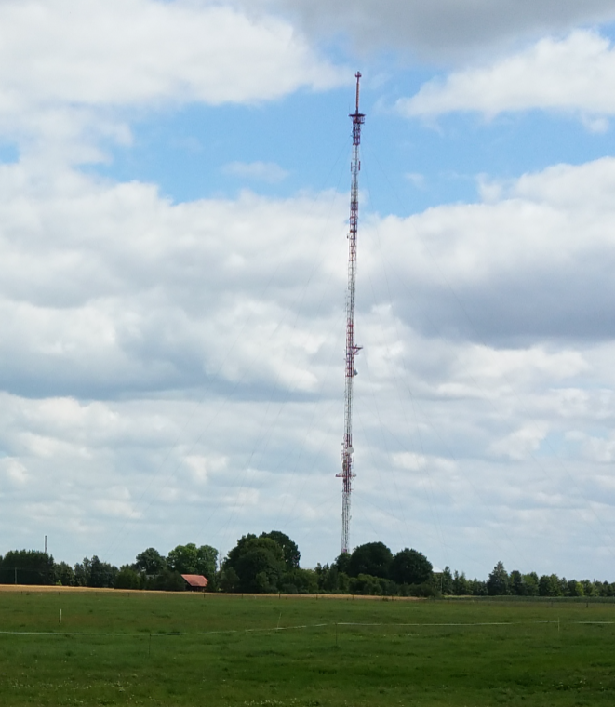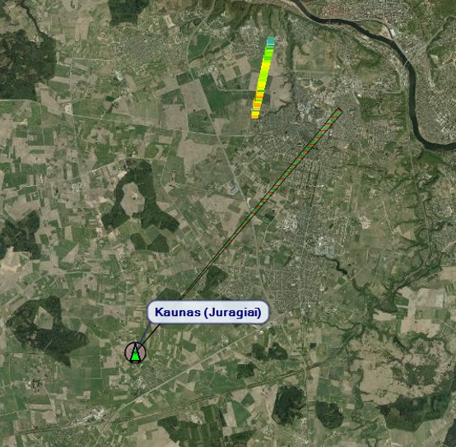
- b)
Fig. 3. View of the FM radio station (a) and satellite map, showing the measurement route and H-polarization antenna beam axis (b)
The antenna system for H-polarization consists of 4 bays stocked array and 4 panels K5231187 per bay. The horizontal pattern is close to omnidirectional with four slightly expressed leaflets. Several radio stations shared this broadband antenna system and it was transmitting at several frequencies.
The antenna system for V-polarization consists of 4 bays stocked dipole AV1311-96 array, 1 dipole per bay. The horizontal pattern of this antenna array is very close to omnidirectional.
The selected measurement route for this radio station was a country road 10 km away. Next to the road there are bushes, trees, passes power lines etc. (Fig. 4).
Fig. 4. View of the country road leading to the transmitting antenna mast
Table 1. Key data of the FM radio stations
Measured frequency, MHz | 90.3 | 96.2 | 102.1 | 104.1 | 97.6 | 103.5 | 106.6
Actual e.r.p., dBW | 34.44 | 40.59 | 41.1 | 42.14 | 35.1 | 35.78 | 35.3
Antenna height, m above ground, m | 188 | 188 | 188 | 188 | 137 | 137 | 137
Antenna polarization | H | H | H | H | V | V | V
Coordinates | 23,79444444 54,80194444

The measurement results for all frequencies were very similar, so only the results for 90.3 MHz (H polarization) and 97.6 MHz (V polarization) will be presented.
Fig. 5. The field strength level dependence on the distance
from the transmitting antenna mast.

Fig. 5 illustrates variations of the field strength along the route for horizontal (in red) and vertical polarizations. We see that the observed variations of the field strength are synchronous for both polarizations, because they mainly depend on the road height. It should be noted that field strength values are scattered more for vertical polarization.
All measurement results were analyzed using the methodology described above. In processing the field strength data series, the transmitting antenna H plane patter was considered, because the measurement route did not coincide with the antenna beam axis. (see Fig. 3b). The results were similar for all frequencies, therefore only the results for one frequency of each polarization will be presented.
Fig. 6. Moving error (colored curves) and cumulative moving error (black curve) dependence on the distance to the transmitting antenna mast. 90.3 MHz, H-polarization.

Fig. 6 represents radiated power measurement error calculation (modeling) results for broadcasting station with horizontal polarization, transmitting at 90.3 MHz. Colored curves show moving error for route’s segments of different length, black curve – the cumulative moving error dependence on a distance from the transmitting antenna mast. It should be noted, that here and in all other figures the error value is displayed not for the center of segment, but for its end. That is why starting points of all curves for moving error coincide with the black curve of cumulative moving error.
It is clearly seen from Fig. 6 that in case the measurement segment is short, the measurement error is strongly dependent on the place at which the segment is in the route. In example we can see from Fig. 5 that at 9300 m the field strength is pretty stable, and the measurement error at this place for segment of 250 m is minimal. The map of this place is presented in Fig. 7. We can see that this segment is located in an open area with almost flat surface. Of course the value of measurement error (but not its absolute value) will change to the lower side at those locations in the route, where deep minimums of the field strength are observed. With the increase of segment length, the measurement error variation diminishes when the segment “moves” along the measurement route. In case of segment of 250 m the measurement error varies within 3.3 dB, in case of segment of 1000 m this range reduces to 1.7 dB.

Fig. 7. Ideal route segment in country road.

Fig. 8 represents the calculated (modeled) radiated power measurement error for vertical polarization. In this case the moving error variations, when segment “moves” along the route, do not differ much from the horizontal polarization. For the route segment of 250 m the measurement error varies within 2.7 dB, for the route segment of 1000 m the variation range decreases to 2 dB.

Fig. 8. Moving error (colored curves) and cumulative moving error (black curve) dependence on the distance to the transmitting antenna mast. 97.6 MHz, V-polarization.

3.2. Bubiai
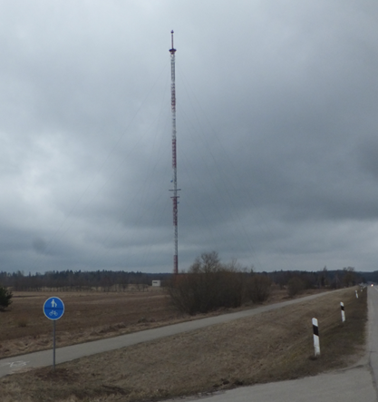
1
2
- b)
Fig. 9. View of the FM radio station (a) and satellite map showing the measurement routes and H-polarization antenna beam axis (b)
In Bubiai, the same as in Juragiai, the antenna system for H-polarization consists of 4 bays stocked array and 4 panels K5231187 per bay. The horizontal pattern is close to omnidirectional with four slightly expressed leaflets. The several radio stations shared this broadband antenna system and it was transmitting at several frequencies.
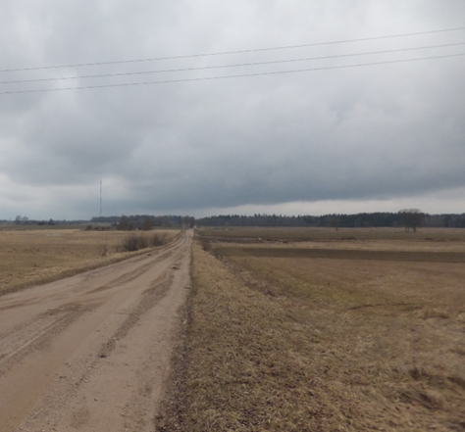
- b)
Fig. 10. View of the roadway (a) and country road (b) leading to the transmitting antenna mast
Table 2. Key data of the FM radio stations
Measured frequency, MHZ | 88.2 | 100.9
e.r.p., dBW | 34.95 | 41.75
Antenna height above ground, m | 178 | 178
Antenna polarization | H | H
Coordinates | 23.15 55.85416667

Fig. 11. The field strength level dependence on the distance
from the transmitting antenna mast. (88.2 MHz, roadway).

Fig. 11 represents the field strength variations along the roadway for broadcasting station at 82.2 MHz. We can see that at 400 m. there is a deep minimum because of the transmitting antenna pattern. After this critical distance the measurements are done in the main lobe, and starting from the distance of 0.9 km the antenna directivity can be ignored. For the frequency 100.9 MHz we obtained very similar results.
Fig. 12. Moving error (colored curves) and cumulative moving error (black curve) dependence on the distance to the transmitting antenna mast. 88,2 MHz; roadway.
Fig. 12 represents the radiated power measurement error calculation (modeling) results for segments of different length. Comparing to Juragiai case, here we can see noticeably bigger error variation range when segment “moves” along the route. In case of segment length of 200 m the measurement error variation range is 5.2 dB, in case of segment length of 1000 m this range reduces to 4.4 dB.
Fig. 13. The field strength level dependence on the distance from the transmitting antenna mast (88,2 MHz, country road).
Fig. 13 represents the field strength variations along the country road for the station broadcasting at 88.2 MHz. We can see that for this route the field strength varies significantly more irregularly than in case of the roadway. Nevertheless, for this route we obtained more accurate e.r.p. measurement results.

Fig. 14. Moving error (colored curves) and cumulative moving error (black curve) dependence on the distance to the transmitting antenna mast. 88,2 MHz; country road.

Fig. 14 represents radiated power measurement error calculation (modeling) results for route segments of different length. Here the measurement error variations when the segment “moves” along the route are similar to the roadway case. In case of segment length of 200 m the measurement error variation range is about 5.7 dB, in case of segment of 1000 m this range decreases to 2.2 dB.
4.2. Estimation of a route selection
From the above presented results, it follows, that the route segment should be not shorter than 1 km if we need reliable results. This conclusion is obtained for real routes, when the road is not flat enough, there are separate trees or power lines nearby. Although good results were obtained and for shorter routes. When measurement technique was tested in 2015-2017, many measurements were carried out. The results of these measurements are presented in Fig. 15. We see, that good results were obtained also for routes, shorter than 1 km. However, it must be said that only the best routes were selected for testing. The height variations for the longest route did not exceed 13.5 m, and there were no massive forest nearby.
Fig. 15. Radiated power measurement errors for routes of different length.
Measurement of one FM broadcasting station gave a high error exceeding 4 dB, although the measurement was repeated using a different route (see Fig. 15). But in that case the problem was with the broadcasting station itself, because the measurements of different stations with separate antenna systems in the same tower gave errors less than 2 dB for the same routes.
It must be assumed, that there will not always be the possibility to select a good route for application of this method of e.r.p. measurement. In such a case, the question will arise on the reliability of the results. Some reliability can be judged from the cumulative moving error dependence on a length of a route, presented in Fig. 16. The calculation of this cumulative moving error was described in section 2.3 above, it was also represented by black curves in figures 6, 7, 11 and 13 for each route separately.
Fig. 16. Radiated power measurement error dependence on route‘s length.
In case the measurement error variation exceeds 1-1.2 dB for routes longer than 1000 m, we can suspect that the route is not suitable for the measurements. To be sure, it is useful to carry out the e.r.p. measurements in different types of routes with not flat surface, with some separate trees or buildings nearby. It is understood that the direct visibility of the transmitting antenna must be ensured for the largest part of the route.
- Summary

- The analysis has shown that in order to get reliable results, the route length should be no shorter than 1 km.

- In principle, good results can be obtained and for shorter routes of 200-300 m if they are selected correctly in flat and open areas. But it is more reliable to choose the measurement route as long as possible.

- In order to try to get some kind of criteria, helping to judge the suitability of the route for e.r.p. measurements, it would be useful to carry out the e.r.p. measurements in different types of routes with not flat surface, with some separate trees or buildings nearby.

- Experimental FM-BC e.r.p. measurement confirmed the effectiveness of the method. In general, this method should not be frequency dependent. It would be appropriate to apply this method for e.r.p. measurements of DVB-T broadcasting stations, which usually use antenna systems of 10 and more bays and their elevation angle at -1 dB level is less than 1 degree. Therefore application of the height scan method is not possible. First test e.r.p. measurements of DVB-T broadcast station in Vilnius with 15 bays antenna gave positive results.

