Project Team FM22
44th Meeting of FM22  Copenhagen, 06 – 09 October 2015 | FM22(15)55

Date issued: 1 October, 2015

Source: Lithuania

Subject: Working material for Draft New ECC recommendation on determination of the radiated power through field strength measurements in the frequency range from 87.5 MHz to 108.0 MHz
N
Password protection required? (Y/N) *

Summary
Document contains measurement results of e.r.p. determination through field strength measurements for 22 vertically and horizontally polarized FM broadcasting radio stations.

Proposal
Exact vertical and horizontal diagrams of a transmitting antenna must be known and the vertical and horizontal corrections must always be taken into account. To get reliable results, measurements should be carried out within the main TX antenna beam.

Background
During the 43rd meeting of FM22, working group was invited to review proposed draft new Recommendation (Document No. FM22(15)09) and consider the creation of new ECC Recommendation on determination of the radiated power through field strength measurements in the frequency range from 87.5 MHz to 108.0 MHz.
Delegates were asked to verify the applicability of this measurement method and to report at the next FM22 meeting.

Measurement distance and inclination angle α

h
H
d
TX
α
RX
α

Inclination angle α may be calculated if we know TX antenna height H, receiving antenna height h and the measurement distance d:
α=(180/π)*ATAN((H-h)/d)

Critical inclination angle

The critical inclination angle, at which maximum and minimum field strength values may be observed from 3 to 10 meters, depends on frequency – it varies from 8 degrees for highest frequency (108 MHz) to 10 degrees for the lowest (88 MHz). If the angle is lower, no maximums and minimums will be observed from 3 to 10 meters.

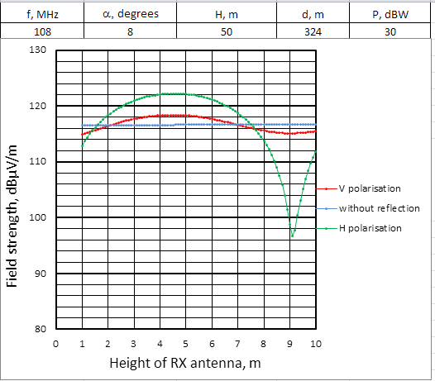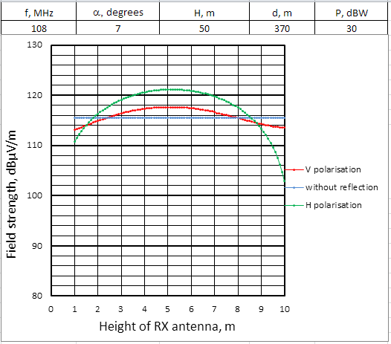

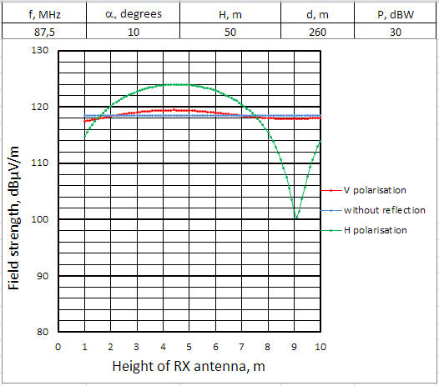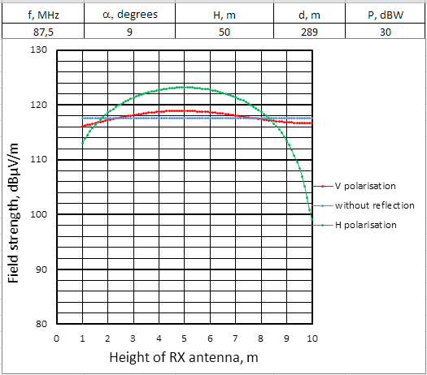

Transmission antenna diagram corrections

When calculating e.r.p. from measured field strength, the vertical and horizontal transmission antenna corrections must be taken into account, because our measurements usually will be carried out not in the main beam of the transmission antenna. Horizontal and vertical transmission antenna diagrams must be known for our inclination angle (in vertical plane) and azimuth (in horizontal plane):

Example of horizontal radiation patterns

Examples of vertical radiation patterns

To have reliable results, measurements should be carried out in the main TX antenna beam. Because calculated critical inclination angle varies from 8 to 10 degrees, from the above examples of vertical radiation patterns we can see, that this method may be applied for antennas with up to 4 bays. If our measurements are carried out closer to transmitter with higher inclination angle, we might be measuring side lobes, and this will lead to big mismatch.

Measurement results

Measurements of 22 FM broadcast transmitters were carried out. Inclination angles were calculated for the height of a receiving antenna at h=5 m. The results with mismatch of more than 3 dB are highlighted.

Measurement No | ERP licensed, dBW | ERP calculated, dBW | ERP Mismatch, dB | Inclination angle α, degrees | Azimuth, degrees | Correction ∆Vert, dB | Correction ∆Azim, dB
88,2 MHz H
1 | 35,0 | 37,7 | 2,7 | 16,6 | 3,0 | -16,5 | -0,3
2 | 35,0 | 34,8 | -0,2 | 13,8 | 85,5 | -11,7 | -0,5
90,3 MHz H
1 | 34,8 | 34,7 | 0,0 | 20,7 | 324,4 | -14,9 | -1,3
2 | 34,8 | 36,5 | 1,8 | 42,5 | 283,3 | -14,0 | -0,4
3 | 34,8 | 34,3 | -0,4 | 12,8 | 337,6 | -10,5 | 0,0
92,2 MHz V
1 | 36,1 | 29,9 | -6,2 | 17,2 | 3,0 | -10,5 | -1,6
2 | 36,1 | 26,7 | -9,4 | 14,4 | 85,5 | -6,3 | -0,3
96,2 MHz H
1 | 40,0 | 40,5 | 0,5 | 24,6 | 318,4 | -15,9 | -3,8
2 | 40,0 | 43,0 | 3,0 | 20,7 | 324,4 | -14,9 | -3,3
3 | 40,0 | 39,4 | -0,6 | 42,5 | 283,3 | -14,0 | -1,0
4 | 40,0 | 42,0 | 2,0 | 42,5 | 283,3 | -14,0 | -1,0
5 | 40,0 | 37,7 | -2,4 | 12,9 | 337,5 | -10,5 | -1,5
6 | 40,0 | 39,0 | -1,1 | 12,8 | 337,6 | -10,5 | -1,5
97,0 MHz V
1 | 29,5 | 32,4 | 2,9 | 17,7 | 3,0 | -2,0 | -3,3
2 | 29,5 | 30,2 | 0,7 | 14,8 | 85,5 | -1,3 | -0,1
97,6 MHz V
1 | 36,0 | 29,4 | -7,5 | 31,3 | 288,9 | -13,3 | -3,1
2 | 36,0 | 32,7 | -4,1 | 15,0 | 324,8 | -8,2 | -0,9
3 | 36,0 | 36,2 | -0,7 | 9,3 | 6,3 | -5,0 | 0
4 | 36,0 | 36,0 | -0,8 | 8,8 | 6,3 | -4,5 | 0
5 | 36,0 | 36,7 | -0,1 | 9,4 | 337,2 | -2,1 | -0,6
98 MHz V
1 | 32,7 | 40,4 | 7,9 | 18,6 | 324,8 | -20,0 | -3,7
2 | 32,7 | 30,8 | -1,7 | 37,4 | 288,9 | -12,5 | -8,5
3 | 32,7 | 30,6 | -1,9 | 11,8 | 337,2 | -7,5 | -0,8
100,5 MHz V
1 | 34,7 | 34,6 | -0,1 | 11,8 | 3,0 | -4,3 | -2,2
2 | 34,7 | 34,2 | -0,5 | 9,9 | 85,5 | -2,7 | 0,0
100,9 MHz H
1 | 43,0 | 38,0 | -5,0 | 16,4 | 3,0 | -16,5 | -0,3
2 | 43,0 | 39,4 | -3,6 | 13,7 | 85,5 | -11,7 | -0,5
101,7 MHz V
1 | 32,1 | 20,7 | -11,4 | 17,2 | 3,0 | -15,0 | -1,5
2 | 32,1 | 19,8 | -12,3 | 14,4 | 85,5 | -7,5 | -0,4
101,9 MHz H
1 | 42,4 | 43,9 | 1,2 | 13,9 | 37 | -15,8 | -1,16
2 | 42,4 | 44,0 | 1,3 | 11,5 | 32 | -11 | -1,76
3 | 42,4 | 43,3 | 0,6 | 9,5 | 30 | -6,94 | -2
4 | 42,4 | 43,3 | 0,7 | 8,8 | 30 | -5,83 | -2
102,1 MHz H
1 | 40,0 | 35,7 | -4,6 | 24,6 | 318,4 | -15,9 | -3,8
2 | 40,0 | 39,3 | -0,8 | 13,0 | 6,3 | -15,8 | -2,4
3 | 40,0 | 39,8 | -0,5 | 20,7 | 324,4 | -14,9 | -3,3
4 | 40,0 | 35,9 | -4,4 | 42,5 | 283,3 | -14,0 | -1,0
5 | 40,0 | 42,4 | 2,1 | 42,5 | 283,3 | -14,0 | -1,0
6 | 40,0 | 35,3 | -4,9 | 12,1 | 6,3 | -12,1 | -2,4
7 | 40,0 | 36,6 | -3,7 | 12,9 | 337,5 | -10,5 | -1,5
8 | 40,0 | 37,8 | -2,5 | 12,8 | 337,6 | -10,5 | -1,5
103,4 MHz H
1 | 43,0 | 40,0 | -3,0 | 16,4 | 3,0 | -16,5 | -0,3
2 | 43,0 | 38,7 | -4,3 | 13,7 | 85,5 | -11,7 | -0,5
103,5 MHz V
1 | 36,3 | 31,3 | -5,5 | 31,3 | 288,9 | -13,3 | -3,1
2 | 36,3 | 28,2 | -8,6 | 15,0 | 324,8 | -8,3 | -1,0
3 | 36,2 | 32,8 | -3,9 | 9,3 | 6,3 | -5,0 | 0
4 | 36,2 | 32,3 | -4,3 | 8,8 | 6,3 | -4,5 | 0
5 | 36,3 | 35,3 | -1,4 | 9,4 | 337,2 | -2,6 | -0,6
103,9 MHz V
1 | 35,7 | 34,9 | -0,8 | 11,8 | 3,0 | -4,3 | -2,1
2 | 35,7 | 35,1 | -0,6 | 9,9 | 85,5 | -2,7 | 0,0
3 | 35,7 | 35,2 | -0,5 | 9,9 | 85,5 | -2,7 | 0,0
104,1 MHz H
1 | 43,0 | 41,7 | -2,2 | 24,6 | 318,4 | -15,9 | -3,3
2 | 43,0 | 42,7 | -1,2 | 20,7 | 324,4 | -14,9 | -3,8
3 | 43,0 | 32,8 | -11,1 | 42,5 | 283,3 | -14,0 | -1,3
4 | 43,0 | 43,4 | -0,6 | 42,5 | 383,3 | -14,0 | -1,3
5 | 43,0 | 36,4 | -7,5 | 12,9 | 337,5 | -10,5 | -1,7
6 | 43,0 | 36,7 | -7,3 | 12,8 | 337,6 | -10,5 | -1,7
104,4 MHz H
1 | 42,6 | 43,0 | 0,2 | 11,5 | 32 | -11 | -1,9
2 | 42,6 | 43,7 | 1,0 | 9,5 | 30 | -6,94 | -2,3
3 | 42,6 | 44,0 | 1,3 | 8,8 | 30 | -5,83 | -2,3
4 | 42,6 | 43,1 | 0,4 | 8,5 | 30 | -2,96 | -2,3
105,8 MHz V
1 | 36,2 | 34,2 | -2,0 | 17,2 | 3,0 | -16,0 | -0,4
2 | 36,2 | 32,5 | -3,7 | 14,4 | 85,5 | -9,0 | -1,4
106,3 MHz V
1 | 34,0 | 34,2 | 0,2 | 11,8 | 3,0 | -4,3 | -2,1
2 | 34,0 | 35,7 | 1,7 | 9,9 | 85,5 | -2,7 | 0,0
106,5 MHz H
1 | 29,6 | 33,4 | 4,0 | 13,9 | 37 | -15,8 | -0,98
2 | 29,6 | 32,5 | 3,1 | 11,5 | 32 | -11 | -1,78
3 | 29,6 | 31,4 | 2,0 | 9,5 | 30 | -6,94 | -2,1
4 | 29,6 | 31,0 | 1,5 | 8,8 | 30 | -5,83 | -2,1
106,6 MHz V
1 | 36,0 | 33,4 | -2,9 | 9,3 | 6,3 | -5,0 | 0
2 | 36,0 | 34,0 | -2,2 | 8,8 | 6,3 | -4,5 | 0
107,1 MHz V
1 | 35,8 | 42,0 | 5,1 | 31,1 | 288,9 | -13,0 | -0,6
2 | 35,8 | 27,8 | -9,1 | 14,9 | 324,8 | -11,0 | -0,2
3 | 35,8 | 33,8 | -3,0 | 9,3 | 337,2 | -3,0 | -0,2

Conclusions

The proposed method on determination of the radiated power through field strength measurements in the frequency range from 87.5 MHz to 108.0 MHz works well if we carry out measurements within the main beam of a transmitting antenna, and we know exact vertical and horizontal radiation patterns. Practical measurement results show that measurements at inclination angles from 8 to 12 degrees in most cases give us a result of e.r.p. within 3 dB mismatch.

