Guidance on Cross border coordination between MFCN and ATS in the 1429-1518 MHz band
approved DD Month YYYY (Arial 9)
ECC Report <No>
[last updated: DD Month YYYY] (Arial 9)

Executive summary
At WRC-15, the frequency bands 1427-1452 MHz and 1492-1518 MHz were identified globally for International Mobile Telecommunications (IMT) in accordance with Resolution 223 (Rev.WRC-15) and ECC Decision (17)06 harmonises the use of the frequency bands 1427-1452 MHz and 1492-1518 MHz for Mobile/Fixed Communications Networks Supplemental Downlink (MFCN SDL). The ECC Decision (17)06, together with the amendments to ECC Decision (13)03 for the frequency band 1452-1492 MHz, opens the possibility for a combined use of the whole 1427-1518 MHz frequency band for MFCN SDL. Both ECC Decisions harmonising technical conditions for the use of the frequency bands 1427-1452 MHz, 1452-1492 MHz and 1492-1518 MHz leave flexibility for administrations with regards to the use of incumbent services and applications to adapt to specific national circumstances.
In some CEPT countries, the band 1429-1518 MHz is also allocated on a co-primary basis to the aeronautical mobile service (AMS) for the purpose of aeronautical telemetry within the national territory according to No 5.342 RR. At present, the MIFR contains 1653 assignments to aeronautical telemetry systems (ATS) in the some CEPT countries within the given band. This essential part of ATS stations is used in border areas and needs protection from MFCN base stations (BSs). Both mentioned ECC Decisions refer to the need for cross-border coordination between MFCN and ATS and ECC/DEC(17)06 refer to the need for study in order to provide further guidance, where needed, to administrations for bi/multi-lateral negotiations.
All previous studies on this matter have already defined the criteria for protection of the ATS and the trigger distances to initiate coordination. But according to the results of these studies, the protection criteria and coordination distances had such values that prevented to initiate coordination negotiations. In addition, previous studies did not describe the procedure for coordination calculations taking into account the aggregate interference affect from the BSs of MFCN. The purpose of these studies is to determine a protection criterion acceptable for practical purposes, and to propose an effective mechanism for calculating and monitoring compliance with the requirements established by the coordination agreement. The studies should be completed by developing a coordination agreement template.
This report investigates two protection criteria methods - I/N and C/(I+N). In general, when the information concerning the system sensitivity is available, I/N criteria could be used as a baseline. In cases where information on the link budgets for telemetry system is available, appropriate way to define permitted levels of interference would be the C/(I+N) method.
In order to determine the practical values of the protection criterion for ATS, a comparative analysis of the characteristics of ground and on-board equipment of ATS receivers was carried out. The results of the analysis made it possible to compare the protection level of these receivers. Taking into account the requirements of footnote 5.432 RR regarding the restriction of the service area outside the national territory, the assumption was made to limit the reception of the ATS in the direction of the border only by the side and back lobes of the ATS antenna pattern.
The assumptions mentioned above requires carrying out more accurate calculations of the aggregate interference from the MFCN BSs. Due to random nature of the MFCN interference and due to the rotation of the antenna of the ATS station the measurements conducting at the locations of ATS stations could be complicated or even impossible. In order to reduce the uncertainty in measured results the proposal to transfer the calculations and measurements places from ATS positions to the test points at the borderline was considered.
Analysis were performed including the reception by the main beam of the ATS antenna pattern, i. e. taking into account full antenna pattern characteristics. Two types of systems were examined: 1) tracking-type system with antenna pattern in accordance with Recommendation ITU-R M.1459-0, 2) radar-type antenna system with antenna pattern in accordance with Recommendation ITU-R M.1851-0 for which investigations were performed for elevation angles of 9 degrees and 11 degrees.
In some other cases the threshold level can be specified on the location of the ATS station using I/N or C/(I+N) method.
For the case of interference scenario when the ATS on-board transmitter is placed above the borderline at the height of 10000 meters and the ATS ground receiver antenna is always pointing to the aircraft the results also indicate that C/(I+N) ratio of ATS station increase when the ATS station is located closer to the borderline for the tracking-type ATS antenna only.
Calculations were performed for few types of MFCN topologies: single interferer, single MFCN cluster, several MFCN clusters, MFCN surrounding ATS station, MFCN linearly placed along borderline and modelled based on the real mobile Lithuanian and Poland networks.
Based on a practical interference case between POL-UKR for UMTS-BWA the methodology for aggregated interference calculation/ measurements was presented.
Possible technical measures to eliminate harmful interference from MFCN to ATS stations were considered.
The example of draft template for coordination Agreement is provided in the Annex 3.

TABLE OF CONTENTS

0 Executive summary 2
1 Introduction 6
2 Operational characteristics of the systems 7
2.1 Technical characteristics of ATS station 7
2.1.1 Radar-type antenna system 7
2.1.2 Tracking-type antenna system 7
2.2 Technical characteristics of mobile system 9
3 ATS system operation 10
3.1 Protection criteria 10
3.2 Coordination trigger 10
3.3 Receiving system block diagram 10
4 Derivation of the maximum permissible interfering field strength to ATS by method of I/N 12
4.1 Method 1. Recalculation of the power flux density to the field strength level 12
4.2 Method 2. Obtaining the permissible field strength from the typical technical characteristics of the receiver for the L-band 12
5 Principles of frequency usage in the band 1427-1518 MHz in border areas 13
6 Provisions of cross-border coordination between the MFCN and ATS stations 14
7 Methodology for field strength calculations for stations located in the border areas 15
7.1 Interference analysis for different protection methods 15
7.1.1 Aggregate interference simulations 15
7.1.1.1 Network cluster case 15
7.1.1.2 Surrounding network (ring) case 21
7.1.1.3 Additional investigation for Scenario 1 (perpendicular) 25
8 Example of ATS in Kaliningrad region 29
9 General procedure for field strength calculation on the borderline using I/N or C/(I+N) methods in order to eliminate harmful interference 35
10 Field strength measurement procedure 36
10.1 Common provisions 36
10.2 Requirements to the monitoring equipment 36
10.3 Information to be provided by the affected Administration in case of harmful interference 36
11 Assessment of interference from MFCN at the borderline 38
12 Conclusions 39
ANNEX 1: antenna patterns 40
ANNEX 2: Averaged value of iRSS for surrounding network interference calculations 45
ANNEX 3: The approach to calculate the interfering power flux density 47
ANNEX 4: Methodology for field strength calculations based on practical case 49
ANNEX 5: The example of draft template for coordination Agreement 54
ANNEX 6: Example of single interference calculation with using different AP of ATS 55
ANNEX 7: List of Reference 60

LIST OF ABBREVIATIONS

Abbreviation | Explanation
ATS | Aeronautical Telemetry System
BS | Base Station
BWA | Broadband Wireless Access
CEPT | European Conference of Postal and Telecommunications Administrations
ECC | Electronic Communications Committee
EIRP | Equivalent Isotropically Radiated Power
FDR(∆f) | Frequency-Dependent Rejection
FSL | Field Strength Level
IMT | International Mobile Telecommunications
iRSS | Interfering Received Signal Strength
MFCN | Mobile/Fixed Communications Network
MIFR | Master International Frequency Register
SDL | Supplemental Downlink
SRTM3 | Shuttle Radar Topography Mission

Introduction
The documents [2]-[5] provide examples of various ATS systems. Despite the different characteristics of the ground and on-board equipment, the destination and the main functions of the system remain the same and mainly provide the flight safety of the aircraft by obtaining current information to maintain the state of the performance of systems and crew during the test and during the operation of the aircraft. One such system is the aeronautical telemetry system in the aeronautical mobile service that has been in service for a long time and uses the band 1429-1535 MHz in accordance with RR No. 5.342. The system is intended for the current automatic display and registration, at the ground level, of generic indicators of the state of on-board equipment and crew located in the airplane and for the transfer of these data to the ground station on request from the ground. Currently, the MIFR contains 1653 assignments to aeronautical telemetry systems (ATS) in some CEPT countries (Belarus, the Russian Federation and Ukraine) within the given band.
According to RR (2016 edition) the frequency band 1 429-1 535 MHz in Region 1 is allocated to mobile service, except aeronautical mobile, on a primary basis. According to the footnote No. 5.342 the frequency band 1 429-1 535 MHz is additionally allocated to the aeronautical mobile service on a primary basis in Armenia, Azerbaijan, Belarus, the Russian Federation, Uzbekistan, Kyrgyzstan and Ukraine, exclusively for the purposes of aeronautical telemetry within the national territory. As of 1 April 2007, the use of the frequency band 1 452-1 492 MHz is subject to agreement between the administrations concerned. According to the footnote No. 5.341A in Region 1, the frequency bands 1 427-1 452 MHz and 1 492-1 518 MHz are identified for use by administrations wishing to implement International Mobile Telecommunications (IMT) in accordance with Resolution 223 (Rev.WRC-15). This identification does not preclude the use of these frequency bands by any other application of the services to which it is allocated and does not establish priority in the Radio Regulations. The use of IMT stations is subject to agreement obtained under No. 9.21 with respect to the aeronautical mobile service used for aeronautical telemetry in accordance with No. 5.342.
A more detailed analysis of the operational and technical characteristics of the ATS station, obtained theoretically and practically, will allow to clarify protection criteria, introduce certain restrictions on the protection of ATS and suggest a possible way for efficient use of the band 1427-1518 MHz, along with provision of protection of ATS stations from the MFCN stations, located in the border area.

Operational characteristics of the systems

Technical characteristics of ATS station

Radar-type antenna system
A distinctive feature of the system is the use of pulse-code signals, which allows in some cases to partially combine the functionality of radar and ATS. Therefore, ATS stations can have as a separate functional implementation and be an additional component of radar equipment. In particular, the reflector-type radar antenna and separate components of the radar feeder system are used both by the radar and by the ATS station. The main operating mode of such system is receiving the data from the tested aircraft by synchronised rotation with radar. In this case antenna pattern is according to Recommendation ITU-R M.1851-0 [1]. Further details are provided in Annex 1.

Tracking-type antenna system
Another technical implementation of the ground station ATS works only on receiving data from the tested aircraft by slow tracking the movement of the aircraft. In this case antenna pattern is according to the Recommendation ITU-R M.1459-0 [2], see Annex 1 for further details.
Therefore, when determining the protection criterion, this could be taken into account.
According to the RR footnote No. 5.342, the service area of ATS stations is limited to the national territory. Since the service area limit is determined by the maximum radius of the system, which in turn is limited by the power budget of the link from the aircraft to the ground level, the possibility of data receiving and transmitting on the aircraft is determined by the flight path of the aircraft within the national territory. Thus, in the course of research, the scenario of the interference from the IMT BS should take into account the effect of interference towards both the main and side lobes of the antenna pattern of the ATS station located in the border area.
Table 1: Telemetry system characteristics
Parameter | Value
Station of aeronautical telemetry system
Application | Automatic display and registration, at ground level, of parameters of the status of on-board equipment and crew, located in the airplane, by transmitting them to the ground station of the aeronautical telemetry system of aeronautical mobile service
Characteristics of transmitter
Station name | ATS on-board transmitter
Place of deployment | aircraft
Maximum EIRP, dBW | 38
Average power, dBW | 5
Pulse duration, µS | 0.5
Occupied bandwidth of emission, MHz | 1/3/5
Class of emission | VХD
Operation frequencies, MHz | 1434, 1439, 1444, 1449, 1454, 1459, 1464, 1469, 1474, 1479, 1484, 1489, 1494, 1499, 1504, 1509, 1514, 1519, 1524, 1529, 1533
Maximum antenna height, m | 10000
Maximum antenna gain, dB | 6
Antenna pattern on -3 dB level, º | Nondirectional or low directional
Main lobe direction | Low hemisphere
Transmission path length, km | up to 320
Characteristics of receiver
Station name | ATS ground (terrestrial) receiver
Station class in accordance with Chapter IV Section 6 of Preface to BR IFIC | FA
Place of deployment | land
Antenna height, m | 10
Polarization | linear
Thermal noise floor (kTB), dBW/5 MHz | −136.98
Noise figure, dB | 7
Maximum antenna gain, dB | 30
Feeder losses, dB | 3
Antenna pattern on -3 dB level (average), º | Vertical pattern: 10º; Horizon pattern: 4⁰
Main lobe direction | Azimuth: 0-360⁰
C/N ratio, dB | 13
Protection criterion for the ground ATS station proposed by ATS users based on measurements is provided in Table 2 for information.
Table 2: Protection criterion for the ground ATS station proposed by ATS users
Parameter | Value
Field strength for protection, (dBµV/m) | 14
Percentage of time, (%) | 10
Frequency-Dependent Rejection FDR(∆f) | Table 3
Reference bandwidth, MHz | 5
Table 3: Frequency-Dependent Rejection FDR(∆f) value of the ground ATS station
Parameter | Value
∆f–IMT-ATS central frequency difference, (МHz) | -15 | -10 | -8 | -4 | -2 | 0 | 2 | 4 | 8 | 10 | 15
FDR(∆f), (dB) | -62 | -47 | -20 | -3 | -1 | 0 | -1 | -3 | -20 | -47 | -62

Technical characteristics of mobile system
The characteristics of mobile service systems are according to Report ITU-R M.2292-0 and are extracted in Table 4. For the analysis in this document the channel bandwidth of 5 MHz will be considered, however other channel bandwidth values also may be under consideration.
Table 4: Parameters of macro base station
Base station characteristics
Cell radius | 4.75 km
Antenna height | 30 m
Sectorization | 3 sectors
Downtilt | 3 degrees
Frequency reuse | 1
Antenna pattern (see Annex 1) | Recommendation ITU-R F.1336 (recommends 3.1)  ka = 0.7  kp = 0.7  kh = 0.7  kv = 0.3  Horizontal 3 dB beamwidth: 65 degrees  Vertical 3 dB beamwidth: determined from the horizontal beamwidth by equations in Recommendation ITU-R F.1336
Antenna polarization | Linear / ±45 degrees
Feeder loss | 3 dB
Channel bandwidth | 5 MHz
Maximum base station output power (5 MHz) | 43 dBm
Maximum base station antenna gain | 18 dBi
Maximum base station output power/sector (EIRP) | 58 dBm

ATS system operation

Protection criteria
The maximum permitted interference power level at the receiver input may be specified according to one of the two criteria:
“I/N” criterion – where the maximum permitted interference is defined in relation to the thermal noise level (I is interfering signal and N is system thermal noise power);
“C/(I+N)” criterion – where the value of the maximum permitted interference is defined in relation to a target reduction in the receiver’s signal-to-interference-plus-noise ratio (C is wanted signal, I is interfering signal, N is thermal noise). This criterion might be appropriate if the receiver operates at some margin above its minimum sensitivity and in cases where information on the link budgets is available.

Coordination trigger
The main goal of international cross-border coordination is to allow each of the countries a mutual and optimal use of the radio spectrum. Different administrations may wish to adopt different approaches to cross-border coordination. In order to calculate the effect of harmful interference a parameter for permissible harmful interference impact on the receiving station needs to be determined. Coordination triggers could be defined as a) maximum permitted field strength levels (land mobile and broadcasting services), b) coordination distances (broadcasting and fixed services, radars), c) coordination area (broadcasting and space services), triggering power flux density (fixed service). This document will analyse the field strength level method.
The required maximum permitted field strength level for the protection of ATS stations from interference could be calculated in one of two following ways:
at the location of ATS station. This should be seen as the primary method since the main objective is to protect the station in the place where it is located. The information on the location of these stations can be obtained from the Master International Frequency Register (MIFR) or from the administrations concerned;
at the borderline. This should be agreed between neighbouring countries concerned. In such situation the requirements for the protection of ATS ground stations should not impose higher levels comparing to the case of known location. This provides implementation flexibility for the country using ATS without creating additional constraints to the mobile service in the neighbouring countries.

Receiving system block diagram
The receiving system of the ATS is characterized by a narrow beam directional antenna, therefore a concept of isotropic received signal level (IRL) at the antenna input is not applicable for path analysis in the case of multiple and multidirectional radiation sources. Instead, C/N is calculated at the input of the first active stage of receiving system, usually this is the low-noise amplifier (LNA). Figure 1 presents a simplified functional block diagram of such a receiving system. The received signal level (RSL) or received field strength level (FSL) and the effective noise temperature (noise power N) are calculated at the same reference point at the input of the LNA.
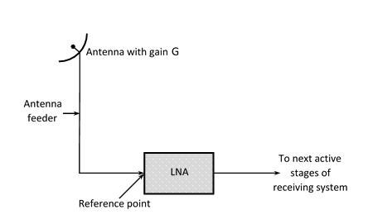
Figure 1: Simplified block diagram of ATS ground receiver
If the characteristics of antenna of the station seeking protection is known then the protection requirement could be calculated at the reference point taking into account antenna pattern.

Derivation of the maximum permissible interfering field strength to ATS by method of I/N
The protection criterion for protecting the ground component of the ATS from the broadcasting-satellite service (BSS) and mobile satellite service (MSS) provided in the document [2] was automatically transposed to study the protection from the land mobile service (IMT) [4], while the theoretical and practical results for obtaining a protection criterion for the last case were not obtained separately. Comparison of the technical characteristics of ATS receivers indicates their similarity and therefore the basis for obtaining a protective criterion may be taken from the power flux density (pfd) of S = −140 dB(W/m2) in the reference bandwidth of 4 kHz [4]. Then the protection criterion can be obtained in two ways.

Method 1. Recalculation of the power flux density to the field strength level
Field strength level at a given isotropic-radiative power (Recommendation ITU-R P.525-2):
E [dBμV / m] = S + 145.8 = −140 + 145.8 = 5.8 dB (μV / m) / 4 kHz = 36.8 dB (μV / m) / 5 MHz
The ATS antenna gain depends on the antenna pattern used. Taking into account that the reception of interference for the ground receiver (g) occurs on the side lobes of the antenna pattern, for example, at the average side lobes level -20 dB from the gain in the main lobe, then Eg = 26.8 dB (μV / m) / 5 MHz.

Method 2. Obtaining the permissible field strength from the typical technical characteristics of the receiver for the L-band
Taking into account the total estimated effect of interference from other services, the receiver's sensitivity threshold may be adopted to determine the permissible field strength of interference at the ATS reference point. The receiver's sensitivity threshold for typical parameters in this frequency range is:
Pr [dBW] = 10 log10 (kTBF× (I / N)) = −228.59 dB (k) + 24.62 dB (T) + 7 dB (F) + 66.99 dB (B) − 6 dB (I / N) = −135.98 dBW = −105.98 dBm,
where k = 1.381x10-23 J / deg - Boltzmann constant, T = 290 Kelvin degrees - ambient temperature, B - noise bandwidth of 5 MHz, F - noise factor = 5, I / N = −6 dB is the interference to noise ratio (interference criterion) at 1 dB sensitivity degradation, which takes into account the estimated effect of total noise from other services.
When recalculating the sensitivity threshold value to the field strength at the reference point by the formula from Recommendation ITU-R P.525-2 for the average frequency of 1482 MHz and for isotropically received power involving no feeder loss, we have the following:
E [dBμV / m] = Pr [dBm] + 20 log F [MHz] + 77.2 = −105.98 + 63.42 + 77.2 = 34.6 dBμV / m / 5 MHz
Taking into account the average losses in the feeder (3 dB), the antenna gain for receiving on the ground (10 dB) and PR (Δf = 0), we obtain the following values of the maximum permissible field strength for the co-channel interference:
Eg = 27.6 dBμV / m / 5 MHz

Thus, the calculations for the field strength levels by these two methods, for ground ATS receivers described above, convey to very similar results.

Principles of frequency usage in the band 1427-1518 MHz in border areas
Several regulatory documents regulate the use of the band 1427-1518 MHz. Regarding ATS stations, the documents [6] and [7] provide for the development of guidance on cross-border coordination between MFCN and ATS in order to conclude bilateral or multilateral agreements between affected administrations. The defined protection criteria for ATS stations [2]-[5] and the relevant methods of calculations are preventing the conclusion of such agreements. It becomes impossible to plan and deploy MFCN BSs due to the huge separation distances and incomplete techniques for summing up of individual BSs interference.
However from the analysis of the provided operational and technical characteristics of the ATS station, it follows that part of the frequency band 1427-1518 MHz can be used by existing ground ATS receivers with protection, which is determined by the average level of the side lobes of the ATS station antenna pattern.
Such protection of the ATS receivers could be achieved by modifying technical parameters of individual BSs under the already existing MFCN deployment, or initial planning of the MFCN with predetermined limited parameters.
At the same time, the harmonized use of the entire band 1427-1518 MHz provides an opportunity for equitable access to the spectrum in border areas for countries with different frequency bands allocations, as is the case of countries that use the ATS in aeronautical mobile service in accordance with footnote 5.342 of the Radio Regulations.
All affected countries should take all necessary measures to ensure equal access to spectrum on both sides of the border, in the bands under discussion (1429-1452 MHz, 1452-1492 MHz, 1492-1518 MHz) and to avoid producing harmful interference while providing possibility to use the frequency bands by other countries without unnecessary restrictions.
All concerned parties have to conduct a work to minimize possible harmful interference. Mutual coordination process includes calculation procedures, measurement campaigns, correspondence, etc. This work is carried out with equal commitment by all parties involved.

Provisions of cross-border coordination between the MFCN and ATS stations
The cross-border coordination process includes a number of theoretical and practical aspects. For the case of MFCN-ATS, the following coordination provisions may be recommended:
Definition of communication systems and stations involved in coordination:
- service name and communication system;
- status (active, new, planned, notified …) of frequency assignments to the stations;
- frequency bands in which coordination is carried out;
- frequencies usage conditions (SDL, ground, on-board, duty cycle etc.) and technical specifications, if needed;
- current regulatory documents relevant to the situation of systems interactions.
Recommended threshold level for coordination: as follows from Section 4, the permissible level of the field strength (threshold), produced by MFCN BSs is determined by the parameters of the BSs MFCN transmitters and ATS receivers and can be transferred to the borderline (see Section 8) due to the uncertainty of the direction of reception and duty mode of the ATS receiver. As a baseline, when I/N method is used, it was proposed as an example to use the threshold value of 30 dBμV/m / 5 MHz / 10 m which takes into account the average level of side lobes of ATS antenna pattern. If the permissible field strength value is transferred to the borderline this value will be recalculated in accordance with the distance and position of the ATS station from the border. In some other cases the threshold level can be specified with using the location of the ATS station or using C/(I+N) method.
Concerning the new ATS stations to be put into operation, it is proposed to apply the criterion of the secondary cross-border line located on a distance of 15 km from the borderline. All new ATS stations, which are planned to be located closer than 15 km from the border, should be coordinated with the neighbouring administration. Such a distance is recognized as critical in terms of requiring excessive protection for ATS receivers under the conditions of the operating BSs of the MFCN in a neighbouring country.
The main provisions of coordination, to be inserted in a bilateral/multilateral agreement, should include: a description (or reference) of the format of the request for interference; the actions of concerned parties in the case of interference issues, including the procedure for measuring; method of calculations, including calculation of aggregate interference; the parties' responsibility for the results of calculations and measurements.

Methodology for field strength calculations for stations located in the border areas

Interference analysis for different protection methods
The following analysis investigates interference from MFCN network to ATS ground station based on protection criterion by methods I/N and C/(I+N) (see Section 3.1).

Aggregate interference simulations
Due to variety of border shapes two possible borderline cases will be analysed: straight line type (see Figure 2 and Figure 10) and a ring type (see Figure 12). For the first case (straight line) the ATS system (ground station and aircraft station) will be placed either perpendicular (scenario 1) (Figure 2) or parallel (scenario 2) (Figure 10) to the borderline. These two scenarios will try to assess the interference from MFCN into main lobe and side lobes of the ATS antenna pattern. Both radar-type and tracking-type antenna systems will be considered (i.e. antenna pattern according to Recommendation ITU-R M.1851-0 and Recommendation ITU-R M.1459-0).

Network cluster case
  - Scenario 1 (perpendicular)
In this case the situation when all systems (mobile network base stations, ATS receiver and ATS transmitter) are in the same line is considered.
Simulations for 1 cell or BS (3 sectors) as interferer and 19 cells or BSs (57 sectors) as interferers (the maximum number of cells or BSs in SEAMCAT cluster, version 5.3.0) are performed. Since the cell radius is 4.75 km then the radius of such network will be 38 km, consequently, this would cover an area of 4536 km2. A system layout is provided in Figure 2.
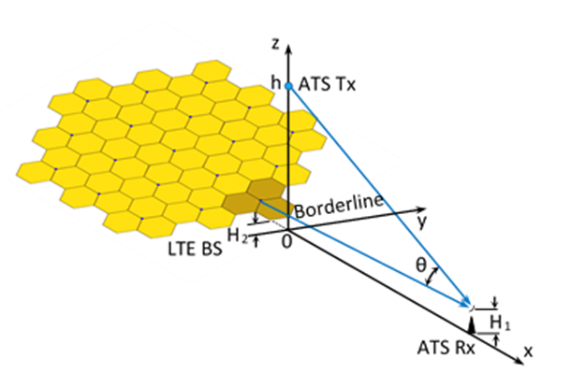
Figure 2: Aggregate interference from MFCN cluster (scenario 1)
The ATS on-board transmitter is placed above the borderline at the height of 10000 m and 2000 m. Antenna is omnidirectional in lower semi sphere with 6 dBi antenna gain. The ATS ground receiver antenna is always pointing to the aircraft. The ATS ground receiver antenna height is 10 m. The nearest base station (reference cell) is 9.5 km from the borderline (i.e. two cell radii) and one of its three sectors is looking directly to ATS. The BS antenna height is 30 m, antenna pattern is in accordance with Recommendation ITU-R F.1336 and the antenna downtilt angle is set to 3 degrees. A flat-earth terrain profile with land path is considered.
Firstly, we analyse the ATS ground receiver antenna gain of Recommendation ITU-R M.1459 (maximum antenna gain of 29 dBi) towards base station dependence on the distance.
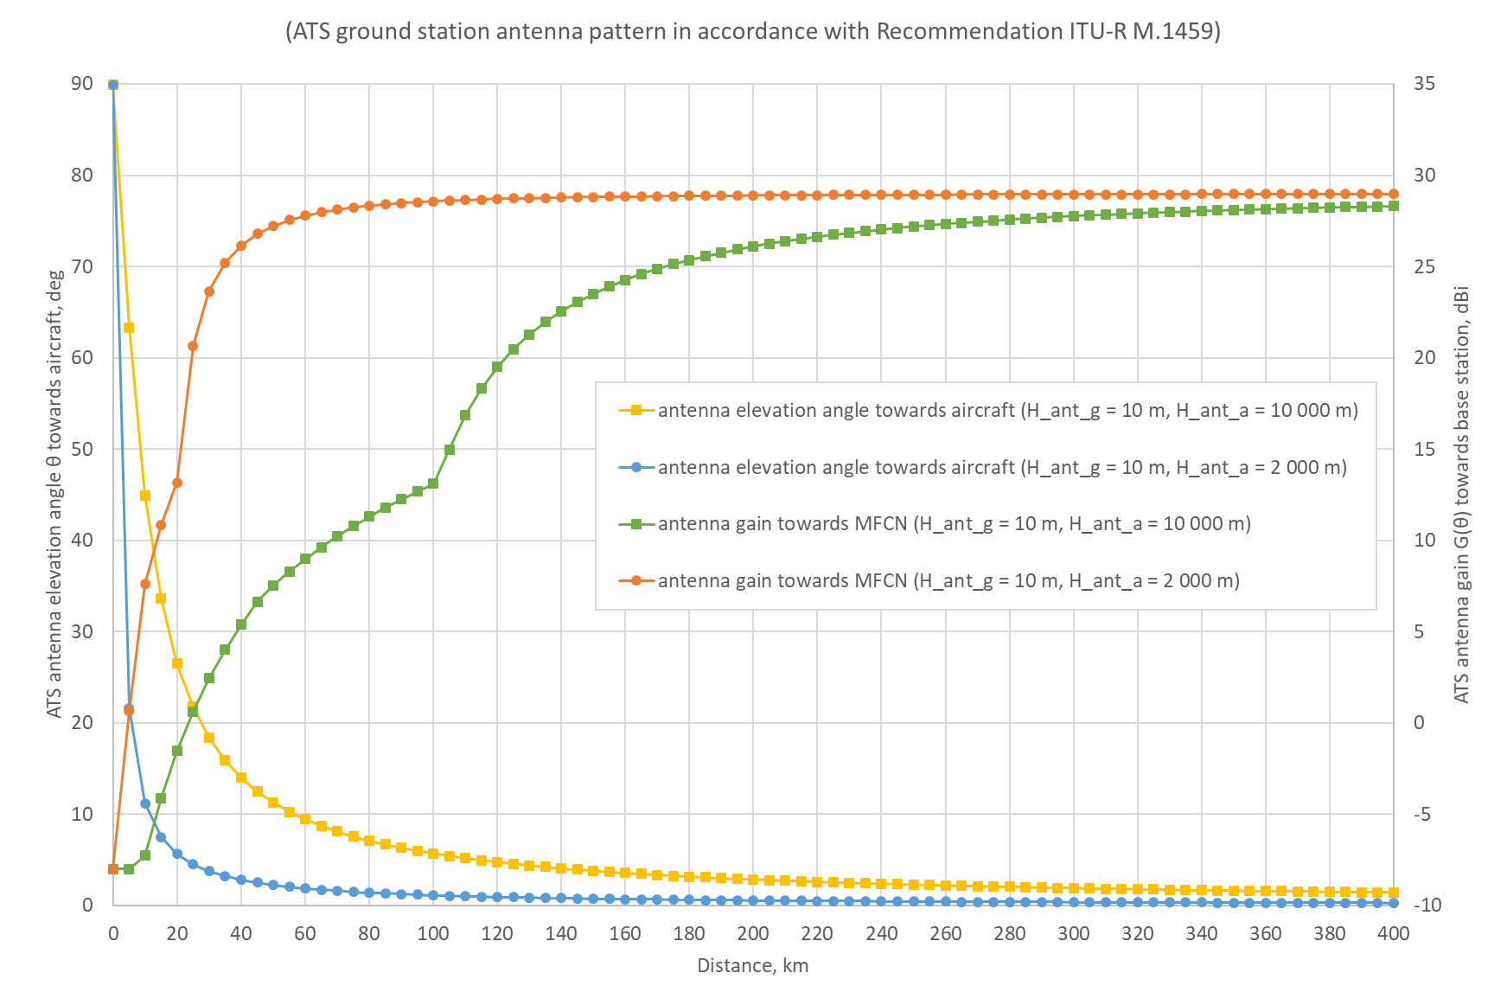
Figure 3: ATS ground receiver antenna elevation angle towards aircraft and gain towards BS versus the distance to the borderline
From Figure 3 when aircraft altitude is 10000 m, it can be noted that for the distances up to 100 km from the borderline the interference at the ATS ground receiver is received mainly by the side lobe of antenna pattern (with corresponding antenna gain). At the distance of approximately 120 km from the border antenna gain reaches 22 dBi and only from 240 km antenna gain exceeds 27 dBi.
It is also worth to note the difference between line-of-sight (LOS) wave propagation versus radio horizon (RH) for different aircraft altitudes. Assuming a perfect sphere with no terrain irregularity, the distance to the horizon from an on-board transmitter (i.e., line of sight) to the ground receiver can be calculated as follow
$d≈3.57\left(\sqrt{h_{1}}+\sqrt{h_{2}}\right)$ (1)
where h is antenna height above ground level in meters and distance d is in kilometres.
Considering the effect of atmosphere on the propagation path of radio waves the maximum service range is increased and is known as radio horizon which is calculated as
$d≈4.12 \left(\sqrt{h_{1}}+\sqrt{h_{2}}\right)$ (2)
The Table 5 provides the comparison of LOS and RH for different antenna heights.
Table 5: LOS and RH distance of radio wave propagation
h1_agl, m | h2_agl, m | LOS, km | RH, km
10 000 | 10 | 368.29 | 425.03
10 000 | 30 | 376.55 | 434.57
10 000 | 50 | 382.24 | 441.13
2000 | 10 | 170.94 | 197.28
2000 | 30 | 179.21 | 206.82
2000 | 50 | 184.90 | 213.38
The results of interference from clustered network into ATS ground station using antenna pattern in accordance with Recommendation ITU-R M.1459 for I/N and C/(I+N) calculation methods are provided in Figure 4, Figure 5 and Figure 6. The propagation model for the interfering Received Signal Strength (iRSS) path from MFCN BSs to ATS ground station is in accordance with Recommendation ITU-R P.1546-5 and Recommendation ITU-R P.525-2 is used for wanted signal path from ATS on-board transmitter. The use of other propagation models (e.g. in accordance with Recommendation ITU-R P.526-14 [8] or Recommendation ITU-R P.528-3 [9]) is presented in Annex 4.
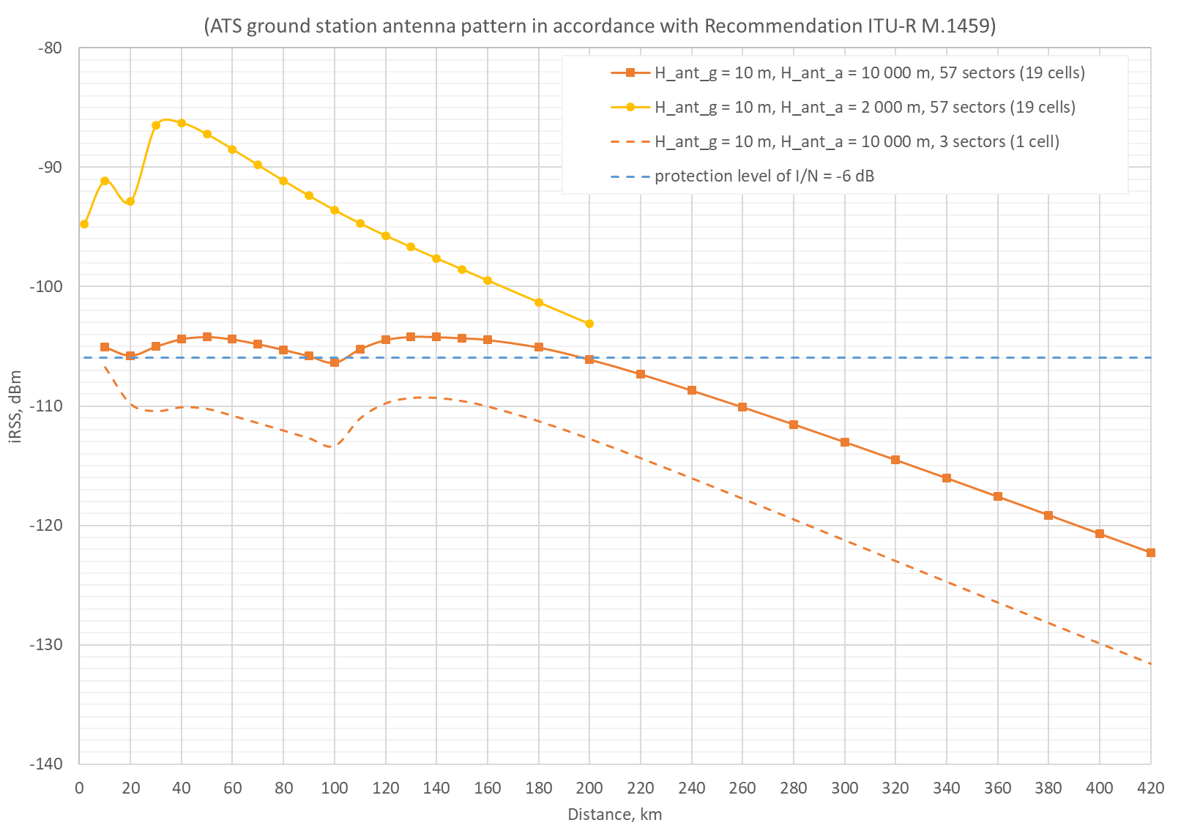
Figure 4: Interfering signal level (iRSS) dependence on distance between ATS and MFCN (ATS antenna acc. to ITU-R M.1459)
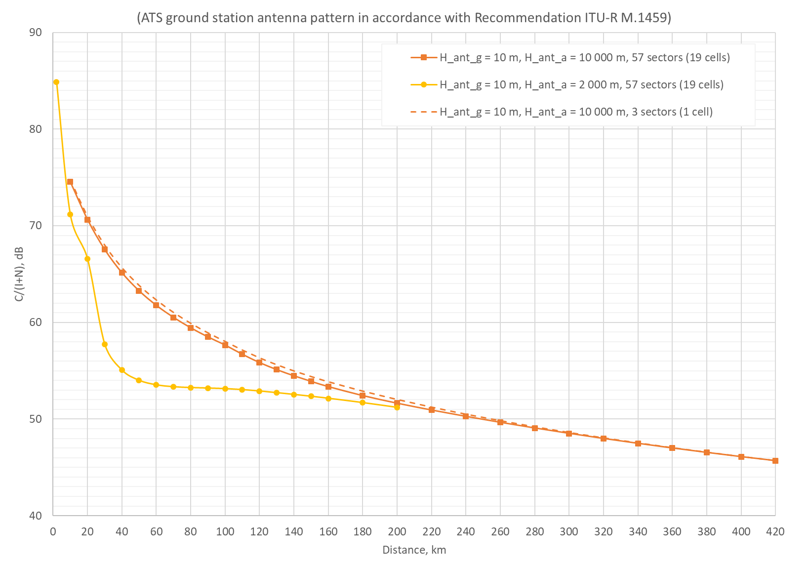
Figure 5: C/(I+N) dependence on distance between ATS and MFCN (ATS antenna acc. to ITU-R M.1459)
According to parameters provided, the transmission path length of the ATS system is up to 320 kilometres and the required C/N = 13 dB. From Figure 5, we can see that for the aircraft flying at a distance of 320 km from the receiver and operating with the maximum EIRP, the C/(I+N) is over 45 dB for the interferer of 1 base station and over 40 dB for the interfering network of 19 base stations. It means that there is a margin of 27-32 dB accordingly.
The results for the analysis based on I/N method are provided in the Figure 6.
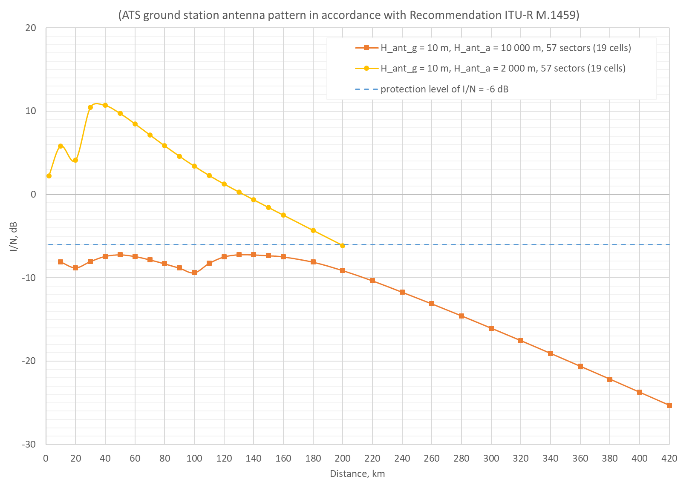
Figure 6: I/N dependence on distance between ATS and MFCN (ATS antenna acc. to ITU-R M.1459)
The results of interference from clustered network into ATS ground station using antenna pattern in accordance with Recommendation ITU-R M.1851 (see Annex 4) for the same calculation methods are provided in Figure 7, Figure 8 and Figure 9. The horizontal antenna pattern could be two types (more information on antenna pattern is provided in Annex 2), but the results are presented only for sin antenna distribution pattern type for horizontal antenna pattern as the difference using cos antenna distribution pattern type in the direction of main lobe is very small. This is because almost all interference is received by the main lobe of ATS ground station.
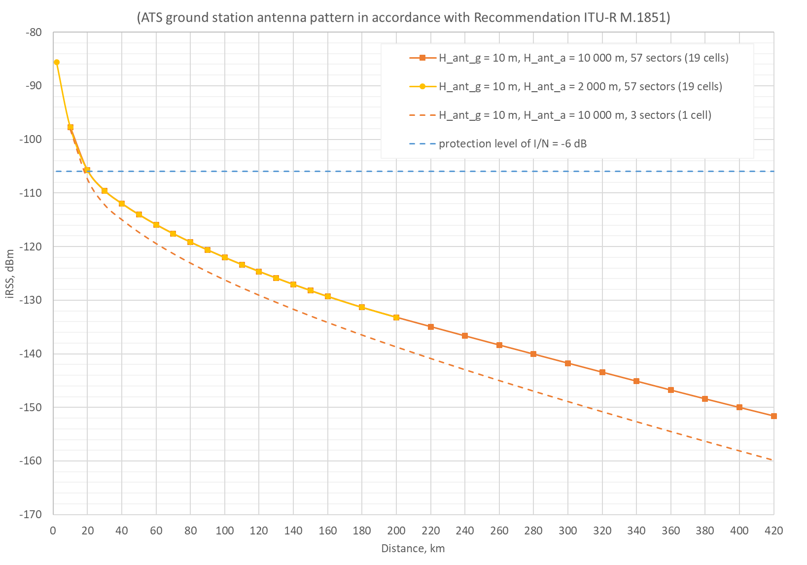
Figure 7: iRSS dependence on distance between ATS and MFCN (ATS antenna acc. to ITU-R M.1851)
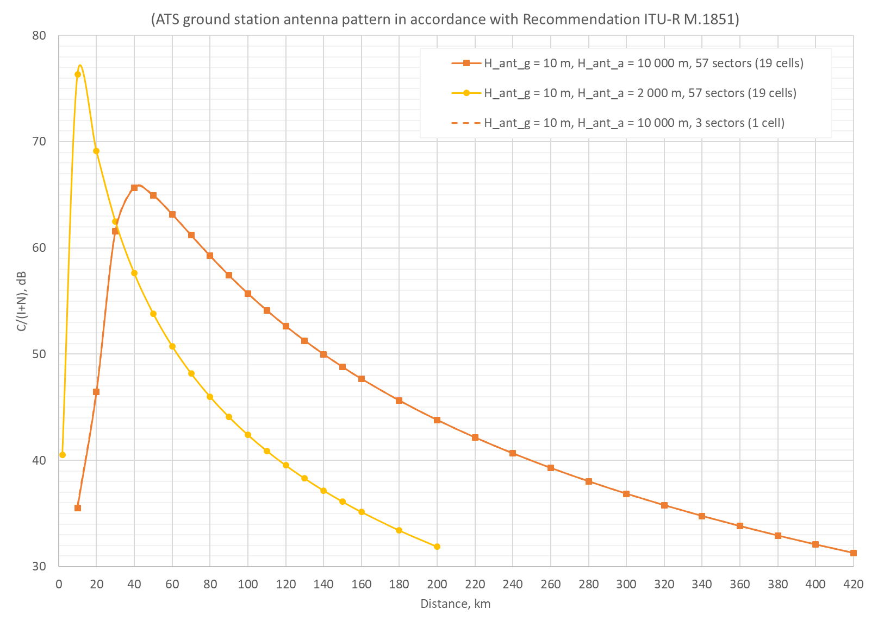
Figure 8: C/(I+N) dependence on distance between ATS and MFCN (ATS antenna acc. to ITU-R M.1851)
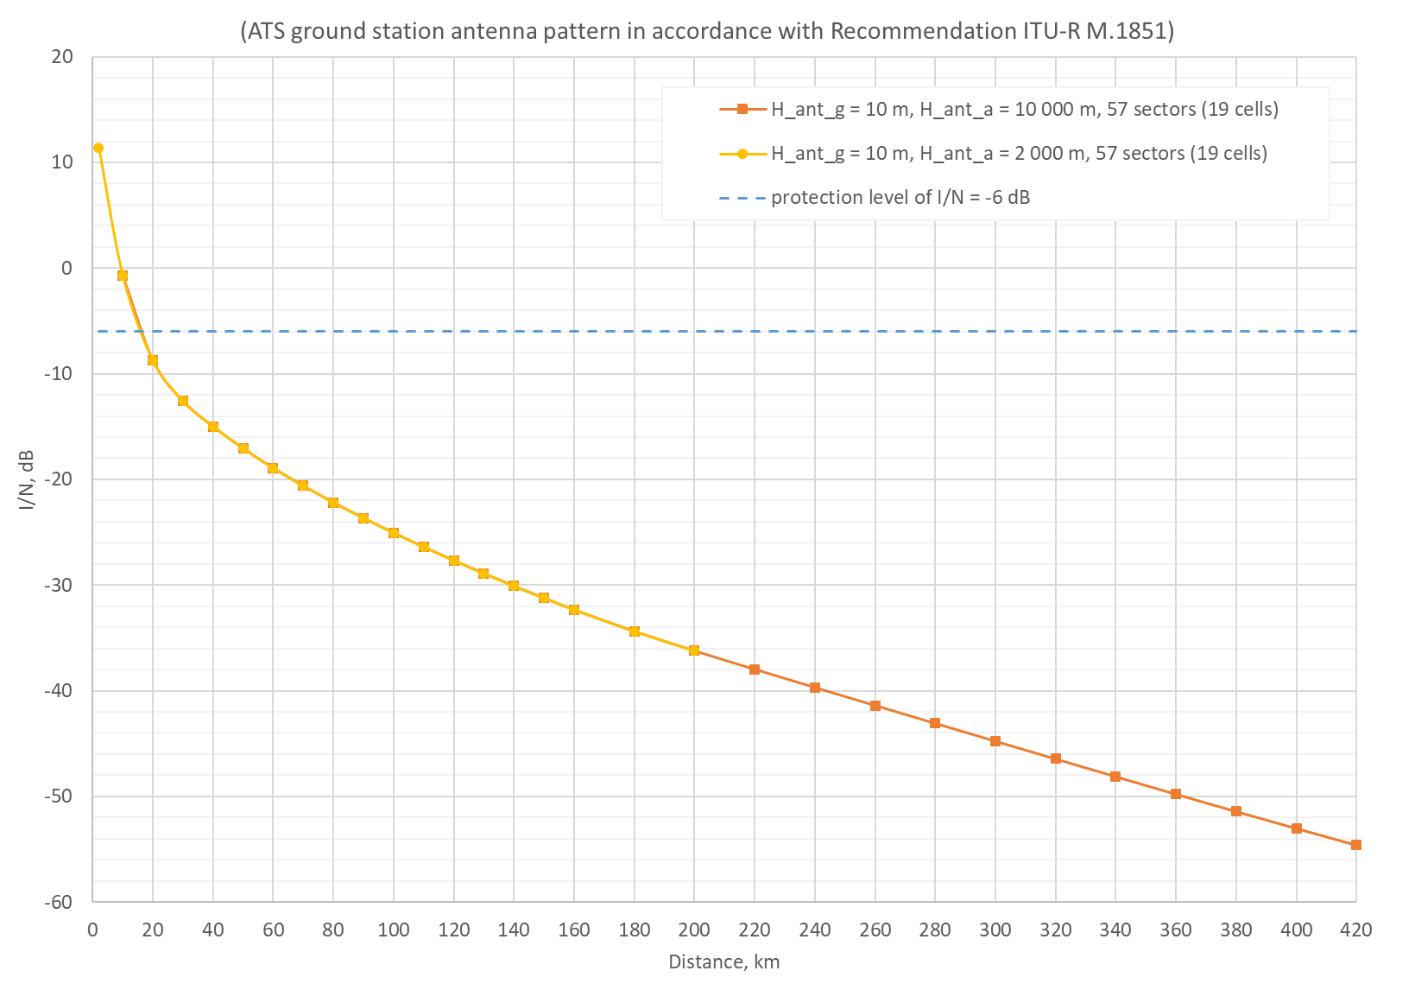
Figure 9: I/N dependence on distance between ATS and MFCN (ATS antenna acc. to ITU-R M.1851)
The results indicate that protection requirement I/N = −6 dB is not exceeded already at the distance around 15 km from the borderline when ATS ground receiver antenna height is 10 m.
  - Scenario 2 (parallel)
In this case the situation when ATS aircraft is flying alongside borderline is investigated. Additional five network clusters, as in scenario 1, are placed along the borderline. The interference from each of the network is calculated at ATS ground station location. ATS ground station distance from the borderline is 10 km, antenna height is 10 m, ATS aircraft station is 320 km from ATS ground station alongside the borderline, aircraft altitude is 10000 m.
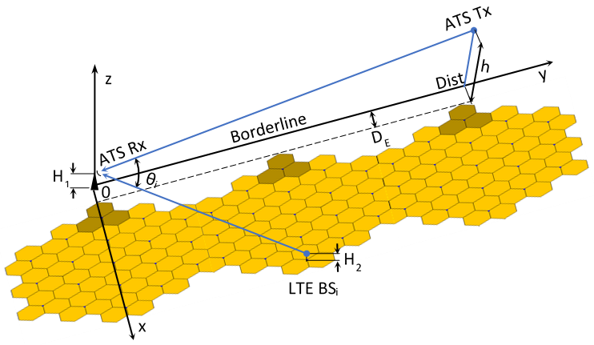
Figure 10: Aggregate interference from MFCN clusters (scenario 2)
The results from each clustered network and aggregated from all networks are provided in Table 6 for both type of ATS systems (radar-type antenna and tracking-type antenna).
Table 6: Interference levels for scenario 2
iRSS, dBm | Antenna pattern
 | M.1459 | M.1851_cos | M.1851_sinc
iRSS1 | −105.64 dBm | −118.13 dBm | −98.13 dBm
iRSS2 | −114.71 dBm | −138.18 dBm | −118.17 dBm
iRSS3 | −117.08 dBm | −154.31 dBm | −135.02 dBm
iRSS4 | −120.79 dBm | −158.74 dBm | −142.79 dBm
iRSS5 | −123.23 dBm | −161.17 dBm | −148.34 dBm
iRSS6 | −126.22 dBm | −161.42 dBm | −153.10 dBm
iRSS total | −104.66 dBm | −118.09 dBm | −98.09 dBm
It could be noted that for this type of scenario the highest interference is from the first network which is placed closest to the ATS. The results also indicate that protection requirement of I/N = −6 dB for ATS with antenna ITU-R M.1459 is exceeded only by 0.36 dB and for the ITU-R M.1851_sinc antenna type by 7.87 dB. But for the ITU-R M.1851_cos antenna type iRSS is below the protection requirement by 12.3 dB.

Surrounding network (ring) case
In addition to the above analysis there could be some cases when mobile networks could possibly surround ATS ground station therefore the ATS receiver could experience the interference not only from main lobe and side lobes but also from back lobes.
The previous calculations have been based on 2-tiers tri-sector 3GPP layout with the cell radius of a 4.75 km. The geographical separation of the victim receiver and interferer LTE network was modelled by specifying the modelled cellular cell as centred “infinite” network. This is illustrated in the Figure 11, where DE is ATS Rx distance from the network edge, DC is distance from hexagonal cluster centre, RC is cluster maximum range, and α is central (network visibility) angle. The ATS aircraft is considered to be above the edge of the network, i.e. at DE, this corresponds to the borderline.
Figure 11: Layout used in SEAMCAT simulation
It is obvious that in case of any surrounding network, interfering Received Signal Strength (iRSS) will depend on the BS arrangement inside the LTE cluster (especially in near distances, DE, from the cluster), therefore, and for getting the more even distribution of interfering BS over the cluster area, the LTE-C cluster was rotated around its centre and iRSS was calculated every 5 degrees. It is equivalent to the ATS antenna rotation around the cluster keeping the unchanging distance and antenna pointing direction to the cluster centre. A set of simulations were done using ATS Rx antenna (in accordance with Recommendations ITU-R M.1459 and M.1851) and aggregated iRSS were calculated. Then the averaged value of iRSS were evaluated for each antenna. It depends on the distance DE and aircraft altitude. The results of such simulations are presented in Annex 2.
Knowing the iRSS average from the LTE cluster we can estimate the interference of any surrounding network. This can be achieved by introducing the interfering angular power flux density of interfering network which directly follows from the calculated by means of SEAMCAT average value of the iRSS (see Annex 3).
Thus, having defined the power flux density value ρ, the whole interfering signal strength iRSS produced by a ring-shaped network of the width of 2RC in the range of ϕ varying from 0 to 360 degrees with one degree angle increment (Figure 12) can be calculated using equation
(3)
where G(φi,θi) denotes the linear antenna gain factor, and φi and θi are antenna pattern azimuth and elevation angles, respectively.
Figure 12: Effective ring-shaped LTE network
The results of interference from surrounding network when ATS ground station uses antenna patterns according to Recommendation ITU-R M.1459 (tracking-type antenna system) and Recommendation ITU-R M.1851 (radar-type antenna system) are provided in Table 7 when ATS ground receiver antenna height is 10 m and MFCN BS antenna height is 30 m. Three radii DE (10, 40 and 80 km) of surrounding networks are studied. This corresponds to the area of 314 km2, 5026 km2, 20106 km2 and could be compared to the territory of Riga city, twice as country of Luxembourg and Slovenia respectively, surrounded by MFCN.
Table 7: Interference from surrounding network
Antenna pattern | h, m | DE, km | ±φfront, deg | iRSSfront, dBm | iRSSback, dBm | Diff1, dB | iRSSring, dBm
tracking-type antenna system  (M.1459) | 2000 | 10 | 46 | −95.69 | −101.21 | 5.51 | −94.62
tracking-type antenna system  (M.1459) | 2000 | 40 | 47 | −90.95 | −108.62 | 17.67 | −90.88
tracking-type antenna system  (M.1459) | 2000 | 80 | 47 | −93.81 | −113.76 | 19.95 | −93.77
tracking-type antenna system  (M.1459) | 10000 | 10 | 19 | −109.25 | −100.57 | −8.67 | −100.02
tracking-type antenna system  (M.1459) | 10000 | 40 | 46 | −104.90 | −108.93 | 4.02 | −103.46
tracking-type antenna system  (M.1459) | 10000 | 80 | 47 | −105.82 | −113.78 | 7.96 | −105.18
radar-type antenna system  (M.1851_cos) | − | 10 | 22 | −108.00 | −112.22 | 4.22 | −106.60
radar-type antenna system  (M.1851_cos) | − | 40 | 22 | −117.84 | −121.88 | 4.05 | −116.39
radar-type antenna system  (M.1851_cos) | − | 80 | 22 | −123.05 | −127.00 | 3.95 | −121.58
radar-type antenna system  (M.1851_sinc) | − | 10 | 29 | −107.33 | −101.16 | −6.17 | −100.22
radar-type antenna system  (M.1851_sinc) | − | 40 | 29 | −115.57 | −109.35 | −6.22 | −108.42
radar-type antenna system  (M.1851_sinc) | − | 80 | 29 | −119.18 | −112.93 | −6.24 | −112.01
radar-type antenna system  (M.1851_cos), ant_downtilt_2 deg | − | 10 | 23 | −91.20 | −110.68 | 19.48 | −91.15
radar-type antenna system  (M.1851_cos), ant_downtilt_2 deg | − | 40 | 23 | −100.66 | −120.10 | 19.45 | −100.61
radar-type antenna system  (M.1851_cos), ant_downtilt_2 deg | − | 80 | 23 | −105.91 | −125.34 | 19.43 | −105.87
radar-type antenna system  (M.1851_sinc), ant_downtilt_2 deg | − | 10 | 29 | −90.94 | −92.59 | 1.66 | −88.68
radar-type antenna system  (M.1851_sinc), ant_downtilt_2 deg | − | 40 | 29 | −100.04 | −101.68 | 1.63 | −97.77
radar-type antenna system  (M.1851_sinc), ant_downtilt_2 deg | − | 80 | 29 | −105.01 | −106.63 | 1.62 | −102.74
radar-type antenna system  (M.1851_cos), ant_downtilt_5 deg | − | 10 | 23 | −83.43 | −110.35 | 26.91 | −83.43
radar-type antenna system  (M.1851_cos), ant_downtilt_5 deg | − | 40 | 23 | −92.81 | 119.71 | 26.90 | −92.80
radar-type antenna system  (M.1851_cos), ant_downtilt_5 deg | − | 80 | 23 | −98.06 | −124.95 | 26.89 | −98.05
radar-type antenna system  (M.1851_sinc), ant_downtilt 5 deg | − | 10 | 29 | −83.21 | −91.03 | 7.82 | −82.54
radar-type antenna system  (M.1851_sinc), ant_downtilt 5 deg | − | 40 | 29 | −92.46 | −100.27 | 7.81 | −91.79
radar-type antenna system  (M.1851_sinc), ant_downtilt 5 deg | − | 80 | 29 | −97.61 | −105.41 | 7.80 | −96.94
Where h is ATS aircraft altitude, φfront is antenna pattern angle covering main lobe and side lobes, iRSSfront is received interference level for φfront, iRSSback is received interference level for the rest of antenna pattern, Diff1 is the difference between interference level of iRSSfront and iRSSback, iRSSring is overall interference level from ring type network.
From the Table 7 it is observed that for tracking-type antenna ATS system (i.e. ITU-R M.1459 antenna pattern) when surrounding network radius, DE, is 10 km and altitude of aircraft is 10000 m and also for radar-type antenna system with sinc antenna distribution pattern type for horizontal antenna pattern the main interference is received by back lobes of ATS antenna. For all other cases in the Table 7 the main interference is received by main lobe and side lobes of ATS antenna and the interference from back lobes is lower from 4 dB up to 20 dB. For the radar-type antenna system antenna if antenna is downtilted by 2 degrees the interference will increase.
The comparison of ring-type network results with the clustered network case (scenario 1) is provided in Table 8.
Since for the clustered network case simulations were performed when the nearest base station (reference cell) one of three sectors was looking directly to ATS, therefore to compare the results with ring type network we need to look at the averaged value of iRSS for clustered network at these three radii DE under investigation. The values for iRSSring, iRSSfront, iRSSback and Diff1 from Table 7 are also included in Table 8.
Table 8: Comparison of clustered network and ring network interference
ATS type | h, m | DE, km | iRSSclust_max, dBm | iRSSclust_av, dBm | iRSSring, dBm | iRSSfront, dBm | iRSSback, dBm
tracking-type antenna system  (M.1459) | 2000 | 10 | −91.98 | −96.13 | −94.62 | −95.69 | −101.21
tracking-type antenna system  (M.1459) | 2000 | 40 | −86.29 | −91.05 | −90.88 | −90.95 | −108.62
tracking-type antenna system  (M.1459) | 2000 | 80 | −91.13 | −93.94 | −93.77 | −93.81 | −113.76
tracking-type antenna system  (M.1459) | 10000 | 10 | −105.07 | −107.47 | −100.02 | −109.25 | −100.58
tracking-type antenna system  (M.1459) | 10000 | 40 | −104.39 | −106.13 | −103.46 | −104.91 | −108.93
tracking-type antenna system  (M.1459) | 10000 | 80 | −105.29 | −107.04 | −105.18 | −105.82 | −113.78
radar-type antenna system  (M.1851_cos) | − | 10 | −97.75 | −107.95 | −106.60 | −108.00 | −112.22
radar-type antenna system  (M.1851_cos) | − | 40 | −112.11 | −117.95 | −116.39 | −117.84 | −121.88
radar-type antenna system  (M.1851_cos) | − | 80 | −119.38 | −123.36 | −121.58 | −123.05 | −127.00
radar-type antenna system  (M.1851_sinc) | − | 10 | −97.72 | −107.29 | −100.22 | −108.37 | −100.94
radar-type antenna system  (M.1851_sinc) | − | 40 | −111.97 | −117.44 | −108.42 | −116.62 | −109.13
radar-type antenna system  (M.1851_sinc) | − | 80 | −119.16 | −122.97 | −112.01 | −120.24 | −112.72
radar-type antenna system  (M.1851_cos), ant_downtilt_2 deg | − | 10 | −81.14 | −91.21 | −91.15 | −91.20 | −110.68
radar-type antenna system  (M.1851_cos), ant_downtilt_2 deg | − | 40 | −94.83 | −100.68 | −100.61 | −100.66 | −120.10
radar-type antenna system  (M.1851_cos), ant_downtilt_2 deg | − | 80 | −101.95 | −105.96 | −105.87 | −105.91 | −125.34
radar-type antenna system  (M.1851_sinc), ant_downtilt_2 deg | − | 10 | −81.14 | −90.97 | −88.68 | −90.94 | −92.59
radar-type antenna system  (M.1851_sinc), ant_downtilt_2 deg | − | 40 | −94.77 | −100.40 | −97.77 | −100.04 | −101.68
radar-type antenna system  (M.1851_sinc), ant_downtilt_2 deg | − | 80 | −101.81 | −105.69 | −102.74 | −105.01 | −106.63
radar-type antenna system  (M.1851_cos), ant_downtilt_5 deg | − | 10 | −73.40 | −83.44 | −83.43 | −83.43 | −110.35
radar-type antenna system  (M.1851_cos), ant_downtilt_5 deg | − | 40 | −87.00 | −92.82 | −92.80 | −92.81 | −119.71
radar-type antenna system  (M.1851_cos), ant_downtilt_5 deg | − | 80 | −94.10 | −98.09 | −98.05 | −98.06 | −124.95
radar-type antenna system  (M.1851_sinc), ant_downtilt_5 deg | − | 10 | −73.39 | −83.23 | −82.54 | −83.21 | −91.03
radar-type antenna system  (M.1851_sinc), ant_downtilt_5 deg | − | 40 | −86.94 | −92.57 | −91.79 | −92.46 | −100.27
radar-type antenna system  (M.1851_sinc), ant_downtilt_5 deg | − | 80 | −93.96 | −97.83 | −96.94 | −97.61 | −105.41
Where iRSSclust_max is maximum interference level from clustered network, iRSSclust_av is average interference level from clustered network, Diff2 is the difference between iRSSclust_av and iRSSring.
From the Table 8 we can see that the interference from surrounding network is higher by 0.17-10.96 dB. It should be highlighted that at the same time the protection requirement of I/N = −6 dB for radar-type antenna systems (both antenna distribution pattern types for horizontal antenna pattern) is not exceeded.

Additional investigation for Scenario 1 (perpendicular)
Additional analyses of some parameters of MFCN which could change interference level were carried out regarding:
- MFCN system layout (i.e. network size) - 1 cluster (19 cells / 57 sectors) and 12 clusters (12×19 cells / 684 sectors), such networks would cover an area of 4536 km2 and 54437 km2 accordingly, see Figure 13 and Figure 14;
- Base station antenna height increase from 30 m to 60 m and increase antenna downtilt from 3 degrees to 6 degrees, see Figure 15 and Figure 16;
- Propagation models - in accordance with ITU-R Recommendation P.528 with 10 percent time probability and in accordance with ITU-R Recommendation P.525, see Figure 17 and Figure 18.
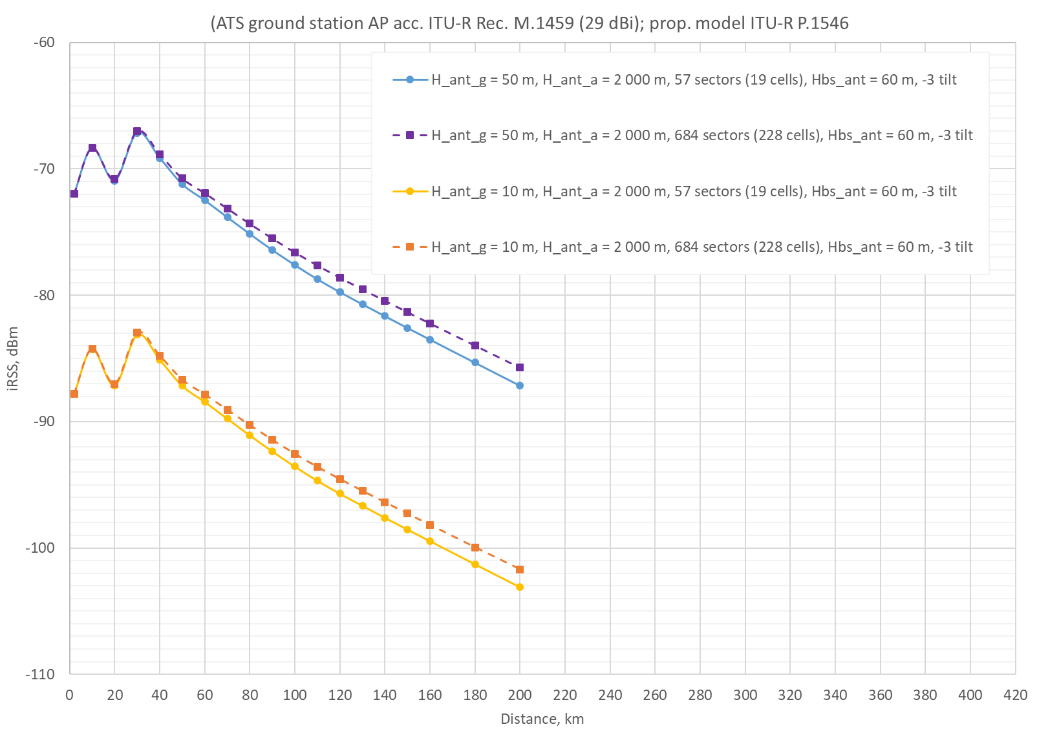
Figure 13: iRSS at ATS location for 1 and 12 MFCN clusters (ATS AP acc. to ITU-R M.1459, aircraft altitude 2000 m)
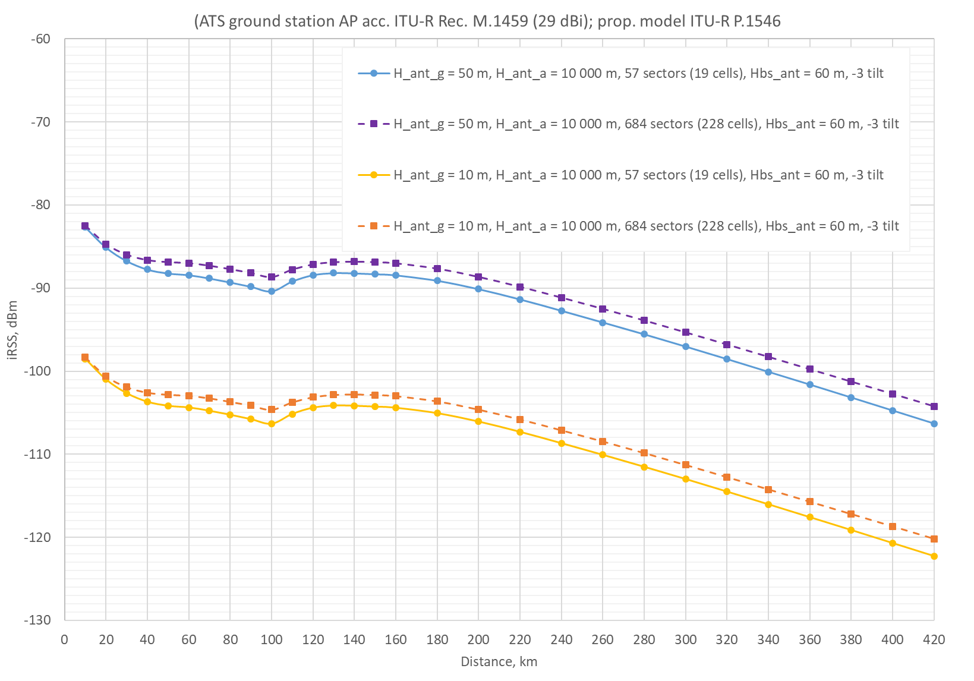
Figure 14: iRSS at ATS location for 1 and 12 MFCN clusters (ATS AP acc. to ITU-R M.1459, aircraft altitude 10000 m)
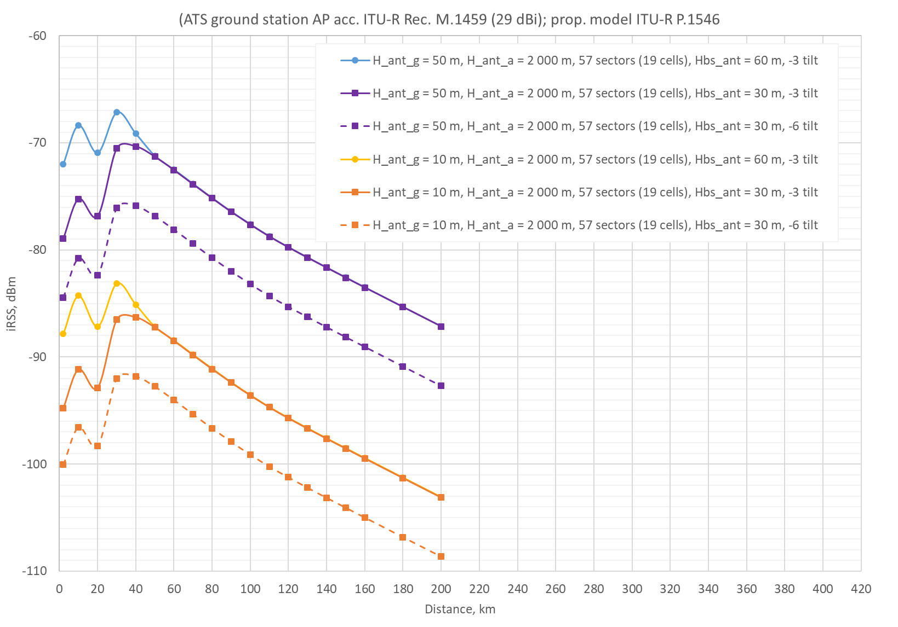
Figure 15: iRSS at ATS location for 1 MFCN cluster with antenna downtilt of 3 and 6 degrees and antenna height of 30 m and 60 m (ATS AP acc. to ITU-R M.1459, aircraft altitude 2000 m)
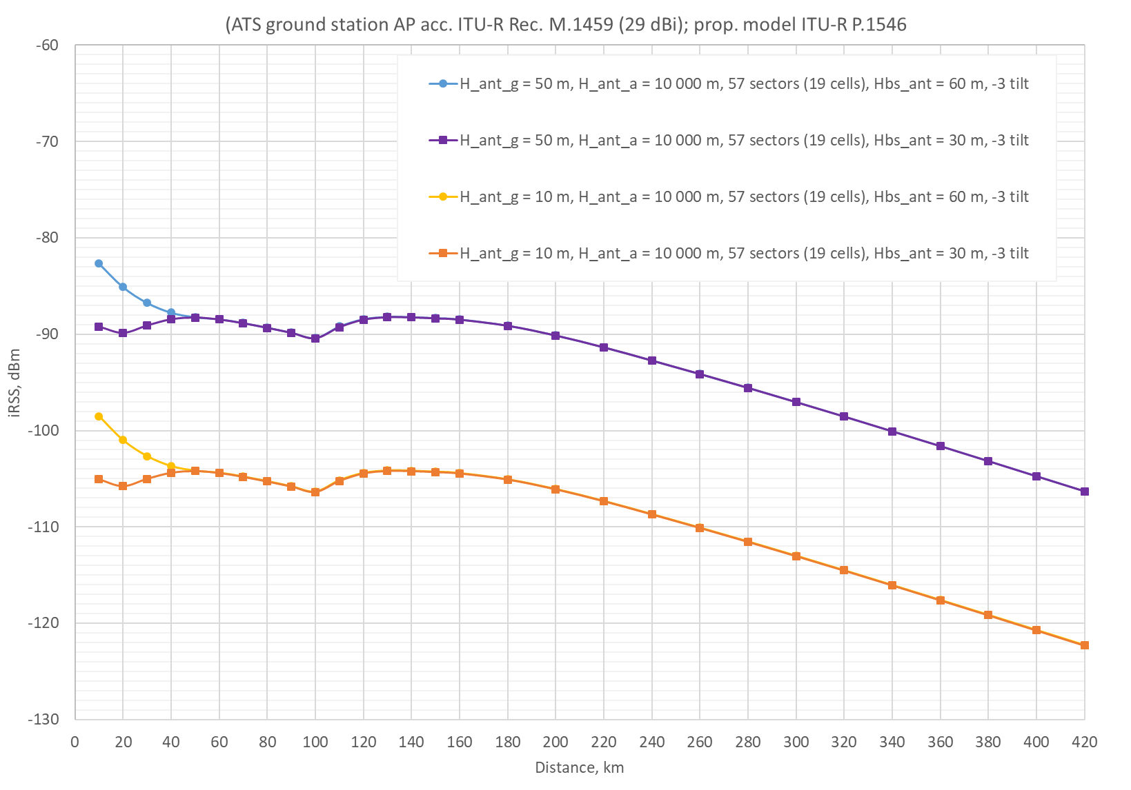
Figure 16: iRSS at ATS location for 1 MFCN cluster with antenna downtilt of 3 and 6 degrees and antenna height of 30 m and 60 m (ATS AP acc. to ITU-R M.1459, aircraft altitude 10000 m)
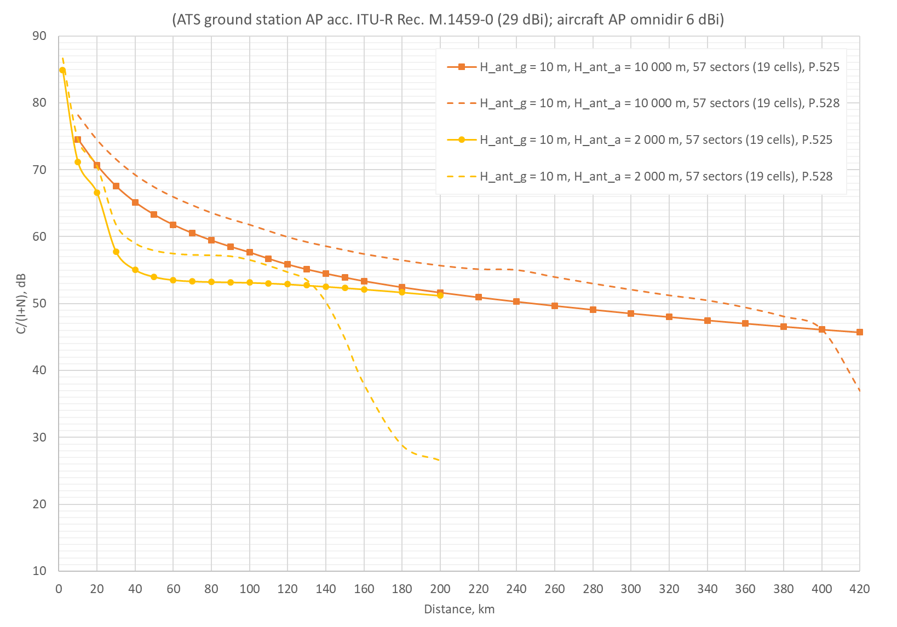
Figure 17: C/(I+N) at ATS location for 1 MFCN cluster with antenna height of 30 m and downtilt of 3 degrees (ATS AP acc. to ITU-R M.1459) and propagation model acc. to ITU-R P.525 and P.528 for signal C
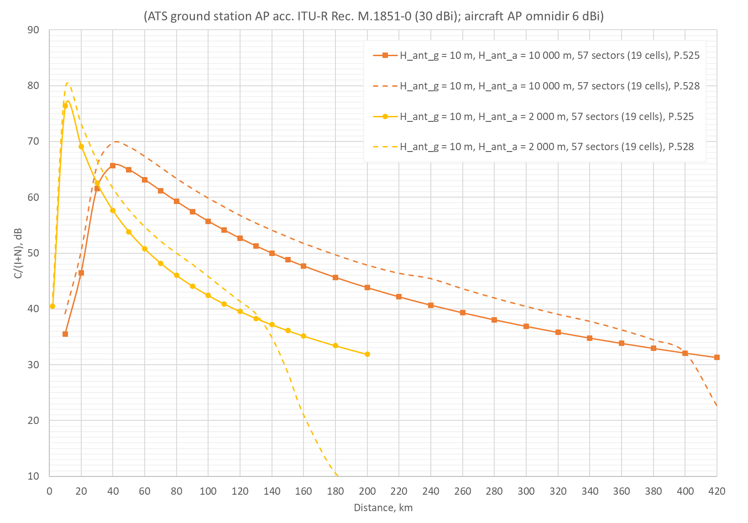
Figure 18: C/(I+N) at ATS location for 1 MFCN cluster with antenna height of 30 m and downtilt of 3 degrees (ATS AP acc. to ITU-R M.1851) and propagation model acc. to ITU-R P.525 and P.528 for signal C

Example of ATS in Kaliningrad region
For the example presented below, an assumption was made that SDL in the frequency band 1427-1518 MHz will be deployed in the same sites of the base stations in the 800 MHz frequency band. This deterministic analysis is based on real mobile network deployment in the 800 MHz frequency band in the Republic of Lithuania. 3959 sectors have been used with all parameters currently in operation, only the frequency was changed to 1482 MHz to represent the L-band situation. The nearest ATS station (located 70 km and away from the border with Lithuania), registered in MIFR is in the Kaliningrad enclave. The antenna height of 50 m is provided for this station (site name Kaliningrad, location 020°24'00" E 54°46'00" N). We will calculate the electric field strength level both on the location of the ATS ground station and on the borderline. The propagation model is according to Recommendation ITU-R P.1546-5 with the probability of 10% of time and 50% of location. SRTM3 terrain data was used.
For the aggregate interference analysis, an area with a radius of 250 km around the ATS station was investigated. The picture below shows the situation of the locations of the ATS ground station, the mobile network base stations and the points on the borderline.
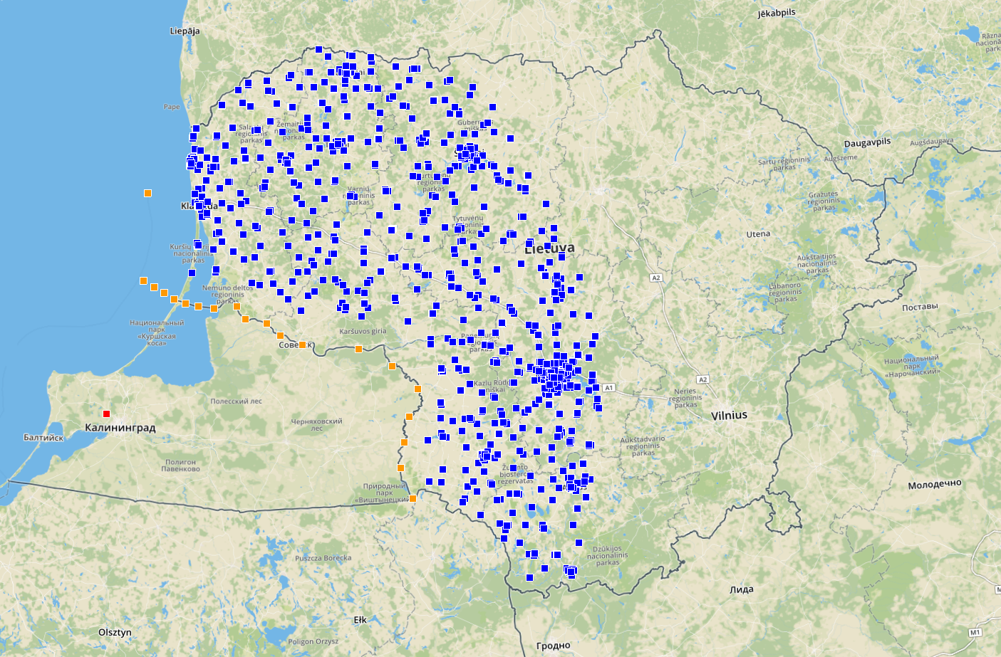
Figure 19: ATS ground receiver and mobile network base stations geographical arrangement
Since the ATS ground station is rotating in the horizontal plane, the azimuths from 10 degrees to 105 degrees (with a step of 5 degrees) were studied. The ATS on-board transmitter is placed on the borderline at the height of 10000 m and 2000 m. For tracking-type ATS system the ATS ground receiver antenna is always pointing to the on-board transmitter and antenna pattern is in accordance with Recommendation ITU-R M.1459. For radar-type ATS system antenna pattern is in accordance with Recommendation ITU-R M.1851.
Taking into account the average feeder losses (3 dB) the results of I/N and C/(I+N) are provided in Figure 20 and Figure 21.

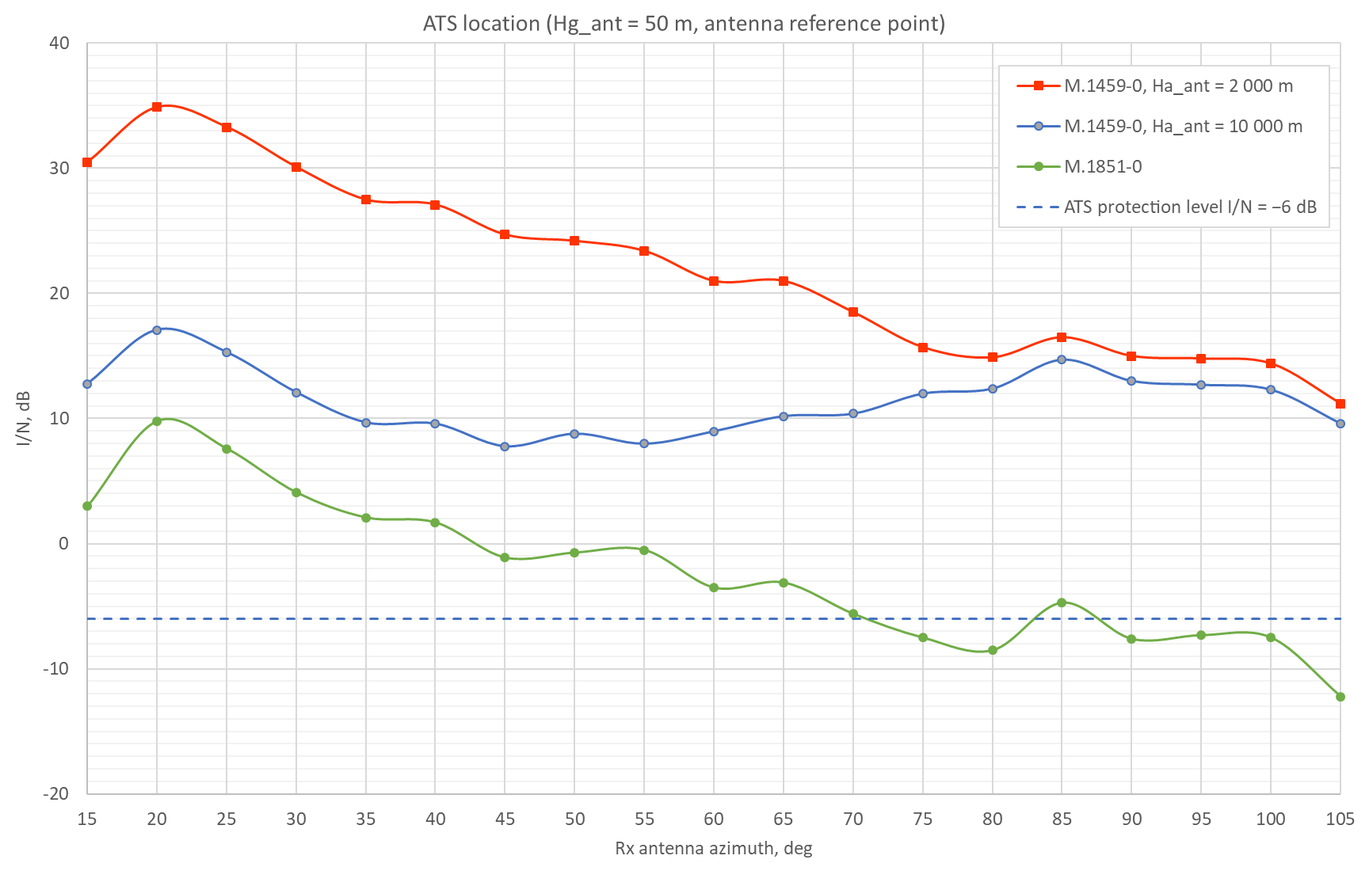
Figure 20: I/N of ATS ground receiver’s reference point with the Lithuanian mobile network as interferer at ATS location dependences on receiver antenna azimuth
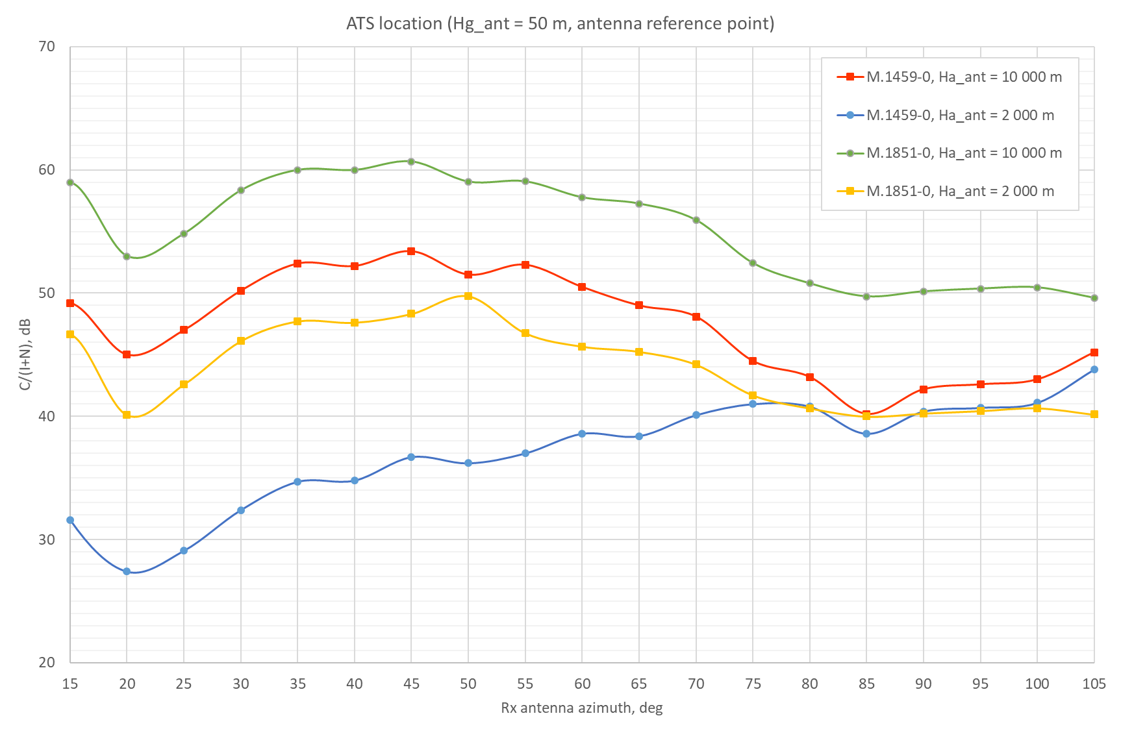
Figure 21: C/(I+N) of ATS ground receiver’s reference point with the Lithuanian mobile network as interferer at ATS location dependences on receiver antenna azimuth
According to analysis by method I/N (Figure 20) we can see that interfering signal should be reduced by more than 20 dB in order satisfy the protection requirement I/N = −6 dB.
According to analysis by method C/(I+N) (Figure 21) we can see that protection criteria is satisfied with excess from 15 dB up to 40 dB.
The electric field strength level on the borderline for an isotropic antenna of 10 m height was also calculated for each azimuth under consideration and is provided in Figure 22 where flat Earth option was also included for comparison.
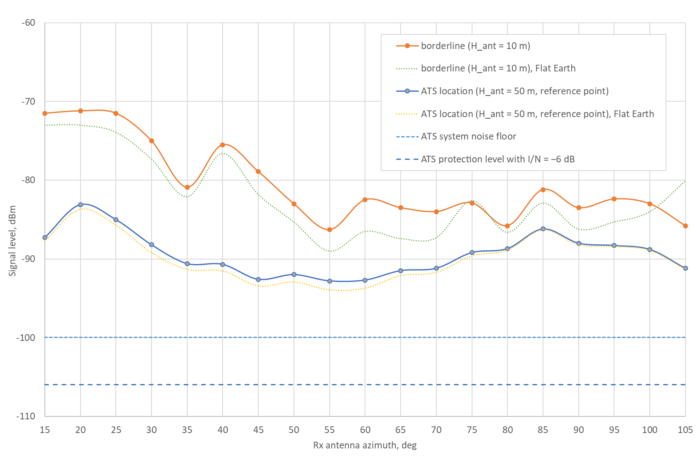
Figure 22: Interfering received signal level at the ATS station for different receiver directional antenna azimuth values and at the borderline
Additionally, the received signal level on the borderline from the Lithuanian mobile network as provided in the Figure 22 and interference levels at ATS ground station from Figure 20 are converted to field strength level and are provided in the Figure 23.
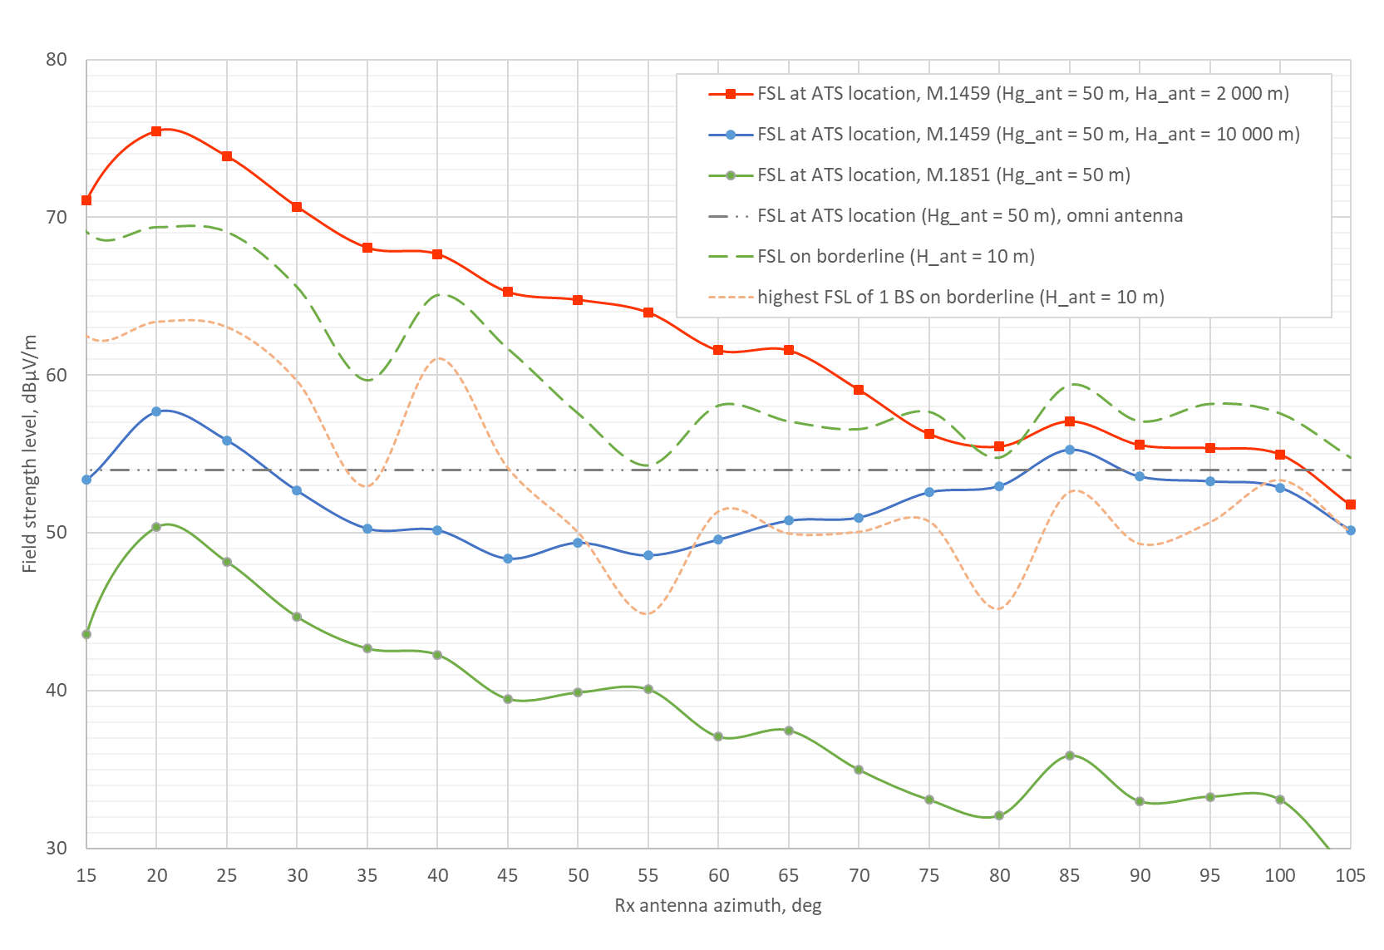
Figure 23: Field strength level at ATS location from the Lithuanian mobile network
The interfering field strength level from mobile network using ATS ground station antenna according to Recommendation ITU-R M.1851 is lower by 15-20 dB than using antenna pattern according to Recommendation ITU-R M.1459. The aggregate field strength level produced by the mobile network is on average 7 dB higher comparing to 1 base station.
Moreover, in order to compare the results for the case of Lithuanian mobile network as interferer and ATS station with 50 m antenna height as a victim with the simulations in Section 7.1 the cases with different distances (from 90 km to 160 km) between systems were also investigated for tracking-type ATS system. The results are provided in Figure 24.
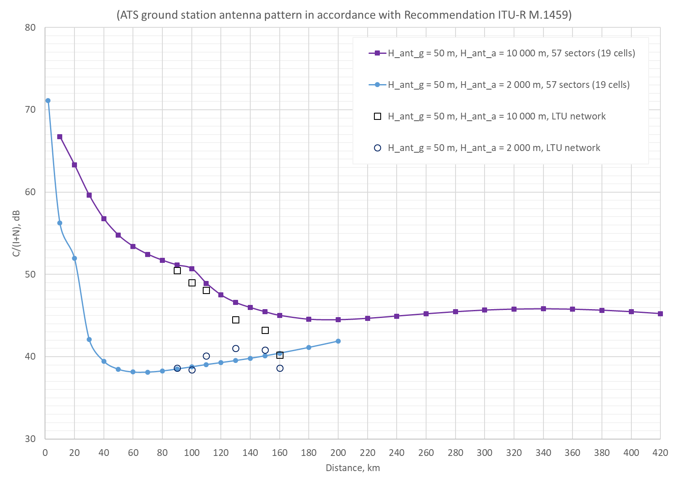
Figure 24: Comparison of network cluster case (scenario 1) and Lithuanian network
Analysis showed that similar tendency of C/(I+N), as for the case of multiple base stations scenario presented in Figure 2, is observed (for ATS ground station antenna height of 50 m). These results for this case, under the assumptions provided in this section, indicate that C/(I+N) ratio of ATS station increase when station is located closer to the borderline which shows that in this case there is no need to change any LTU mobile network parameters in order to protect the ATS station in Kaliningrad.
It is also possible that the neighbouring country mobile networks could have aggregate interference effect into ATS station, therefore additionally POL mobile network was included into this analysis. POL network was also based on real 800 MHz network sites and BS parameters. For the aggregate interference analysis, an area with a radius of 200 km around the ATS station was investigated, this accounts for around 7000 sectors. The Figure below shows the overall situation. The calculation parameters in the analysis were the same as for LTU network case.
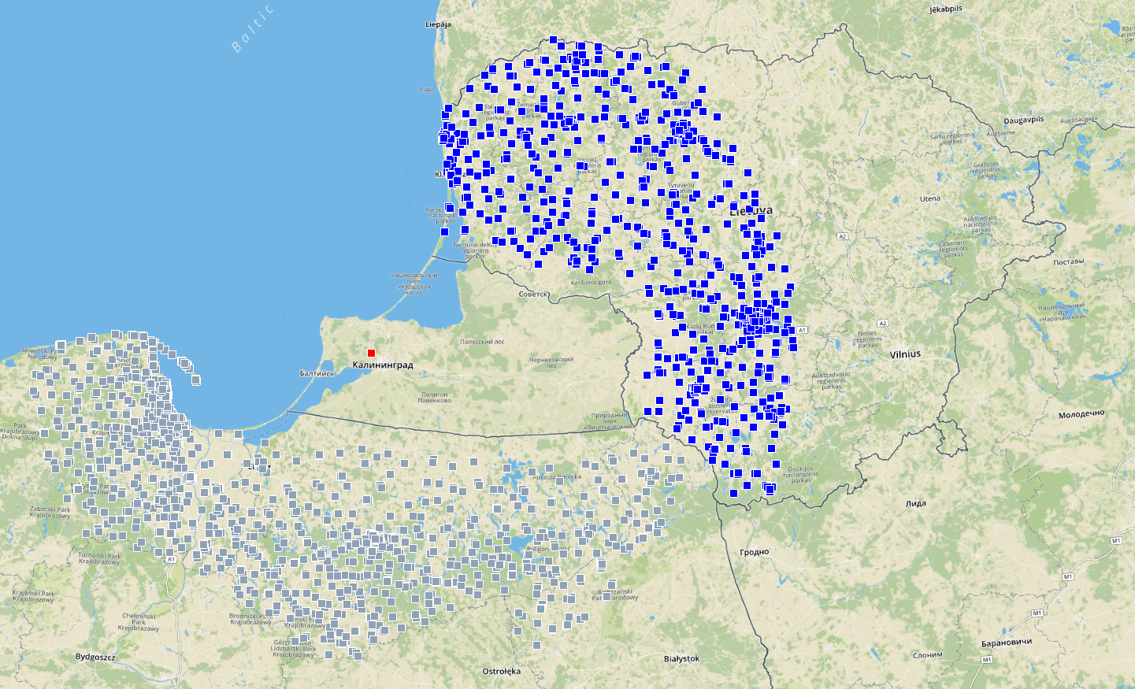
Figure 25: ATS ground receiver and multiple mobile network base stations geographical arrangement
The results are provided in Figures below.
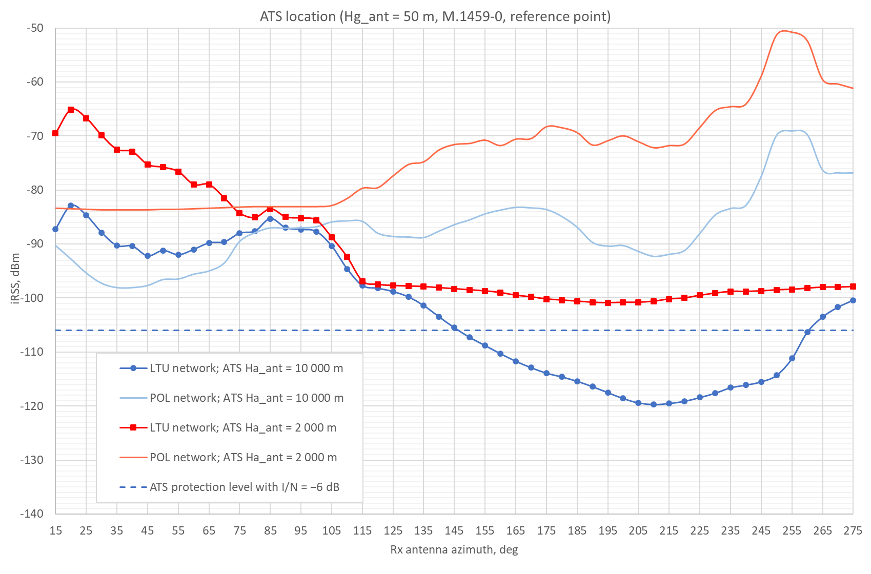
Figure 26: Interference level from LTU and POL MFCNs at ATS location
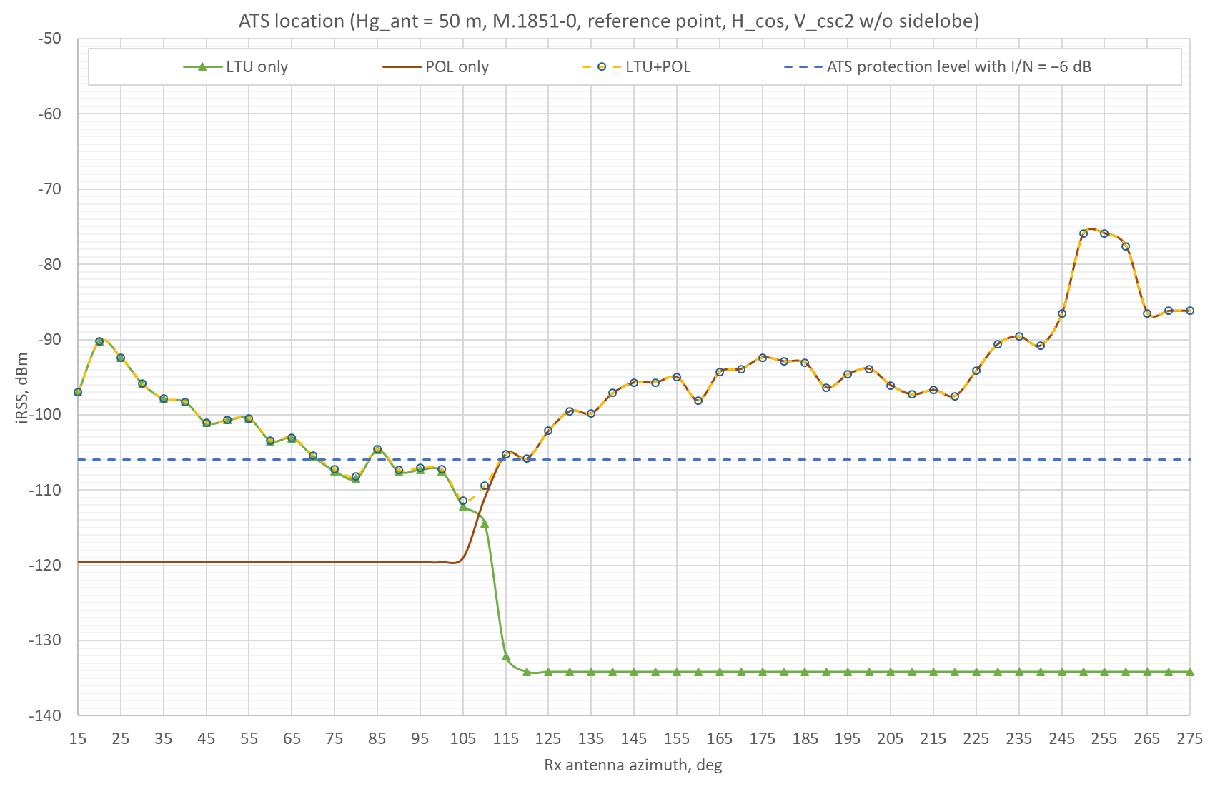
Figure 27: Interference level from LTU and POL MFCNs at ATS location
This clearly shows that interference from multiple networks in Kaliningrad case for ground ATS station could be considered separately.

General procedure for field strength calculation on the borderline using I/N or C/(I+N) methods in order to eliminate harmful interference
This methodology describes multistep approach how to evaluate and eliminate real interference. These steps include calculations, measurement and adjustment of mobile network parameters, if needed. An example of UKR-POL case on BWA-MFCN is provided in Annex 2.
Protection criterion by method I/N or C/(I+N) at ATS ground station location from the BSs MFCN could be recalculated at the borderline if agreed by concerned parties.
Due to random nature of MFCN network interference and rotation of ATS stations antenna the following steps could be used:
- Points of calculation / monitoring of field strength level (FSL) are replaced from the location of ATS station location to the borderline. Figure 28 below shows the need to transfer the test point for the calculation / monitoring to borderline.
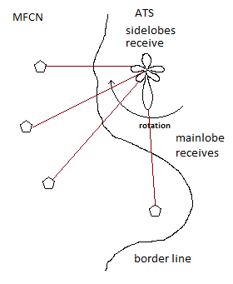
Figure 28: Example of MFCN interference to the ATS receiver close to the borderline
- a test points are determined on the borderline according following the item A4.1;
- all sectors and all frequency channels of MFCN BSs, which are covered by the characteristics of the ATS receiver and radiate in the direction of the test points are involved in calculations. To determine the MFCN BSs the methodology given in item A4.2 could be used for calculations;
- aggregated FSL is calculated at each test point and compared with the permissible (threshold) values of the interference FSL at the reference point of the ATS;
- based on the results of calculations, the adjustment measures to parameters for the individual MFCN BSs are determined, if needed. Examples of such measures which could be applied are listed:
- switching-off the sector;
- changing of the antenna tilt;
- changing of the direction of maximum radiation of the sector antenna;
- reduction of radiation power;
- decreasing of the height of the sector antenna deployment;
- changing the frequency channel.
- After adjustment measures are applied the party using ATS could perform measurements.

Field strength measurement procedure

Common provisions
- Field strength measurements can be carried out on a regular basis or in the event of harmful interference. Administrations (Regulatory Authorities) shall perform measurements in order to verify the agreed level of permissible interferences. The measurements should be performed in accordance with the procedure of measurements given in CEPT/ERC Recommendation 74-02 E (Bucharest 1999).
- In case aggregated FSL of MFCN BSs exceeds the threshold level, an analysis of the highest interfering BSs sectors with their identification should be conducted.
- Due to the threshold level of the MFCN BSs signal to be measured, the general measurement methodology consists of such stages:
  - Search for the maximum aggregated MFCN signal (channel power) with the directional antenna and spectrum analyser / certified measurement equipment;
  - Measure the aggregated level of channel power in already identified directions;
  - Identify the MFCN BSs sectors and measure power of the individual signal level (channel power).
- Measurements of interference level are carried out at the test points on the borderline or, if measurements at the test points cannot be carried out due to practical reasons (e.g. the test point is not accessible), at a point as close as possible to the test point on the borderline.

Requirements to the monitoring equipment
Recommended set of equipment:
- hardware (HD): spectrum analyser + scanner (digital receiver + processor);
- software (SW).
Recommended requirements for monitoring equipment:
- sensitivity – not worse than ATS receiver sensitivity for the reference bandwidth + protection criteria;
- nonconformity of measured level (with S/N ratio more than 16 dB) – not higher than 1 dB;
- reference frequency stability 1×10–6 per 1 year;
- possibility to identify MFCN network, individual BS and sectors of the BS.
Antenna equipment parameters:
- antenna mast up to 10 m height;
- calibrated cable with losses not higher than 3 dB/10 m;
- directional antenna with a determined antenna factor at MFCN BSs frequencies is recommended.
Calculation of an average field strength value (Emeas av, dBµV/m), for n measurements of Еmeas і:
dBµV/m (4).

Information to be provided by the affected Administration in case of harmful interference
- Name of the point of measurements
- Coordinates of the test point (DDNMM'SS" DDEMM'SS")
- Height of the point of measurements above sea level (m)
- Date of measurements
- Azimuth of measurement antenna (degrees)
- Polarization (degrees)
- Antenna factor (dB/m)
- Total attenuation (dB)
- Channel width (MHz)
- Central frequency (carrier) of MFCN BS sector channel (MHz)
- Measured channel power (dBm)
- Field strength (dBµV/m)
- Information which can be useful for affecting and affected sides for investigation of the harmful interference cease:
- identifier (MCC, MNC, CID, PN): MCC - country code; MNC - operator code; CID -base station identifier; PN - sector code.

Assessment of interference from MFCN at the borderline
To estimate the possibility to recalculate the field strength level (FSL) at the borderline the data from the MIFR for frequency assignments to ATS stations of Ukraine were extracted as an example. Under the assumption that agreed between concerned parties permissible FSL is 30 dBμV/m at ATS location the FSL at the nearest point at the borderline was recalculated using Recommendation ITU-R P.1546-5 (10% time, 50% locations) and results are provided in Table 9.
Table 9: Example of some ATS stations in Ukraine and distance from them to neighbouring countries
Site name | Location | Administration | Minimum distance to borderline, km | Maximum distance to borderline*, km | FSL recalculated to nearest point at borderline, dBμV/m / 5 MHz / 10 m
BALTA | 029°36'00" E - 47°56'00" N | MDA | 24 | 293 | 40.5
BOLHRAD | 028°40'00" E - 45°40'00" N | MDA | 9 | 338 | 34.7
BOLHRAD | 028°40'00" E - 45°40'00" N | ROU | 37 | 509 | 44.1
CHERNIVTSI | 025°58'00" E - 48°15'00" N | ROU | 27 | 230 | 41.4
CHERNIVTSI | 025°58'00" E - 48°15'00" N | MDA | 48 | 439 | 46.5
LYMANSKE | 030°01'00" E - 46°40'00" N | MDA | 4 | 310 | 32.2
NOVOVOLYNSK | 024°11'00" E - 50°41'00" N | POL | 7 | 212 | 34.7
RAKHIV | 024°11'00" E - 48°03'00" N | ROU | 14 | 604 | 36.8
STARYI SAMBIR | 022°59'00" E - 49°26'00" N | POL | 18 | 235 | 38.4
STARYI SAMBIR | 022°59'00" E - 49°26'00" N | SVK | 48 | 130 | 46.5
UZHHOROD | 022°15'00" E - 48°38'00" N | POL | 54 | 337 | 47.6
UZHHOROD | 022°15'00" E - 48°38'00" N | SVK | 1 | 57 | 30.4
UZHHOROD | 022°15'00" E - 48°38'00" N | HNG | 23 | 89 | 43.1
VYNOHRADIV | 023°02'00" E - 48°10'00" N | HNG | 16 | 70 | 38
VYNOHRADIV | 023°02'00" E - 48°10'00" N | ROU | 11 | 604 | 35
ZABOLOTNE | 024°15'00" E - 51°38'00" N | POL | 42 | 307 | 45.2
* Maximum distance to the last point of common borderline

Conclusions
The refined operational and technical characteristics of ATS stations indicate the similarity of ground and on-board equipment. This allows accept the reference criterion for the protection of ground equipment.
According to the RR No. 5.342 the ATS service area is restricted by the national territory only. This allows to consider the impact of MFCN BSs to the ATS station on the side and back lobes of the ATS station antenna as the main scenario. Consequently, there is an opportunity to relax the requirements for the maximum permissible interference field strength level at the antenna input of the ATS station.
Due to random nature of the MFCN interference and due to the rotation of the antenna of the ATS station the measurements conducting at the locations of ATS stations could be complicated or even impossible. In order to reduce the uncertainty in results it was proposed to transfer the calculations and measurements places from ATS positions to the test points at the borderline.
Based on a practical interference case between POL-UKR for UMTS-BWA the methodology for aggregated interference calculation/measurements was presented.
In order to provide the protection to ATS station the field strength level in some cases could be calculated at the location of ATS station.
Methods I/N or C/(I+N) could be considered for the evaluation of interference from MFCN BSs to ATS stations. In case of C/(I+N) method a proper attention should be drawn to margin of wanted signal from aircraft in order to account signal losses related with aircraft maneuverer, propagation conditions, etc.
In case of possible aggregate interference from more than one neighbouring country all concerned parties have to conduct a work to minimize possible harmful interference. In this case it is recommended that all affected countries take all necessary measures to avoid harmful interference while providing possibility to use the frequency band for other countries with less possible restrictions.
Calculations shows, that for some cases, surrounding MFCN could increase interference level to ATS station up to 4 dB and for topology of the MFCN located along the borderline (5 clustered networks) would increase the interference level up to 1.2 dB.
The example for Kaliningrad using both methods was investigated together with general simulations using SEAMCAT. Impact of topology and configuration of MFCN network, antenna positioning and height, and propagation model was investigated.
Possible technical measures to eliminate harmful interference from MFCN to ATS stations were considered.
The example of draft template for coordination Agreement is provided in the Annex 5.
- antenna patterns
  - Antenna pattern of Recommendation ITU-R M.1459
For the case when ATS ground station works only on receiving data from the tested aircraft by slow tracking the movement of the aircraft as mentioned in Section 2.1 it was proposed to use antenna pattern according to Recommendation ITU-R M.1459-0.
The ATS ground receiver antenna pattern of Recommendation ITU-R M.1459 (Annex 1, paragraph 1, antenna gain 29 dBi, equations 1a-1f) is provided in Figure 29, Figure 30 and Figure 31.
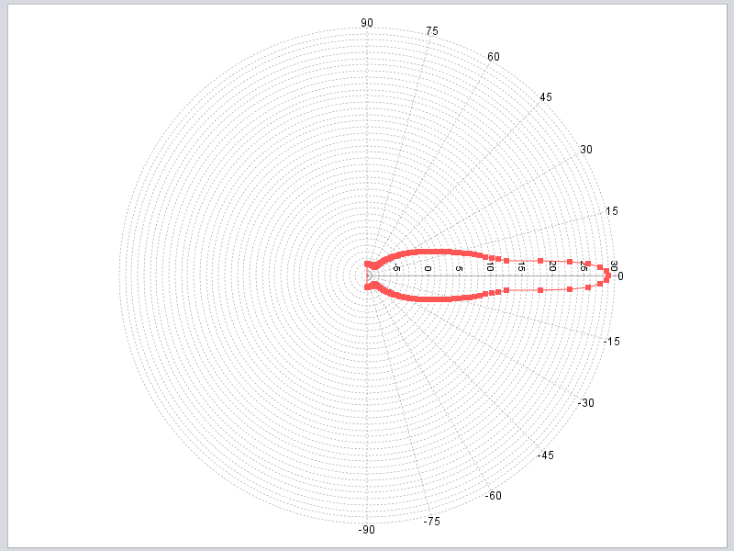
Figure 29: ATS ground receiver vertical antenna pattern
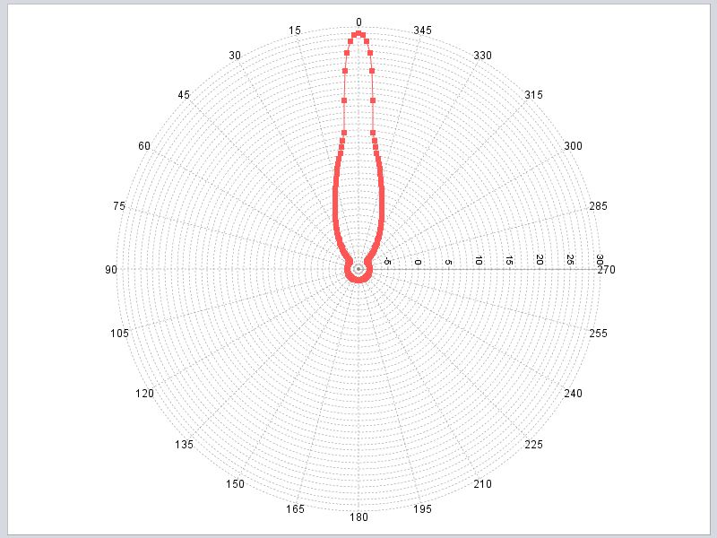
Figure 30: ATS ground receiver horizontal antenna pattern
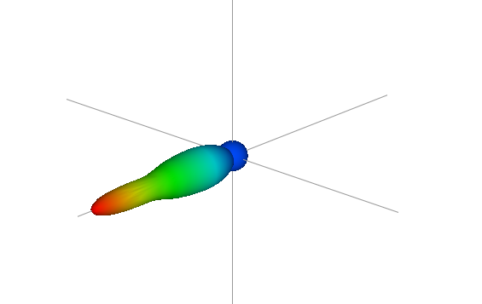
Figure 31: ATS ground receiver 3D antenna pattern
  - Antenna pattern of Recommendation ITU-R M.1851
For the case when ATS stations is an additional component of radar equipment as mentioned in Section 2.1 antenna pattern according to Recommendation ITU-R M.1851-0 is used. This is antenna with constant height pattern or also called cosecant squared pattern. Such antenna patter permits an adapted distribution of the radiation in the beam and cause a more ideal space scanning. With that a more uniform signal strength at the input of the receiver is achieved as a target moves with a constant height within the beam. The ideal pattern is a nearly rectangular shape with rounded corners. In reality, the diagram is superposed with a number of side lobes mainly on the back at higher elevation angles. The shape of all these back-side lobes is combined into a nearly parabolic slope (see http://www.radartutorial.eu/ for more details).
The vertical plane antenna pattern is made using the equations 10-12a from the recommendation. The antenna pattern for the half power antenna beamwidth of the main lobe (θ3) of 10 degrees, the maximum angle of the cosecant squared part of 35 degrees is provided in Figure 32. In the SEAMCAT analyses in this report an electrical elevation antenna angle of 11 degrees were used based on the information provided by ATS users and is shown in Figure 33. For the analyses in Kaliningrad case the cosecant part of the vertical antenna was developed following a graphical description of the patterns as shown in the Figure 4 of the recommendation the antenna pattern. Such antenna pattern applying cosecant floor level of −50 dB is provided in Figure 34. For the horizontal plane the average level for side lobes is −20 dB with cos antenna distribution pattern type. It was also proposed to use sinc antenna distribution pattern type and it was also included in the analysis.
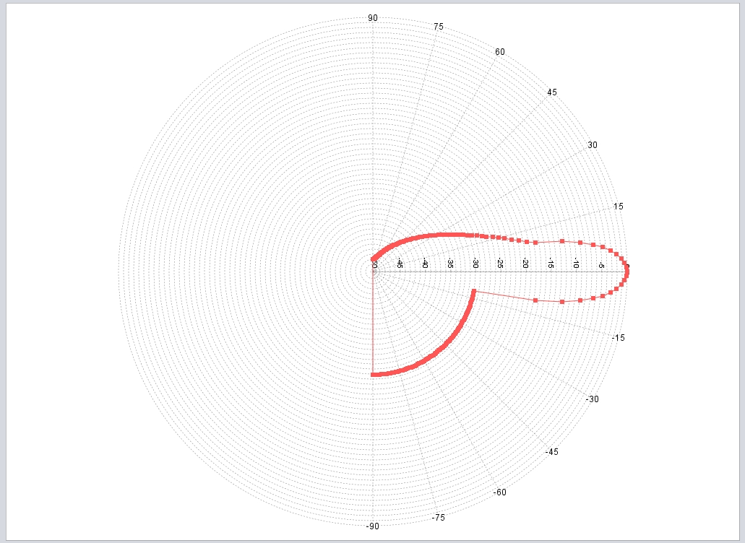
Figure 32: ATS ground receiver vertical antenna pattern
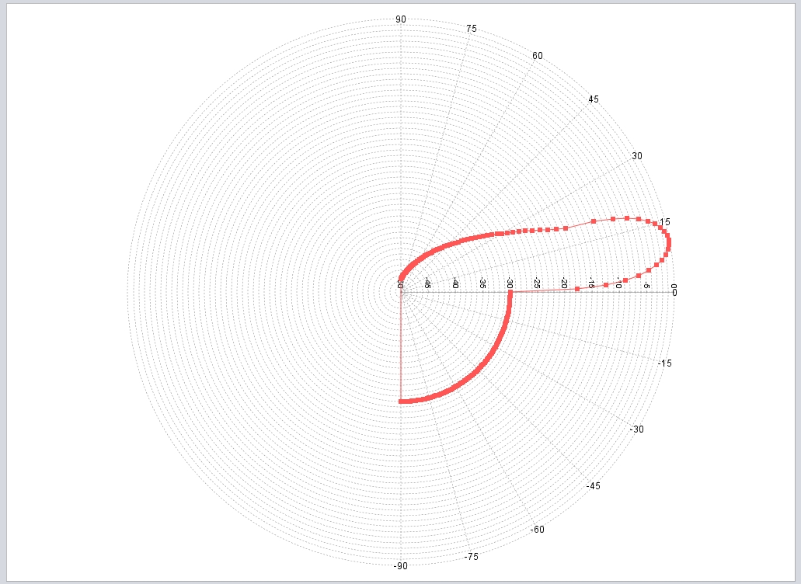
Figure 33: ATS ground receiver vertical antenna pattern (11 degrees el. elevation angle)
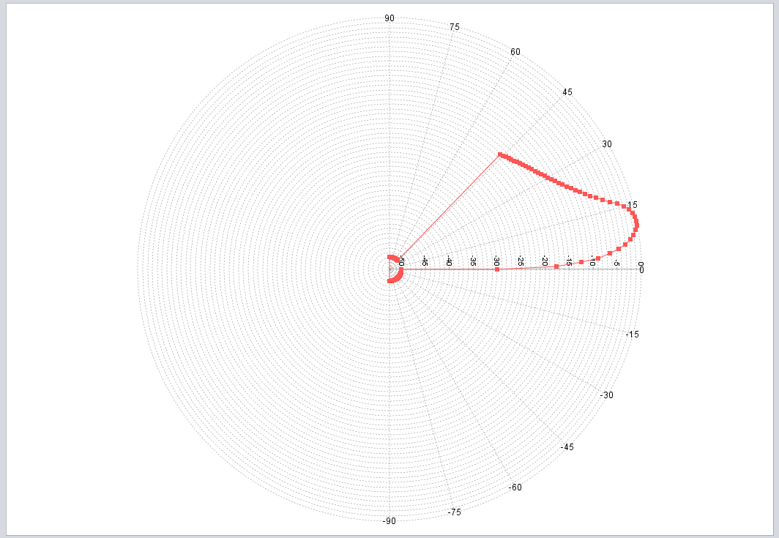
Figure 34: ATS ground receiver vertical antenna pattern (used in Kaliningrad case)
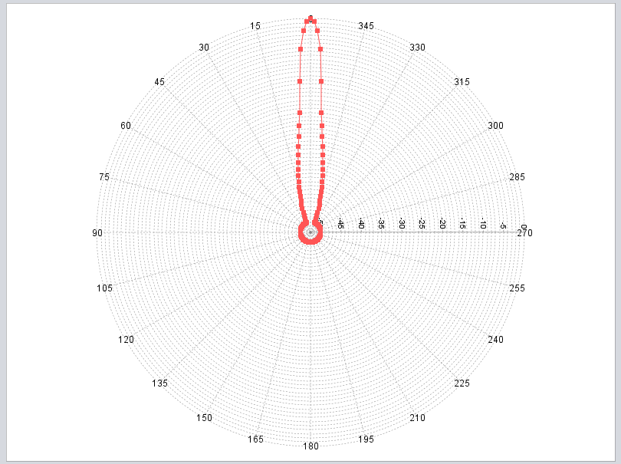
Figure 35: ATS ground receiver horizontal antenna pattern (cos, average envelope)
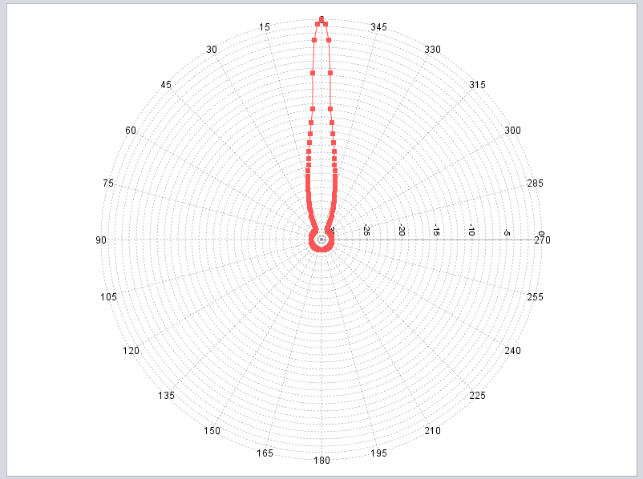
Figure 36: ATS ground receiver horizontal antenna pattern (sinc, average envelope)
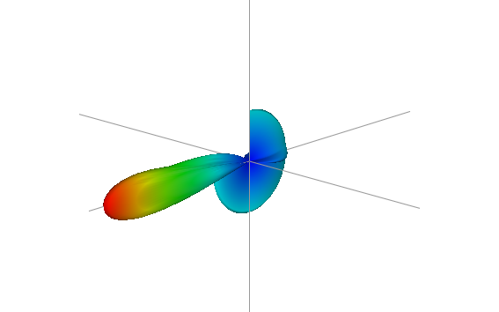
Figure 37: ATS ground receiver 3D antenna pattern (cos)
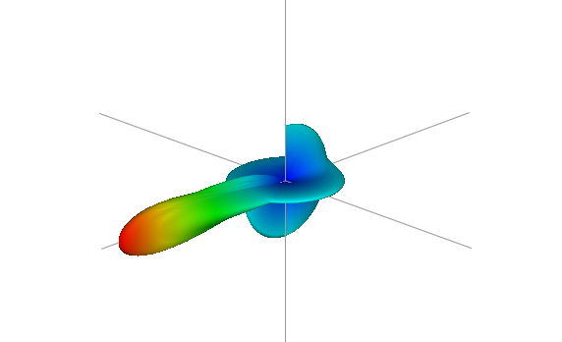
Figure 38: ATS ground receiver 3D antenna pattern (sinc)
  - Antenna pattern of Recommendation ITU-R F.1336-4
For the MFCN BS antenna pattern with parameters from Table 4 of this report is provided in figures below.
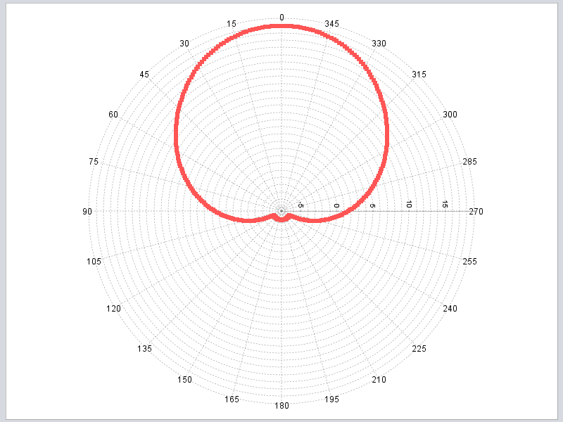
Figure 39: Base station horizontal antenna pattern
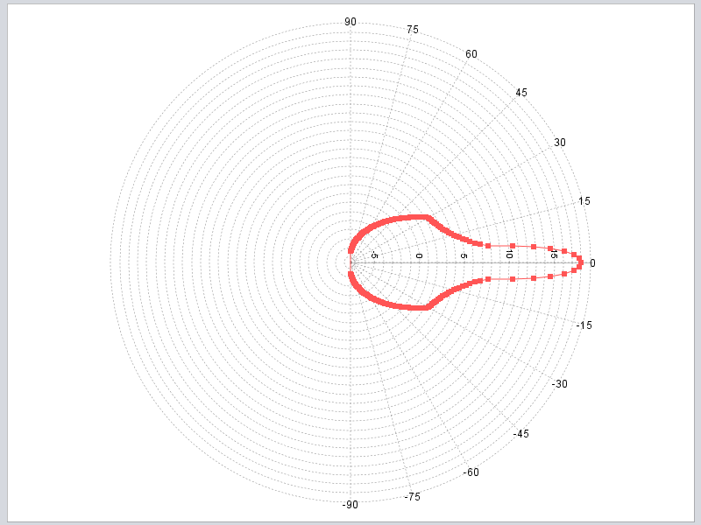
Figure 40: Base station vertical antenna pattern (peak envelope) antenna pattern

- Averaged value of iRSS for surrounding network interference calculations
When ATS antenna rotates, the interfering Received Signal Strength (iRSS) depends on the BS arrangement inside the LTE cluster. To take into account rotation of ATS antenna for any surrounding network, the LTE cluster was rotated around its centre and iRSS was calculated every 5 degrees. This is equivalent to the ATS antenna rotation around the cluster keeping the unchanging distance and antenna pointing direction to the cluster centre. Then the averaged value of iRSS was evaluated. The results of the simulations are presented in Figures below for different ATS antenna under consideration.
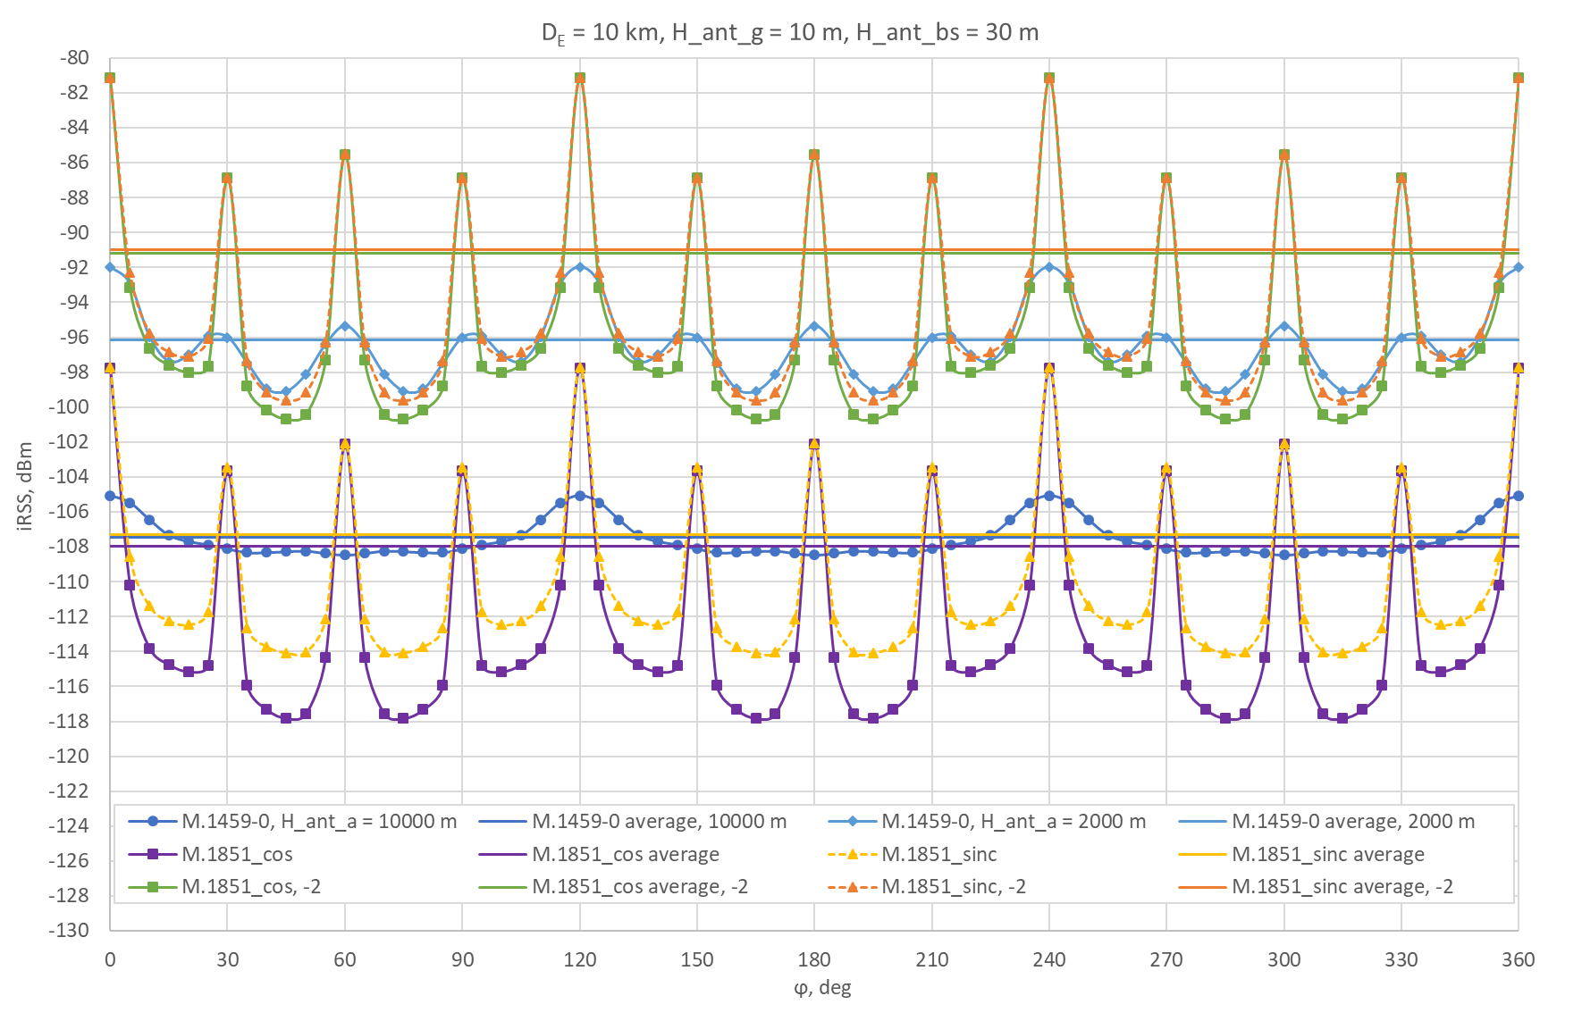
Figure 41: iRSS dependence on LTE cluster rotation angle and its average value for DE = 10 km
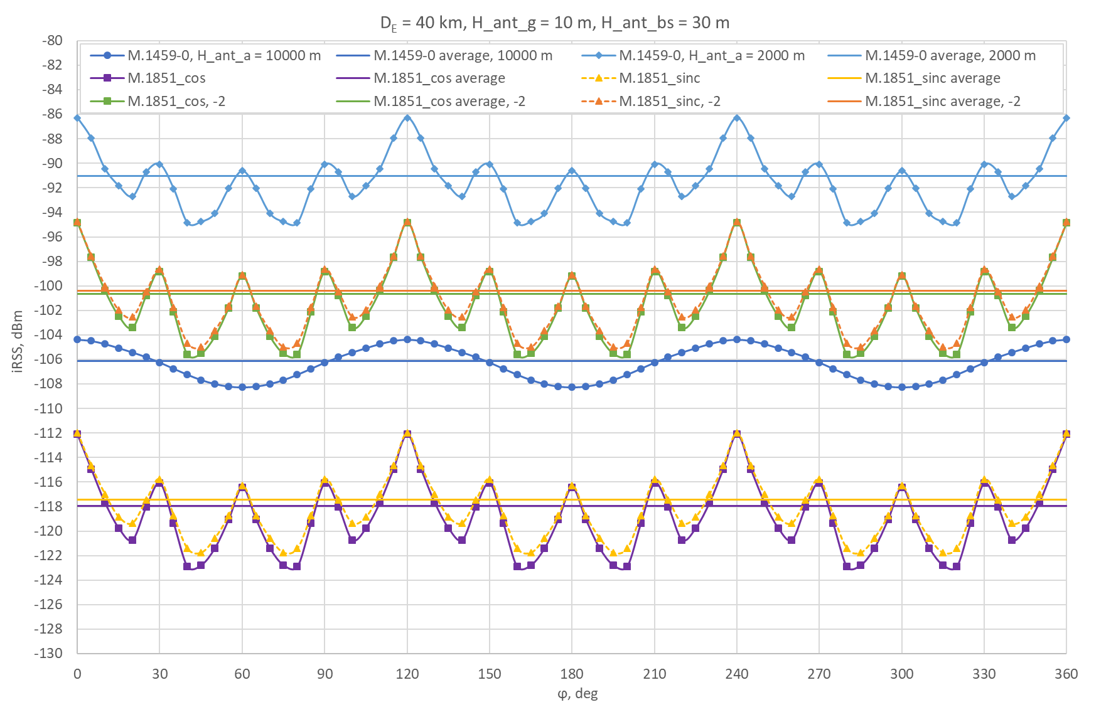
Figure 42: iRSS dependence on LTE cluster rotation angle and its average value for DE = 40 km
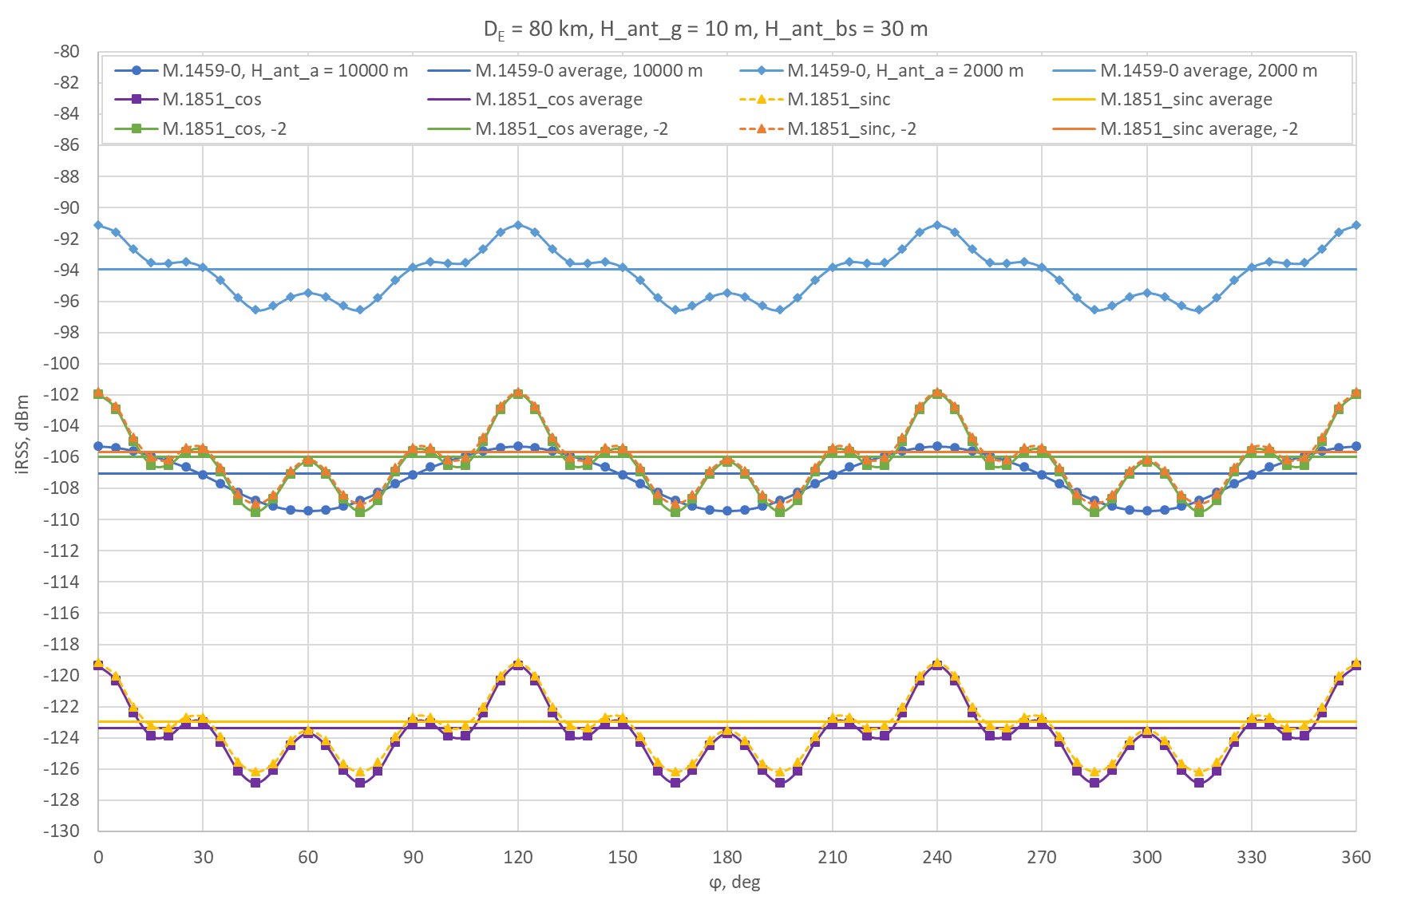
Figure 43: iRSS dependence on LTE cluster rotation angle and its average value for DE = 80 km
- The approach to calculate the interfering power flux density
The hexagonal LTE cluster, to simplify power flux density evaluation, is substituted by a circular LTE cluster of the same effective area, Seff, and the same other BS characteristics, and the distance from the ATS, DC, Figure 44.
Figure 44: Effective area of circular LTE-C cluster to generate averaged interfering signal at ATS receiver
The area of a hexagonal LTE-C cluster consisting of 19 cells is calculated using equation
(1)
where a is cell radius (Cell range = 2a). Then, the circular cluster effective radius, reff, equals to
(2)
and effective central angle, αeff, equals to
(3)
The interfering received signal power element ΔPiRSS entering the ATS receiver is proportional to the BS transmitters number passing the antenna aperture solid angle element and in case of a flat circular LTE cluster (vertical ΔPiRSS component variation is neglected, i.e. is constant) is proportional to the conical beam and circular cluster intersection area (Figure 45), which is expressed as
(4)
Angular power flux density ρ[mW/deg] at the place of ATS can be evaluated for known antenna pattern (AP) and the calculated iRSS power, PiRSS, using equation
(5)
where G(ϕα,θα) is the linear antenna gain factor, ϕα and θα are antenna pattern azimuth and elevation angles, respectively, α is central angle and Kα are weighted coefficients, which are proportional to the intersection area given by the equation (4).
Figure 45: Conical beam and circular cluster intersection area and chord midpoint position
In case of rotational symmetry antenna (spherical antenna pattern), gain factor depends only on off-axis angle Θ, and in case of discrete G(Θi), (5) simplifiers to
(6)
where Θi is defined as
(7)
and $\vec{r_{a}}$ is radius-vector pointing from the ATS ground receiver to the ATS on-board transmitter, $\vec{r_{i}}$ is radius-vector pointing from the ATS receiver to the corresponding point located at the same as the BS antenna height, the distance d(αi) = DC⋅cos(αi), which corresponds to a chord midpoint distance from the ATS Rx in the $\vec{r_{i}}$ direction, and the angle αi, taken from the central line. N/2 is defined as the integer part of αeff/2, when taking angular increment of one degree. Weighted coefficients Ki are expressed as the normalized intersection area ΔS(αi)/ΔS(0), and are evaluated using equation
(8)
When the two different antenna patterns (horizontal and vertical) are used for no spherical antenna gain G(ϕ,θ) calculation, the horizontal and vertical planes are combined to get a pseudo 3-D antenna gain based on the derivations presented in Annex 5 and Annex 7 of Recommendation ITU-R F.1336-4.
- Methodology for field strength calculations based on practical case
The methodologies outlined in items A4.1 and A4.2 are based on the practical experience gained by Ukraine during the calculation exercises conducted in 2014 with the aim of preparing for the conclusion of a bilateral co-ordination agreement between Ukraine and Poland (UKR-POL) in the E-GSM band. To protect the BSs of new MFCN/UMTS networks of Poland from the mobile BWA BSs of Ukraine it was agreed to use a protection criterion of 22 dBμV/m in the 1.25 MHz band at a height of 10 m at the borderline (the interference power at the MFCN/ UMTS receiver input is of −109 dBm/ 5 MHz).
  - The methodology to determine test points
- Requirements for test points:
test points should ensure that the interference is taken into account in all possible directions of it may occur from;
the distance from the borderline is determined as closely as possible, taking into account the availability of the access to the place of measurement on both sides of the border and the availability of a convenient site for the placement of measuring equipment;
- desired placement near the operating BS or one that is planned to be installed;
- the distance between the test points is determined by the mean value of the distance of the MFCN BSs, which create interference, to the borderline and the width of the directional diagram. With accounting the case when no restrictions apply to the BS, it is acceptable to set a distance of 30 km, and a typical width of the diagram at a level of 0.5 P takes 90 degrees. Then the distance between the test points will be 42 km (see Figure 46) and for the length of the UKR-POL border at 542 km, 13 points can be obtained (15 points were actually identified).
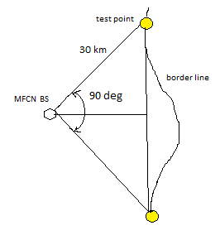
Figure 46: Test point selection
  - The selection of MFCN BSs to be involved in calculations
The selection of the MFCN/UMTS BSs was carried out in three stages.
    - First stage
In the first stage, all operating and planned sectors of the Ukraine BWA BSs, located at a maximum distance (about 150 km) from the borderline, were involved in the calculations. The calculations were carried out for several (3-4) nearest reference MFCN/ UMTS stations. Such calculations allowed to take into account the remote BWA BSs located on high altitude positions. The results of the calculations were compared with the protection criterion for the critical case. Those BWA BSs, which field strength level (FSL) was below the protection criterion, were excluded from further consideration.
From the Ukraine experience with the calculation done in the first stage of the calculations exercises, 2506 sectors of the BWA BSs were involved. The calculations were carried out in relation to 4 deployed MFCN/ UMTS BSs, located close to the borderline. As a result, 2071 sectors remained to be taken into account at the following stages of calculation.
    - Second stage
In the second stage of practical case, the FSL calculations from the remaining sectors of BWA BSs were carried out relative to the test points at the borderline and to the defined MFCN/ UMTS protection criterion 22 dBμV/m/ 1.25 MHz/ 10 m at the borderline (the interference power at the MFCN/ UMTS receiver input is of −109 dBm/ 5 MHz).
Those sectors of BWA BSs, which created FSL lower than the criterion of 5-6 dB excluded from the further calculations. This margin based on the experience of calculations is considered as sufficient to not be taken into account when summing up signals.
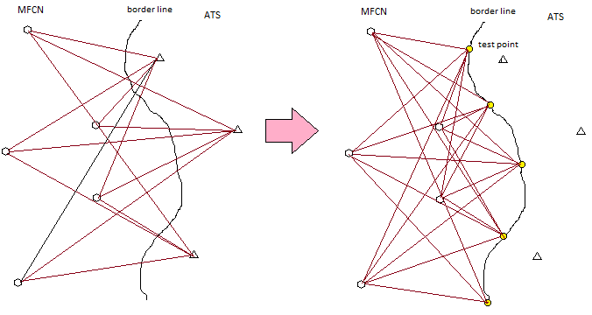
Figure 47: Example of transformation of points of calculation from ATS station location to borderline
As a result of the calculations of the 2nd stage of practical case, it was left to account for about 600 sectors. An example of the calculation results for point 13 is presented in Table 10. Only 7 sectors individually provided an excess of the threshold (–109 dBm at UMTS receiver input), but in order to sum up the individual interference, so many other sectors should have been involved that, as a result of addition, it will give a total level that was lower than protection criterion. For these selected stations the individual measures to reduce the level of emissions are applied including switching-off the interfering sectors.
Table 10: An example of calculation results of total FSL from individual sectors of BWA BSs at test point no. 13
 | Name of point | Rx frequency, MHz | KTBF, dBm | Name of interfering BS | Tx frequency, MHz | Level of interference at the input of receiver, dBm | TD dB
1 | Point 13 (106) | 882.3 | −109 | Sambir 108484 (472) | 882.3 | −86.17 | 22.85
2 | Point 13 (106) | 882.3 | −109 | Yavorivsk (426) | 882.3 | −93.57 | 15.55
3 | Point 13 (106) | 882.3 | −109 | Н14008−46 (359) | 882.3 | −99.92 | 9.59
4 | Point 13 (106) | 882.3 | −109 | Sambir 108484 (470) | 882.3 | −101.86 | 7.91
5 | Point 13 (106) | 882.3 | −109 | UMTS3074−46 (392) | 882.3 | −102.98 | 6.99
6 | Point 13 (106) | 882.3 | −109 | Yavorivsk (427) | 882.3 | −106.25 | 4.6
7 | Point 13 (106) | 882.3 | −109 | Yavorivsk (425) | 882.3 | −107.81 | 3.64
8 | Point 13 (106) | 882.3 | −109 | 461762 (406) | 882.3 | −109.05 | 2.99
9 | Point 13 (106) | 882.3 | −109 | 461762 (407) | 882.3 | −109.55 | 2.74
10 | Point 13 (106) | 882.3 | −109 | Lviv 59866 (373) | 882.3 | −112.33 | 1.66
11 | Point 13 (106) | 882.3 | −109 | Novyi Rozdil 109340 (346) | 882.3 | −114.32 | 1.12
12 | Point 13 (106) | 882.3 | −109 | Sambir 108484 (471) | 882.3 | −115.33 | 0.91
13 | Point 13 (106) | 882.3 | −109 | Н14004−46 (350) | 882.3 | −116.11 | 0.77
14 | Point 13 (106) | 882.3 | −109 | Sokilnyky 109414 (442) | 882.3 | −116.22 | 0.75
15 | Point 13 (106) | 882.3 | −109 | LV0013−46 (389) | 882.3 | −117.19 | 0.61
16 | Point 13 (106) | 882.3 | −109 | Lviv 109325 (205) | 882.3 | −118.35 | 0.48
17 | Point 13 (106) | 882.3 | −109 | Pustomyty 106123 (481) | 882.3 | −119.54 | 0.37
18 | Point 13 (106) | 882.3 | −109 | Lviv 90799 (395) | 882.3 | −120.19 | 0.32
19 | Point 13 (106) | 882.3 | −109 | 461808 (525) | 882.3 | −120.37 | 0.31
20 | Point 13 (106) | 882.3 | −109 | Lviv 59866 (374) | 882.3 | −120.74 | 0.28
21 | Point 13 (106) | 882.3 | −109 | Lviv 25968 (416) | 882.3 | −120.94 | 0.27
    - Third stage
In the third stage of practical case a list of those BWA BSs sectors, which relate to individual test points, was created. For them, the summation of individual levels (in power) was carried out. The summation of individual powers is carried out in an arithmetic form of numbers with further transfer of the summation result into a logarithmic form. Those sectors, which did not lead to exceeding the threshold when involved in summing the results of individual calculations, were removed from the analysis. Table 11 shows the final results of the calculations for the 15-th test points based on Ukraine practical experience.
Table 11: final results of calculations for the 15-th test points, based on Ukraine experience
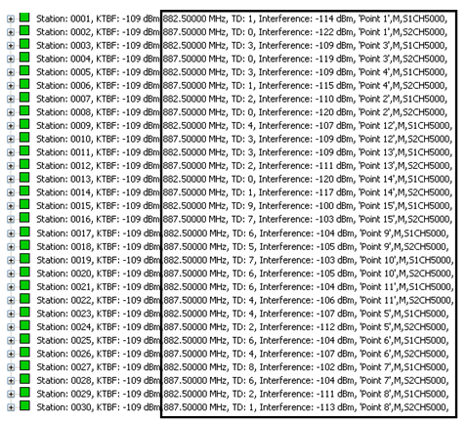
  - Adjustment of MFCN BS parameters based on practical case
As an example, in Table 12, data are presented for taking into account the change in the gain of the real typical and simulated (according to HCM method) antenna, depending on the angle of elevation.
Table 12: Example of antenna gain dependence on antenna tilt
Tilt angle of antenna pattern, degree | Losses La, dB |  | Accounted antenna gain Ga*, dB
Tilt angle of antenna pattern, degree | Antenna pattern of Kathrein 739 650 in vertical plane | Calculated antenna pattern of 004LA type in vertical plane (Appendix 1 to Annex 6 of HCM) | Accounted antenna gain Ga*, dB
0 | 0 | 0.0 | 12
1 | 0.2 | 0.0 | 12
2 | 0.9 | 0.2 | 11
3 | 1.9 | 1.0 | 10
4 | 3.5 | 3.0 | 9
5 | 5.7 | 8.1 | 5
* Ga = 15 dB – L – La – antenna gain, where L = 3 dB – an average feeder loss; La = an average attenuation due to antenna tilt (γ = 0°, 4°, 5°).
In addition, Table 13 presents numerical indicators of sector shutdowns efficiency and adjustment of parameters (example of practical case) during the optimization of the existing BWA network of Ukraine in order to minimize the impact on the UMTS network of Poland. In the beginning 2506 sectors were involved in the calculations. Actually, the change affected the 464 sectors belonging to 111 BWA BSs located in the 80 km wide border area. The number of switched off sectors was 9% of the total number of sectors affected by practical changes. The number of sectors requiring technical adjustments is 28% of the total number of sectors affected by practical changes. The rest of the adjustments (63%) came from the frequency parameters of the BSs of the BWA network.
Table 13: Adjustment of Ukraine BWA network
 | Number of BWA BSs in 80 km border area (number of sectors) | Number of sectors |  | Number of channels
 | Number of BWA BSs in 80 km border area (number of sectors) | Requiring correction of technical characteristics | Requiring switching off | Requiring correction of technical characteristics | Requiring switching off
Total | 111 (464) | 132 | 43 | 619 | 125
Based on these results, the most effective means of changing the parameters of the operating network in the practical case of re-setting the BWA network of Ukraine was the re-setting of frequency plan of the network.
- The example of draft template for coordination Agreement
Draft
TECHNICAL AND PROCEDURAL ARRANGEMENT for usage of the 1427-1518 MHz band by terrestrial systems in the border areas between Telecommunication Administration XX and YY
Date

Introduction
- Principles
- Technical conditions for coordination of the MFCN stations with the ATS stations
- Technical conditions for coordination of ATS stations with MFCN stations
- General provisions
- Harmful interference
- Procedure of coordination
- Revision and cancellation
- Coming into force

On behalf of the Telecommunication Administration of XX
On behalf of the Telecommunication Administration of YY

Appendix
Field strength measurement procedure
- Common provisions
- Requirements to the monitoring equipment
- Information to be provided by the affected Administration in case of harmful interferences
- Examples of test points
- Example of single interference calculation with using different AP of ATS
The task of calculation is to estimate separation distance (SD) needed to meet sharing requirements for MFCN BSs and ATS in border area. A single interference is calculated from the radio link budget equation for a protection criterion (I/N) = −6dB or 34.6 dBμV / m in terms of field strength and with given ATS antenna gain. Two basic wave propagation models were used: Hata and Rec. ITU-R P.1546-5.
  - Hata model
Equations (2) to (6) were extracted from referenced documents for show the connection between radio link budget equation and field strength required.
The power Pr received by receiver is equal to the power transmitted Ptminus the propagation loss Lp:
Pr = Pt - Lp (1)
The relationship between power transmitted by an isotropic antenna and field strength at receiving point (Rec. ITU-R P.525-2):
$P_{r}= {\left(\frac{c}{4πf_{Hz}}\right)}^{2}×\frac{E^{2}}{30 }$ W (EIRP) (2)
Converting from a linear equation to logarithmic form and with f in MHz we get:
Pr = E - 20log f + 12.782 (3)
Using (1) and (3) we get an equation that shows the relationship between loss and field strength depending on the power transmitted:
E = Pt + 20log f − 12.782 - Lp, dB(V/m) (4)
Accounting that all field strengths values were measured with respect to a 1 kW ERP transmitter, which is equal to a 1.637 kW EIRP transmitter and then setting Ptequal to 32.15 dB and converting dB(V/m) to dB(μV/m) with 120 dB, the equation (4) will become:
E = 139.37 + 20 logf − Lp, dB(μV/m) (5)
Replacing Lp by original Hata equation (Wireless Communications, Second Edition. Andreas F. Molisch. 2011. John Wiley&Sons, Ltd, equation 7.14) for urban area
Lp = 69.55 + 26.16 logf − 13.82 logH1 - a(H2 ) + (44.9 - 6.66logH1) logd, (dB) (6)
we receive well known Hata model for field strength depending on distance, frequency and antennas heights (Annex 8 to Rec. ITU-R P.1546-5):

E = 69.82 − 6.16 logf + 13.82 logH1 + a(H2) − (44.9 − 6.55 logH1) (logd)b , (7)
were:
E : field strength (dB(μV/m)) for 1 kW e.r.p.
f : frequency (MHz)
H1 : base station effective antenna height above ground (m) in the range 30 to 200 m
H2 : mobile station antenna height above ground (m) in the range 1 to 10 m
d : distance (km)
a(H2) = (1.1 log f − 0.7) H2 − (1.56 log f − 0.8)
b: factor accounting distance more 20 km and propagation condition,
b = 1 for d ≤ 20 km
b = 1 + (0.14 + 0.000187 f + 0.00107 ) (log [0.05 d])0.8 for d > 20 km,
where:
Input data for calculations:
- E = 34.6 dBμV/m;
- EIRP = 55 dBm (25 dBW) with accounting antenna tilt 3⁰. Difference with 1.637 kW EIRP = 32.15 – 25 = 7.15 dB we will account by subtraction 7.15 from first term of equation (7): 69.82 – 7.15 = 62.67;
- H1(H1eff) = 30 m;
- H2 = 10m;
- f = 1472 MHz.
Interim result:
a(H2) = 27.84 – 4.14 = 23,69
34,6 = 62.67 – 19.51 + 20.41 + 23.69 – 35.22 (logd)b
And finally:
(logd)b = 1.49 for b = 1 d = 31,3 km;
As d > 20km then calculate b = 1 + (0.14 + 0.275 + 0.032) (log1.56)0.8 = 1 + 0.448 x 0.268 = 1.12;
(logd)b = 1.49 for b = 1.12 d = 26.7 km.
This SD corresponds to receiver condition with isotropic type ATS antenna. Other SD values can be defined with accounting ATS antenna gain. The results of calculations for SD depending on the level of main lobe (30dB for AP_1851) and (24.25 dB for AP_UKR2 proposal with antenna tilt −2°), 1-st sidelobe (−13dB), 2-nd sidelobe (−18 dB) and average sidelobes level (−20 and −30 dB) of ATS antenna pattern in horizon plane are presented in Table 14.
Table 14: Separation distance for different ATS receiver antenna conditions
ATS receiver relative gain | 0 dBi | -5.75 dB | -13 dB | -18 dB | -20 dB | -30 dB
SD Hata, km | 137* | 100* | 68* | 52* | 46.6* | 26.7
SD 1546, km | 105 | 71.7 | 50 | 38.9 | 34.8 | 21.5
* - Hata model is applicable for the distance up to 40 km
Separation distances for other values H1(H1eff ) and average side lobes level (−30 dB) level derived with Hata model and 1546 are presented in Table 15.
Table 15: Separation distance for different H1( H1eff ) of MFCN BS
H1(H1eff ), m | 30 | 75 | 150
SD Hata, km | 26.7 | 46.7 | 71
SD 1546, km | 21.5 | 32.9 | 43.9
For presented antenna heights H1 and H2 radio horizon (RH) condition can be accounted for calculation of field strengths over diffraction paths, which may include spherical earth surface or irregular terrain with different kind of obstacles. More accurate calculation for diffraction conditions can be done using terrain data with propagation model Rec. ITU-R P.526-12.
  - Model Rec. ITU-R P.1546-5
SD for required field strength 34.6 dBμV/m may be obtained by 3 ways:
- By reading directly from the curves presented as figures in Annexes 2, 3 and 4 of this Recommendation;
- By using tabulated field strengths available from the Radiocommunication Bureau (SG3).
- With computer implementations of the method (for example EBU Technical Department, Version 1.4).
  - From curves and tabulated data calculations.
Following 1456 to determine SD next steps should be performed:
- Using the figure 10 for the 600 MHz band and the figure 18 for 2000 MHz obtain the average values ​​of SD for a FSL of 34.6 dBμV / m with conditions: 10% of time, 50% of places, land path, antenna height 30 m, transmitter power ERP: 30 dBW − 7dB = 23 dBW.
- Values ​​of SD for 30m for each range will be obtained by averaging the SD for antenna heights of 20m and 37.5m.
- The SD value for the ERP 23 dBW is obtained by shifting the approximated curve down on a value of 7 dB.
- For the 600 MHz band we get 23 km. For the 2000 MHz band we get 21 km. The average SD is 22 km. The average value SD for the 1400 MHz band can be refined using formula (14) Section 6 of Appendix 5 and tabulated data.
  - Computer-based calculations.
A window screen shot of software EBU Version 1.4 for input data and result of calculations performed by EBU Version 2.0 are presented in Figure 48. The results for field strength value of 34.6 dBμV / m for main lobe and side lobes receive conditions are shown in Table 1.
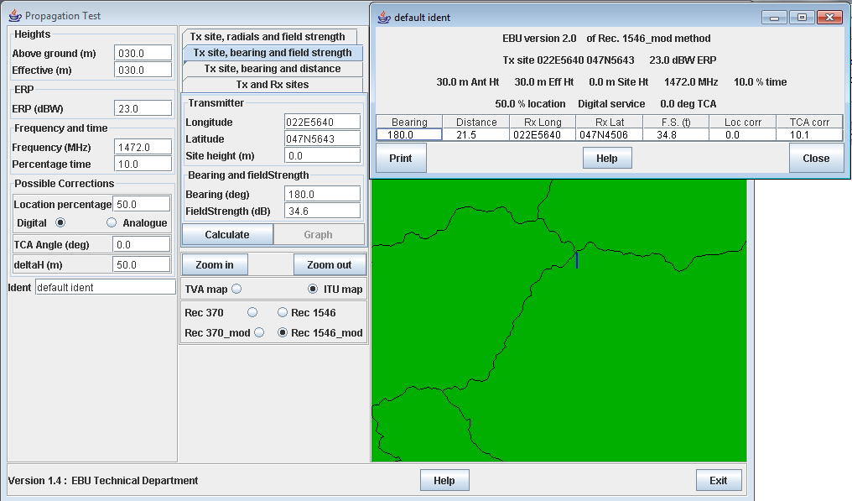
Figure 48: Results of calculations with EBU version 1.4 (input data) and EBU version 2.0 (results) of Rec.1546_mod method
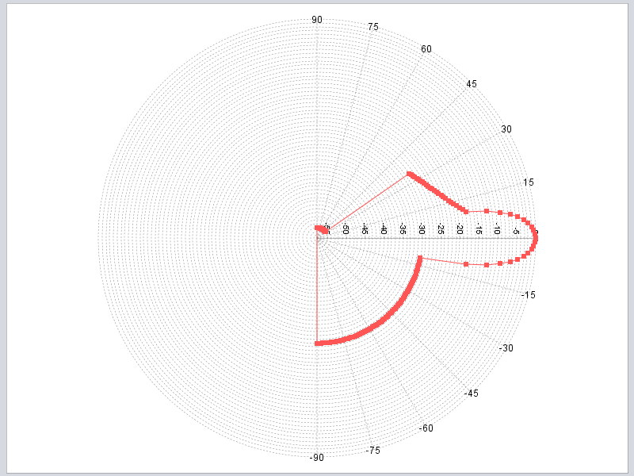
Figure 49: Proposed by Ukraine for vertical AP1

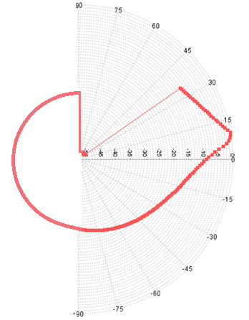
Figure 50: Proposed by Ukraine for vertical AP2
Specification for AP2:
AP vert based on equations (10)-(12a) in Table 4 of Rec 1851 with usage of next input data for ATS:
Ɵ1 = Ɵ3 = 10⁰; Gmax for Ɵ1 = 10⁰;
The part has condition for −11.36⁰≤Ɵ≤ +10⁰;
AP peak mask starts from level = −5.75 dB. Beyond this level AP is described by equation (5), Table 3 up to the floor level −30 dB (−115⁰);
G(Ɵ = 0⁰) = −9dB;
The sin floor level −30 dB is extended to −270⁰ (+90⁰);
The part has condition for +10⁰≤Ɵ≤ +35⁰;
Cosecant floor level = −50 dB for +35⁰≤Ɵ≤ +90⁰;
To account antenna (APvert) tilt the range −2⁰≤Ɵtilt≤ +2⁰ is proposed. G-2⁰(Ɵ = 0⁰) = −5.75 dB. G+2⁰(Ɵ = 0⁰) = −10.5 dB.
- List of Reference
- ITU-R Recommendation M.1851-0 "Mathematical models for radiodetermination radar systems antenna patterns for use in interference analyses"
- ITU-R Recommendation M.1459-0 "Protection criteria for telemetry systems in the aeronautical mobile service and mitigation techniques to facilitate sharing with geostationary broadcasting-satellite and mobile-satellite services in the frequency bands 1 452-1 525 MHz and 2 310-2 360 MHz"
- ECC Report 227 "Compatibility Studies for Mobile/Fixed Communication Network (MFCN) Supplemental Downlink (SDL) operating in the 1452-1492 MHz band"
- ITU-R Report M.2324-0 “Sharing studies between potential International Mobile Telecommunication systems and aeronautical mobile telemetry systems in the frequency band 1 429-1 535 MHz”
- Final acts of the CEPT multi-lateral meeting for the frequency band 1452-1479.5 MHz, Constanţa, 2007 (MA02revCO07)
- ECC Decision (17)06 “The harmonised use of the frequency bands 1427-1452 MHz and 1492-1518 MHz for Mobile/Fixed Communications Networks Supplemental Downlink (MFCN SDL)“
- ECC Decision (13)03 “The harmonised use of the frequency band 1452-1492 MHz for MFCN SDL”
- ITU-R Recommendation P.526-14 "Propagation by diffraction"
- ITU-R Recommendation P.528-3 "Propagation curves for aeronautical mobile and radionavigation services using the VHF, UHF and SHF bands"
- ITU-R Recommendation P.1546-5 "Method for point-to-area predictions for terrestrial services in the frequency range 30 MHz to 3 000 MHz"
- ITU-R Recommendation P.525-2 "Calculation of free-space attenuation"

