 |  | ECC PT1(18)249
ECC PT1 #60
Dublin, Ireland, 17-21 September 2018
Date issued: | 12 September 2018
Source: | Lithuania
Subject: | L-band x-border MFCN vs. ATS
Group membership required to read? (Y/N)
N
Summary:
Draft ECC Report on cross-border coordination between the MFCN and aeronautical telemetry systems contains two ATS antenna patterns (AP). For radar-type system AP is in accordance with ITU-R Recommendation M.1851-0 and for tracking-type system it is in accordance with ITU-R Recommendation M.1459-0. Document ECC PT1(18)191 provides specification how to make AP following ITU-R Recommendation M.1851-0. Thorough analysis showed that it is not fully in line with that recommendation. It is essential that for the general analysis AP should be as described in approved deliverables to be able to compare the calculated results.
Proposal:
To use AP according to ITU-R Recommendation M.1851-0 for radar-type system for the studies in the report.
Background:

1. ITU-R Recommendation M.1851-0 (hereinafter referred as M.1851) provides antenna patterns for cosine (COS), cosine-squared (COS²) and cosine-cubed (COS³) and cosecant-squared distribution functions.
For the horizontal AP the document ECC PT1(18)191 proposes SIN pattern type with peak mask pattern. However, it should be noted that according to Section 2 of the M.1851 this could be used for a single-entry interferer case. It is true that the reference document analyses such situation, but in the draft report aggregate interference is also considered, and for such case average mask pattern should be used to be in line with M.1851. The Figures below show the difference between the peak and average mask pattern of SIN pattern type.
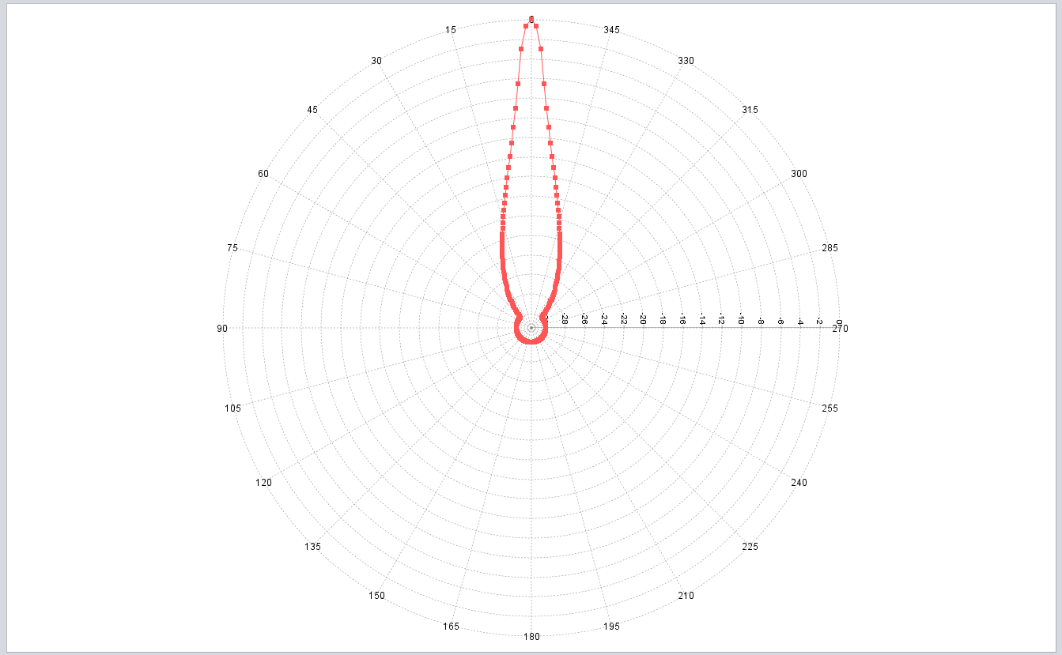
Figure 1: ATS ground receiver horizontal antenna pattern (SIN, peak envelope)
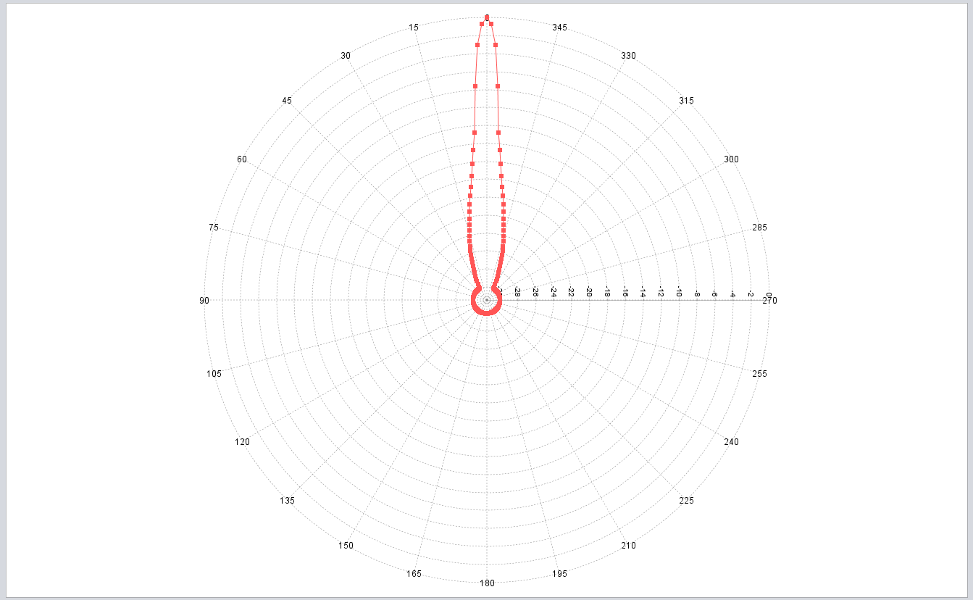
Figure 2: ATS ground receiver horizontal antenna pattern (SIN, average envelope)
During correspondence group activity COS pattern type was also introduced so it should be considered in the simulations as well. The Figure below shows the COS pattern type with average mask pattern.
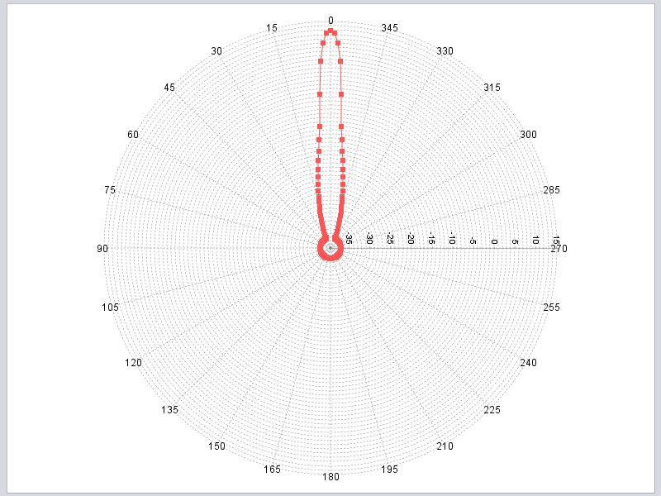
Figure 3: ATS ground receiver horizontal antenna pattern (COS, average envelope)

2. For the vertical AP the equations 10−12a in M.1851 apply. Document ECC PT1(18)191 provides methodology how to derive cosecant-squared AP according to M.1851. However thorough analysis of this methodology showed that it deviates from M.1851 specifications. Considering that θ₃ is 10 degrees, cosecant floor level is −50 dB and antenna elevation is 10 degrees, the comparison with the specification in M.1851 is provided in the Figure below.

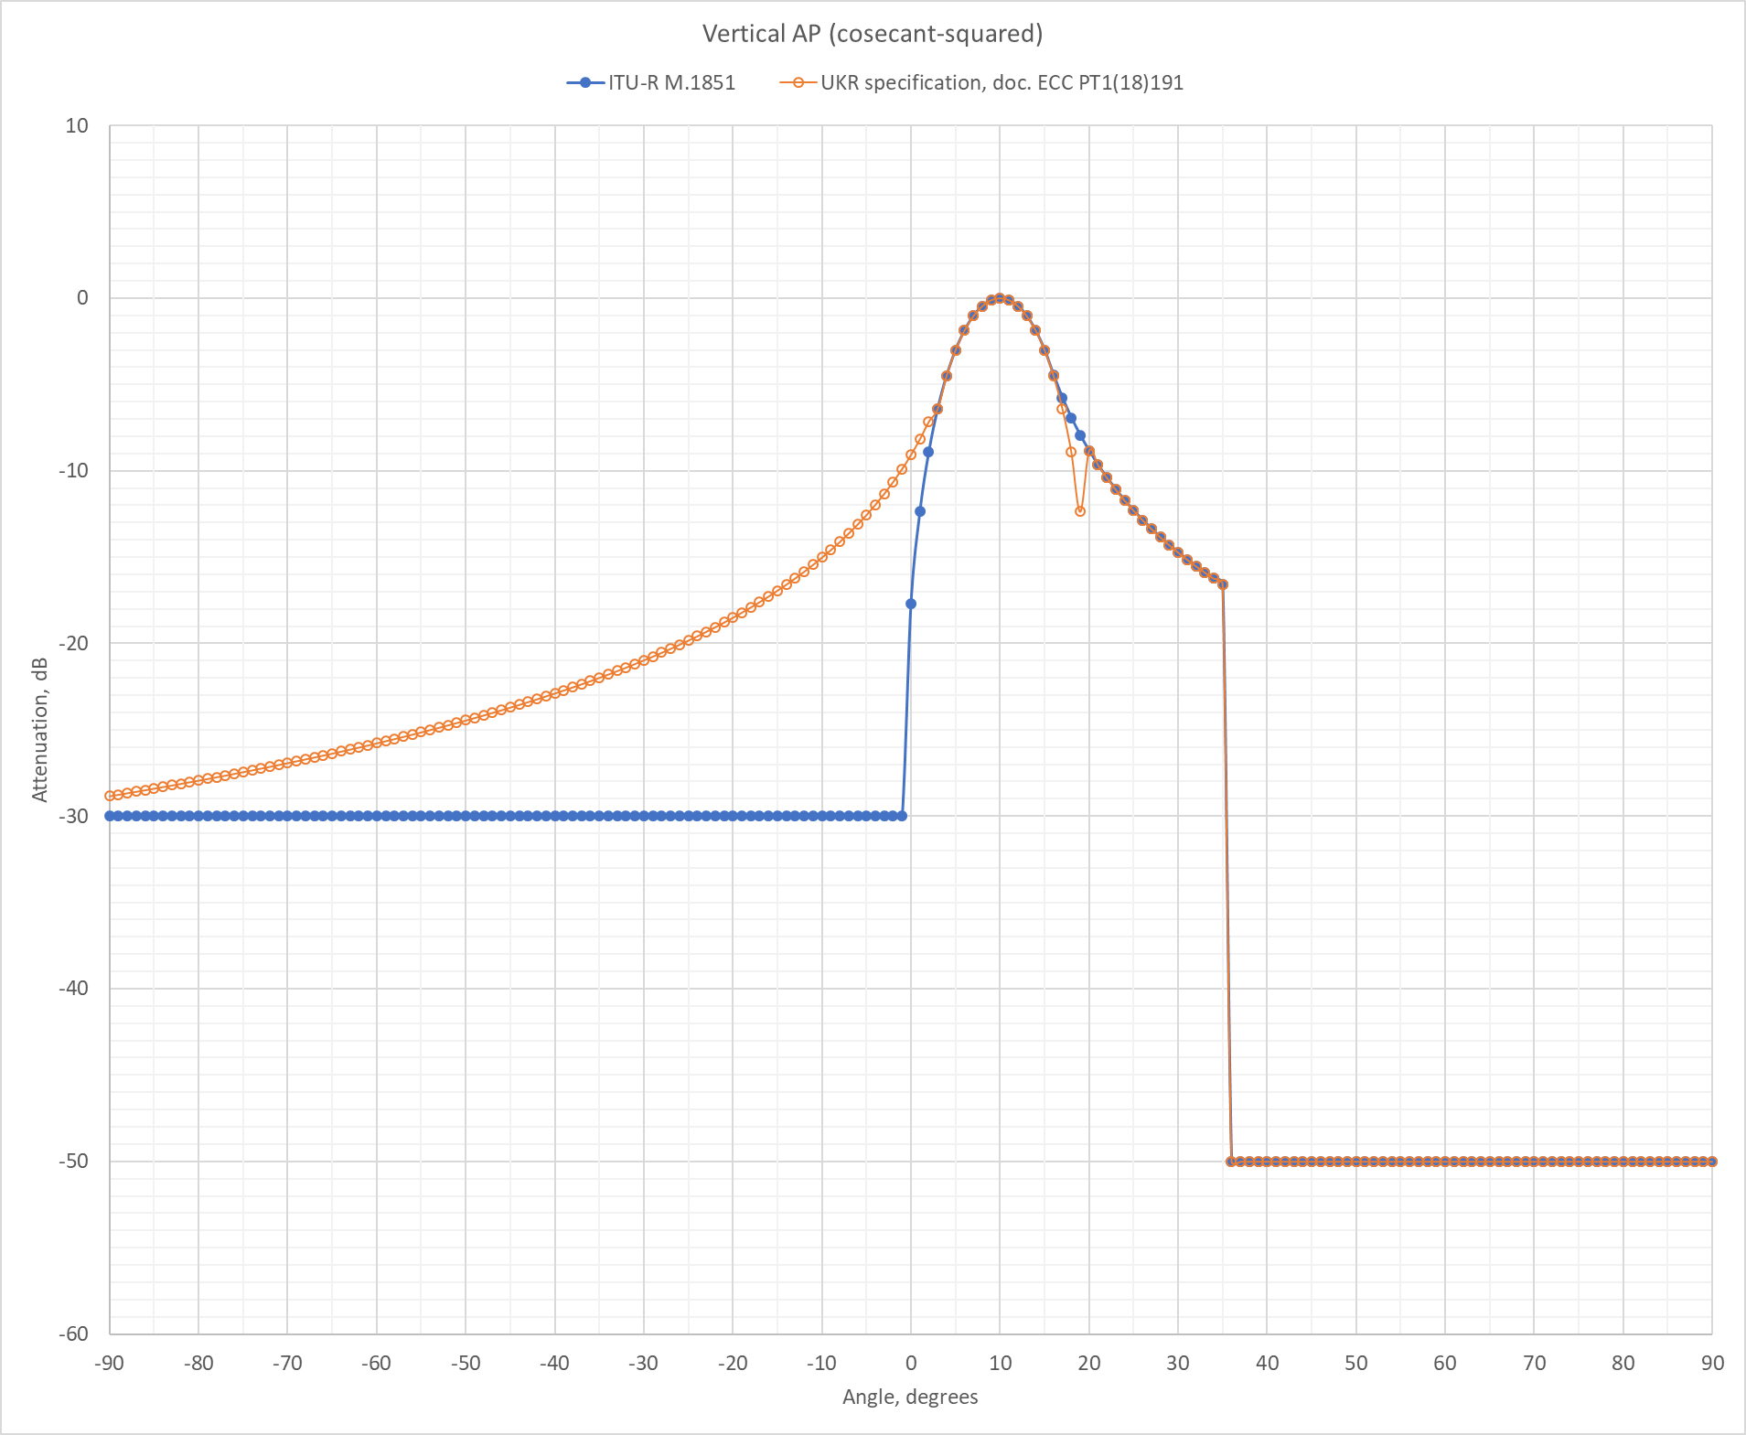
Figure 4: ATS ground receiver vertical antenna pattern
From Figure 4 we can observe that methodology provided in document ECC PT1(18)191 does not follow the specifications from M.1851. Therefore, we believe it should not be used as reference AP for radar-type ATS system since proposed AP deviates from specifications in M.1851. We suggest, it would be more appropriate to use such AP pattern in coordination negotiations, where applicable.

