FM22(23)48Annex

ECC Recommendation (YY)XX

Field strength measurements of Mobile/Fixed Communications Networks (MFCN) in border areas up to 6 GHz
Approved DD Month YYYY

introduction
This Recommendation contains methods to measure the field strength of base stations of Mobile/Fixed Communications Networks (MFCN) in border areas up to 6 GHz.
This Recommendation complements ERC Recommendation 74-02 [1] in order to cover MFCN systems operating in frequency bands harmonised for MFCN usage.

ECC recommendation of YY(No) on Field strength measurements of Mobile/Fixed Communications Networks (MFCN) in Border areas up to 6 GHz
“The European Conference of Postal and Telecommunications Administrations,
considering
- that Mobile/Fixed Communications Networks (MFCN) includes IMT and other communications networks in the mobile and fixed services which would include fixed wireless access but not point-to-point links;
- that administrations may diverge from the technical parameters and procedures described in this Recommendation subject to bilateral/multilateral agreements;
- that commonly agreed measurement methods to assess compliance with cross-border coordination conditions are necessary.
recognizing
- that ERC Recommendation 74-02 describes general methods of field strength measurements at fixed points in the frequency range 29.7-960 MHz;
- that methods of field strength measurement of 3G (UMTS), 4G (LTE) and 5G (NR) technology signals of MFCN have not been defined so far by CEPT;
- that MFCN operates in frequencies up to 3800 MHz, although ERC Recommendation 74-02 covers frequency range only from 29.7 MHz to 960 MHz

recommends
- that measurements of the field strength and other radio frequency (RF) parameters relevant for the cross-border coordination of Mobile/Fixed Communication Networks (MFCN) are carried out according to the methods described in ANNEX 1.
Note:
Please check the Office documentation database https://docdb.cept.org for the up to date position on the implementation of this and other ECC Recommendations.
- Field strength measurements of Mobile/Fixed Communications Networks (MFCN) in Border areas up to 6 GHz
  - Introduction
Cross-border conditions are generally based on methods that provide theoretical predictions of field strength using radiowave propagation models. It is practically impossible to recreate these methods with measurement procedures in the field. Therefore, only some approximation of measurements could be used to check compliance with those methods. Measurements to assess compliance with the conditions derived from theoretical predictions should therefore aim to apply the conditions that were used for the calculations (e.g. detector, bandwidth, location and time probability, etc.) as much as possible.
The permissible field strength produced by base stations at the border is depending on the following parameters:
- the type of duplex mode, i.e. TDD or FDD;
- the operation mode, i.e. synchronised, semi-synchronised or non-synchronised operation of TDD systems;
- the alignment of centre frequencies;
- the use of preferential or non-preferential frequencies;
- the use of preferential or non-preferential Physical Cell Identities.

These parameters have to be known by the administrations. CEPT has developed a number of recommendations for cross-border coordination of mobile systems. These recommendations could be considered by the administrations when developing their bilateral/multilateral agreements. Some CEPT members are also signatories of “HCM Agreement” [2] which defines conditions for coordination of frequencies between 29.7 MHz and 43.5 GHz for fixed service and land mobile service. It should be noted that field strength in those deliverables may be defined differently (i.e. mean, medium, maximum permissible or predicted field strength). This also impacts the measurement procedure.

Field strength levels between MFCN systems in neighbouring countries and measurement procedures should be based on bilateral/multilateral agreements between administrations.
If no cross-border agreement with the neighbouring country exits, the Table 1 provides a list of relevant ECC/ERC Recommendations to be used. Apart from the field strength levels, these documents also contain details relevant for the measurements (such as antenna height and measurement distance from the border).
Table 1: Relevant ECC/ERC Recommendations containing cross-border conditions
Frequency range | MFCN technology | Reference
694–790 MHz | LTE, 5G NR | ECC Recommendation (15)01
790–862 MHz | all | ECC Recommendation (11)04
870–960 MHz | GSM | ECC Recommendation (05)08
880–915 MHz  925–960 MHz | all except GSM | ECC Recommendation (08)02
1427–1518 MHz | LTE, 5G NR | ECC Recommendation (15)01
1710–1785 MHz  1805–1880 MHz | all except GSM | ECC Recommendation (08)02
1920–1980 MHz  2110–2170 MHz | all | ERC Recommendation (01)01
2300–2400 MHz | all | ECC Recommendation (14)04
2500–2690 MHz | all | ECC Recommendation (11)05
3400–3800 MHz | LTE, 5G NR | ECC Recommendation (15)01

Note that recommendations above table are only applicable if MFCN is used on both sides of the border.
In case no cross-border agreement with the neighbouring country exits and no ECC/ERC Recommendation exists, or other frequency bands are to be measured which are not covered by cross-border agreement nor ECC/ERC Recommendation, the values from the HCM Agreement should be taken, if available.
The field strength in those ECC/ERC Recommendations are specified as follow:
- maximum field strength for GSM,
- mean field strength for UMTS and LTE
- median field strength for 5G NR.

  - Determination of relevant MFCN system parameters
Most of the parameters relevant for the measurements of field strength have to be requested by the administration or operators. It is also possible to determine some of them by measurement equipment with a directional antenna directly at the borderline. The antenna should be pointed either in the direction of the nearest domestic or nearest foreign base station. However, in situations when information of the MFCN system is not available, for determination of relevant system parameters specialized measurement equipment with decoding capabilities (receiver or scanner) should be used.
Determination of the technology and frequency alignment can be done with a spectrum analyser in the frequency domain, with the following settings.
Table 2: Spectrum analyser settings for frequency domain measurements
Centre frequency: | Centre frequency of the downlink channel under investigation
Span: | ≥100 MHz (5G/NR), ≥20 MHz (4G/LTE), ≥5 MHz (3G/UMTS)
RBw/capture Bw: | 300 kHz (5G/NR), 30 kHz (4G/LTE), 10 kHz (3G/UMTS)
Sweep/Capture time: | (auto)
Trace: | MaxHold

Determination of the duplex mode can be done with a spectrum analyser in the time domain, with the following settings:
Table 3: Spectrum analyser settings for time domain measurements
Centre frequency: | Centre frequency of the downlink signal measured in the frequency domain
Span: | Zero
RBw/capture Bw: | Nearest available RBw/capture Bw to the signal Bw measured in the frequency domain
Sweep/Capture time: | 20 ms (5G/NR) or 10 ms (4G/LTE and 3G/UMTS)
Trace: | ClearWrite
Trigger: | Fixed every 20 ms (5G/NR), every 10 ms (4G/LTE and 3G/UMTS), or Video (Note)
Note: For a fixed trigger setting, an analyser which is frequency-locked to a GNSS signal is necessary. Video triggering may only work for UMTS TDD systems

The aim is to achieve a trace display, which is time synchronized with a frame of the MFCN system. In FDD systems, the whole frame is (temporarily) filled with data signals, while in TDD systems a certain fraction of the frame time is always left empty.
Alternatively, the system parameters above may also be determined by a specialized measurement system capable of decoding the signal. Apart from being simple in handling, one advantage of this method is the capability to decode parameters for multiple signals, and not only the strongest. If the same system technology and centre frequency is used on both sides of the border, the parameters of both can be measured on one location, even with omnidirectional antennas.

  - Relevant signals to be measured
- It needs to be clarified whether the maximum possible field strength of a network is to be taken, or an average value over a longer time. See FM22(23)12 and ECC Report 331
    - General
- ’Description why measurements are done for received power and not field strength should be developed
In addition to different modulation techniques and bandwidths, the transmitted power, and hence the measured field strength at a certain location, of MFCN systems depends on the actual user traffic. Because it cannot be assumed that the network is fully loaded with traffic during the time of measurement, only certain parts of the signal are actually measured, hence the result should then be extrapolated to simulate a situation with full traffic load. Selection of signals to be measured and extrapolation method depends on the system technology and is described in the following sections. As cross-polarised antennas and MIMO are commonly used in MFCN systems those sections would also address this element whenever relevant. Theoretical background is given in A2.1 and A2.2.

$$E \left({dBμV}/m\right)=P_{tot}\left(dBm\right)+K_{ant}\left(dB/m\right)+a_{c}(dB)+107$$

    - 2G / GSM
One of the RF channels used by a GSM base station is carrying the broadcast control channel (BCCH) and is transmitted with full power on all 8 time slots. Measurements should therefore be done on this channel frequency (C0) and are possible with a spectrum analyser using the following settings.
Table 4: Spectrum analyser settings for measurements of the GSM system
Centre frequency: | Centre frequency of the C0 channel
Span / capture Bw: | 500 kHz
RBw: | 1 kHz
Detector: | RMS
Sweep / capture time: | Auto
Trace: | ClearWrite
Measurement function: | Channel power measurement with a channel Bw of 200 kHz

Although the occupied bandwidth of a GSM signal is slightly higher than 200 kHz (see Figure 1), the smaller setting of the channel width is recommended to avoid influences of neighbouring channels.
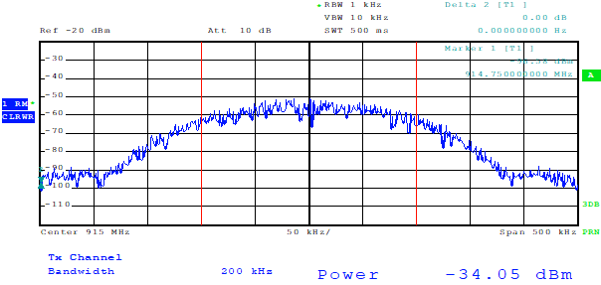
Figure 1: Measurement of a GSM signal with a spectrum analyser
No extrapolation is necessary because the measured level is independent of the traffic.
    - 3G / UMTS
The traffic-independent signal in UMTS is the primary common pilot channel (P-CPICH). It is transmitted at the same frequency and with the same bandwidth as the logical traffic channels, only with a different spreading code. Measurement of the maximum signal level from a UMTS station is therefore only possible with dedicated equipment after decoding in the code domain.
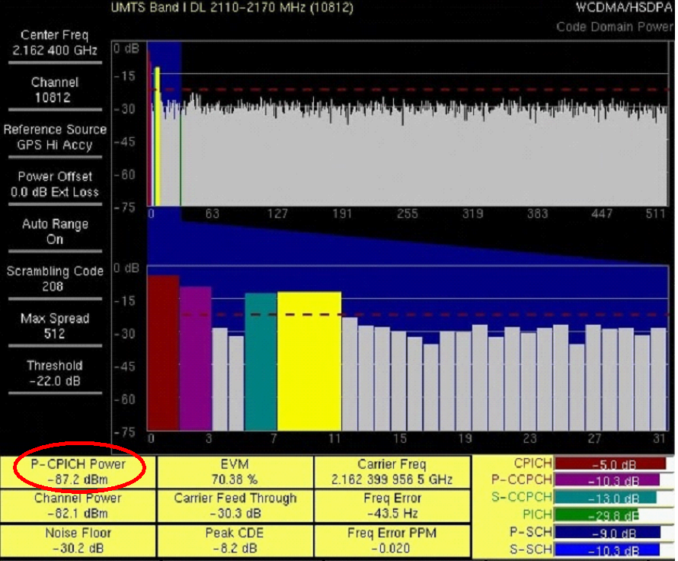
Figure 2: Sample screen for UMTS level measurements with dedicated equipment
Extrapolation to a full traffic situation is done by adding a correction factor to the measurement result (red circle in Figure 2). Unless other information from the provider is available, the correction factor is 10 dB. See also A2.4 for additional information.
    - 4G / LTE
In LTE, the traffic-independent signals used for the measurement is the physical broadcast channel (PBCH), which is transmitted every 10 ms over the inner 1.05 MHz of bandwidth (see Figure 3). Its length is 4 symbols or about 266 µs. However, during the first two symbols, reference signals are also transmitted. The „pure” PBCH is transmitted during the last two symbols for a length of about 133 µs.
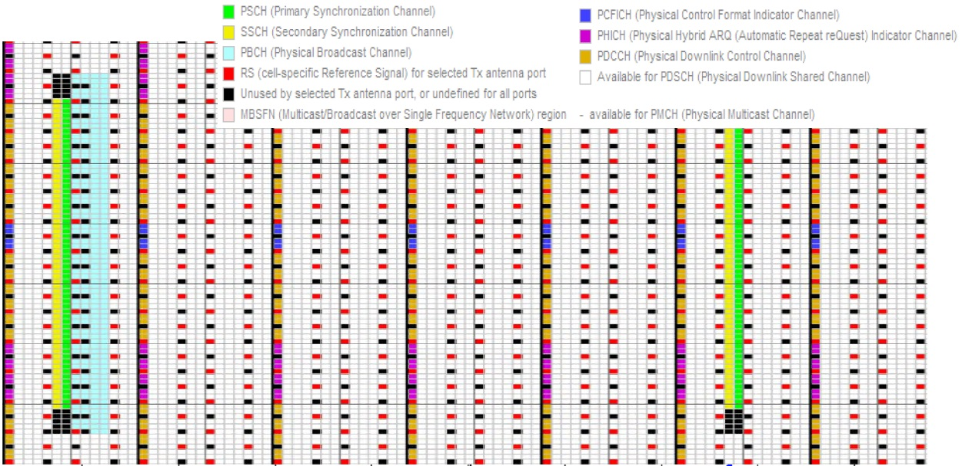
Figure 3: LTE resource grid of the inner 1.2 MHz
The measurement has to be time-synchronized and limited in time and bandwidth. Although challenging, it is in principle possible with a spectrum analyser that is synchronized by GNSS.
Table 5: Spectrum analyser settings for measurements of the LTE system
Centre frequency: | Centre frequency of the LTE channel
Span: | Zero span
RBw/capture Bw: | 1 MHz
Detector: | RMS
Sweep / capture time: | 2 ms
Trace: | ClearWrite
Trigger: | Fixed every 10 ms. Offset adjusted so that PBCH is in display window
Measurement function: | Time domain power with limits set to the PBCH

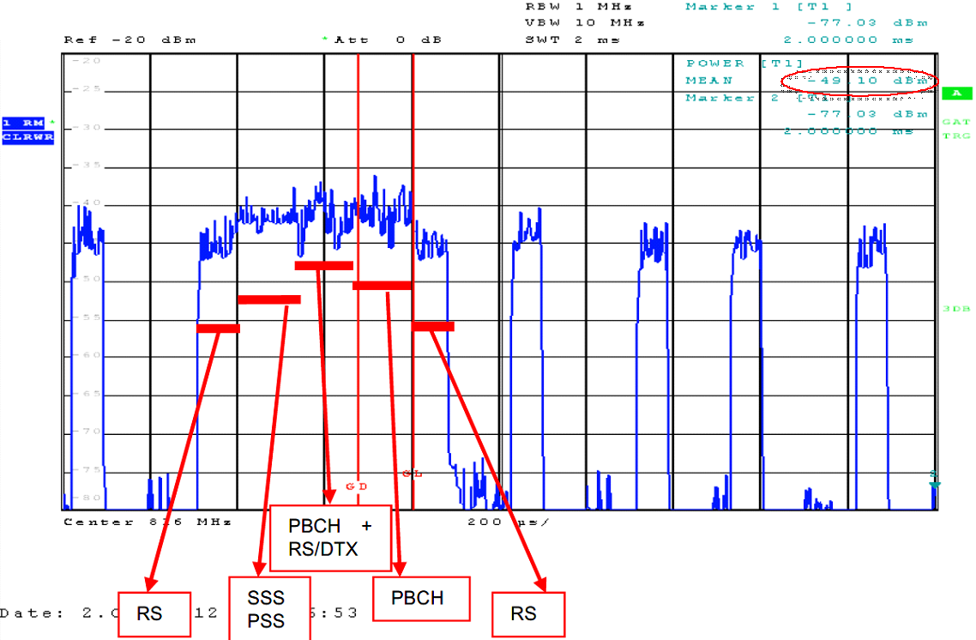
Figure 4: Sample screen for a measurement of the LTE PBCH with spectrum analyser
The actual measurement has to be limited to the last two symbols of the PBCH block (gate length about 133 µs), because the reference symbols transmitted during the first two symbols may be boosted in power.
In Figure 5 the resulting level of the PBCH is circled in red (-49.1 dBm). This is the level of all subcarriers in 1 MHz bandwidth and from all MIMO streams. In a full traffic situation it is assumed that all traffic carriers could be transmitted with the same power as the PBCH. The total LTE level with full traffic would then be:
 | $$P_{tot}\left(dBm\right)=P_{meas}\left(dBm\right)+10×log\left(\frac{B_{LTE} (MHz)}{1 MHz}\right)$$ | (1)
Where:
- P_{tot} is the total LTE level in a full traffic load situation in dBm;
- P_{meas} is the measured PBCH-level in dBm;
- B_{LTE} is the bandwidth of the LTE channel in MHz.

A more convenient way of measurement is the use of dedicated equipment that is able to decode the LTE signal and display the level of the different components separately, like in the following example.
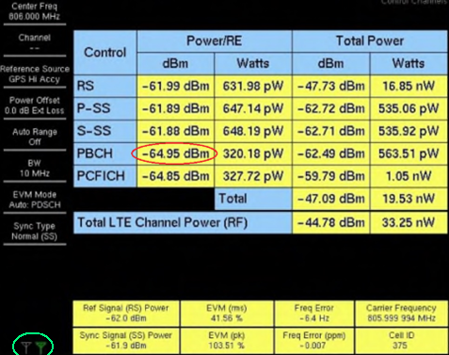
Figure 5: LTE measurement with dedicated equipment
Most decoding equipment displays the power per resource element for each transmitting antennas or, which is the same, for each MIMO streams. In Figure 6, the power of one resource element in the PBCH for one antenna is circled in red (-64.95 dBm) and measured antenna is circled in green. Extrapolation to a full traffic situation can be done with the following formula:
 | PtotdBm=PREdBm10log⁡i=0kPREi(dBm)10+10×logREtot | (2)
Where:
- P_{tot} is the total LTE level in a full traffic load situation in dBm;
- PREi is the measured level of one resource element in the PBCH for i^{th} transmitting antenna in dBm;
- k is the number of antennas,
- RE_{tot} is the total number of resource elements in the LTE channel.

This assumes that the traffic resource elements are transmitted with the same power as the PBCH and MIMO streams are completely uncorrelated with each other.
When taking measurements of LTE signal along a route, scanners are usually used. They usually measure reference signal received power (RSRP) for each transmitting antenna. Extrapolation to a full traffic situation can be calculated with the following formula (see further information and examples in A2.5):
 | PtotdBm=10log⁡i=0k10RSRPi10+10logn-PBdB | (3)
Where:
- P_{tot} is the total (extrapolated) LTE MIMO signal receive level in a full traffic load situation in dBm;
- RSRP_{i} is reference signal level produced by i^{th} transmitting antenna;
- k is the number of antennas;
- n is the number of subcarriers in the relevant LTE signal as provided in Table 6: ;
- PB is reference signal power boosting value (usually equal to 0 dB).

Table 6: Number of active subcarriers in the LTE signal
LTE signal bandwidth, MHz | Number of subcarriers in LTE downlink signal
1.4 | 72
3 | 180
5 | 300
10 | 600
15 | 900
20 | 1200

    - 5G / NR
The 5G NR signal is also composed of some traffic-independent signals and resource elements that are activated during traffic only. The traffic-independent signal used for the measurement is called synchronisation signal block (SSB). This block also contains the broadcast information.
One of the specifics about the NR system is, however, that it may use active antenna arrays (AAS) that are able to form the antenna beam and point it in specific directions. In case of an AAS, the SSB is transmitted with different antenna characteristics and sometimes with different gain from traffic beams. The 5G NR Standard allows between one and 8 SSBs. Typical configurations in Europe are one beam with 120° horizontal main lobe, and 7 or 8 beams transmitted in sequence (see Figure 6).
Tx
Tx
1
2
3
4
5
6
7
Figure 6: Configurations with 1 SSB (left) and 7 SSBs (right)
The SSB is not necessarily transmitted on the centre frequency of the 5G channel. Common configurations are either the centre frequency, or at the lower or upper end of the 5G channel. The bandwidth of the SSB is 7.2 MHz for systems with 30 kHz subcarrier spacing and 3.6 MHz for systems with 15 kHz subcarrier spacing.
Measurements of 5G NR signals can principally be made with spectrum analysers, provided they are synchronized by GNSS. Preferably, real-time analysers should be used. As a first step, frequency and number of the SSB has to be determined. With a real-time spectrum analyser, this is preferably done with a spectrogram display with the following settings:
Table 7: Realtime analyser settings for determination of the SSB configuration
Centre frequency: | Centre frequency of the 5G channel
Span / capture Bw: | Equal to the bandwidth of the 5G channel, e.g.100 MHz
RBw: | Auto
Detector: | Peak or sample
Sweep / capture time: | 20 ms
Trace: | ClearWrite

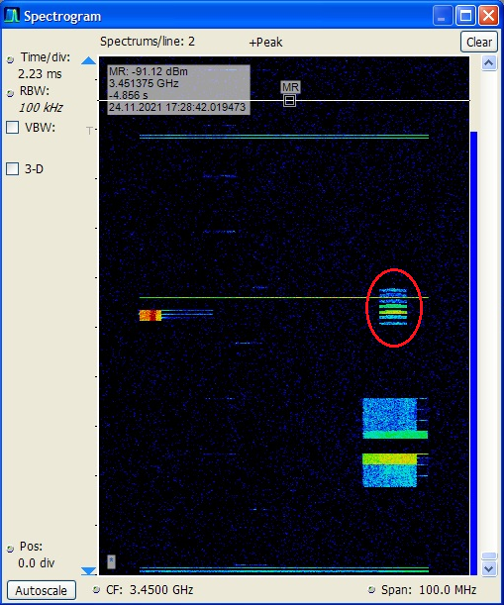
Figure 7: Sample spectrogram of a 5G NR frame with 7 SSBs
The station in Figure 8 is configured for 7 SSBs transmitted at the upper end of the channel (red circle).
Once the frequency of the SSB is determined, its level can be measured with a standard or real-time spectrum analyser with the following settings:
Table 8: Spectrum analyser settings for measurement of the SSB level in 5G NR signals
Centre frequency: | Centre frequency of the SSB
Span: | Zero span
RBw / Capture Bw: | 1 MHz
Detector: | RMS
Sweep / capture time: | 20 ms
Trace: | ClearWrite
Trigger: | Fixed every 20 ms. Offset adjusted so that SSBs are in display window
Measurement function: | Time domain power with limits set to the strongest SSB (gate length)

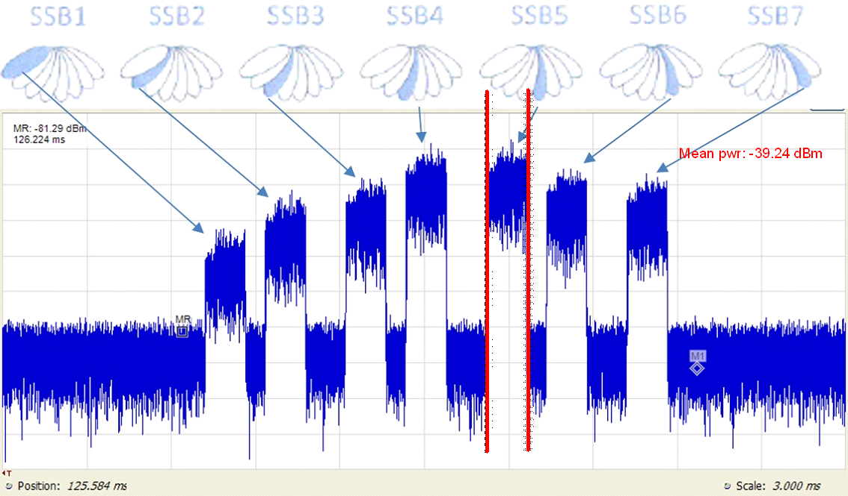
Figure 8: Sample measurement of a 5G NR station with 7 SSBs
The displayed result (Figure 8) represents only the fraction of the strongest SSB in the selected measurement bandwidth.
The total level of the SSB could be calculated as:

 | $$P_{SSB}\left(dBm\right)=P_{meas}\left(dBm\right)+10×log\left(\frac{{Bw}_{SSB} (MHz)}{RBw (MHz)}\right)$$ | (4)
Where:
- P_{SSB} is the total received level of the strongest SSB in dBm;
- P_{meas} is the measured level of the strongest SSB in selected RBw in dBm;
- Bw_{SSB} is the bandwidth occupied by the SSB in MHz (equals to 240 × subcarriers spacing (kHz));
- RBw is the measurement bandwidth in MHz.

A more convenient method of measuring the 5G NR levels is using dedicated equipment that is able to decode the 5G signal and measure the levels of the different resource elements separately.
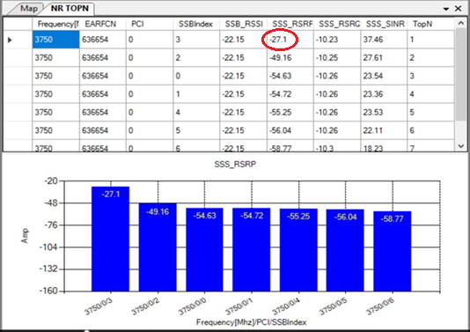
Figure 9: SSB measurement with decoding equipment
The base station in Figure 9 is transmitting 7 SSBs. The level of the strongest SSB 3 is circled in red (-27.1 dBm).
One assumption that has to be made when measuring 5G signals from neighbouring countries is that the measurement location is in the main lobe range of both SSB and traffic beams.
Correct extrapolation to a full traffic situation which would produce the maximum field strength is only possible with knowledge of the antenna gain difference between SSB and traffic beams. This information may be obtained from the operator, but in practice it is seldom available for foreign stations.
In the absence of the antenna data, the following gain differences should be applied:
- For AAS stations with 1 SSB: ∆G = 6 dB;
- For AAS stations with 7 SSB: ∆G = 0 dB;
- For stations with passive antenna systems: ∆G = 0 dB.

The above mentioned gain differences present a conservative approach with the aim not to overestimate the resulting maximum field strength. In some AAS stations, the gain difference is higher. In this case, the measurement would underestimate the maximum possible field strength. If the antenna types are known, it is recommended to use that actual gain differences instead of the generic ones above.
The total level of the 5G signal under a full traffic situation could then be calculated as:
 | $$P_{tot}\left(dBm\right)=P_{SSB}\left(dBm\right)+∆G(dB)+10×log\left(\frac{{Bw}_{5G}(MHz)}{{Bw}_{SSB}(MHz)}\right)$$ | (5)
Where:
- P_{tot} is the total received level of the 5G signal under simulated full traffic situation in dBm;
- P_{SSB} is the SSB level in dBm;
- ∆G is the gain difference between SSB and traffic beam in dB;
- Bw_{SSB} is the bandwidth occupied by the SSB in MHz (equals to 240 × subcarriers spacing (kHz));
- Bw_{5G} is the bandwidth of the 5G channel in MHz.

- Develop text to extrapolate in case of 5G NR
  - Derivation of the field strength
The relation between the measured power in dBm and the field strength in dBµV/m is given by the following equation:
 | EEmaxdBμVm=PtotdBm+KantdB/m+ac(dB)+107 | (6)
Where
- E_{max} is the maximum field strength produced by the MFCN station in dBµV/m;
- P_{tot} is the maximum (extrapolated) receive level in dBm;
- K_{ant} is the antenna factor of the measurement antenna in dB/m;
- a_{c} is the attenuation of the RF cable between measurement antenna and receiver in dB.
- 107 is the conversion coefficient from dBm to dBµV (for 50 Ω RF system).

In addition, depending on the reference value for the specific technology there might be a need to account for the factor between peak (maximum) values and mean values, See section A2.6 for more information. The mean value of the maximum field strength can be calculated by:
 | EmeandBμVm=EmaxdBμVm-CF(dB) | (7)
Where:
- CF is the crest factor in dB.
The value of crest factor depends on the system technology. Representative values for UMTS, LTE and 5G NR are:
- for UMTS downlink carrier crest factor is 10.6 dB [4];
- for LTE carrier crest factor is 10 dB;
- for 5G NR carrier crest factor is x dB.

  - Measurement at fixed locations
    - Application and principle
This method is applicable in cases of reported or assumed interference to a receiver at a specific location, e.g. a base station, or if an administration wants to determine whether the predicted field strength from foreign MFCN exceeds the values in a cross-border agreement at a specific location.
The propagation models used for field strength calculations can only predict the average field strength at a certain distance from the transmitter. Specific terrain conditions and clutter cannot be considered. Excess of the agreed limits at one particular location does not automatically prove a violation of the agreement. It is therefore necessary to perform a cluster measurement of the field strength around the location of interest.
    - Required equipment
The following equipment is recommended for these measurements:
- Measurement car with retractable mast of at least 10 m maximum height;
- Directional antenna suitable for the frequency range of the MFCN band;
- Spectrum analyser or decoding equipment according to section A1.3.
    - Measurement procedure
The required number of measurement locations depends on the required reliability and the difference between the measured values at the best reception point and at the worst reception point, where:
 | ∆E(dBμV/m)=EmaxdBμV/m+-EmindBμV/m | (8)
Where:
- ∆E is the difference between field strength at the best reception point and worst reception point in dB;
- E_{max} is the field strength at the best reception point in dBµV/m;
- E_{min} is the field strength at the worst reception point in dBµV/m.

For a given confidence level of 90% that the real field strength lies within 1 or 1.5 dB of the average measured level, the following table provides guidance on the required number of measurement locations.
Table 9: Required measurement locations for cluster measurements
Confidence |  | ∆E = E_{max} – E_{min}
level | interval | 0 – 5 dB | 5 – 10 dB | 10 – 15 dB | 15 – 20 dB
90% | 1 dB | 3 | 11 | 24 | 43
90% | 1.5 dB | 2 | 5 | 11 | 19

According to ERC Recommendation 74-02, the minimum number of test points is 5, regardless of the entry in the table above.
Measurement locations should be selected so that there are no reflecting objects and as few overhead conductors (power and telephone lines, antennas, buildings with metal roofs or gutters) as possible within ten times the wavelength.
The directional antenna is pointed to the applicable height and pointed in the direction of maximum received level.
If the antenna allows flexible polarisation, the orientation with maximum level is chosen. Otherwise, vertical polarisation is used.
The spectrum analyser or decoding receiver is adjusted to the settings applicable to the MFCN technology used (see section A1.3).
To cancel out the effect of ground reflection, the antenna height is varied around the nominal height (3 m or 10 m) until a maximum and an adjacent local minimum of the received level is detected. When a spectrum analyser is used, a standard height scan can be performed where the received level is constantly measured and recorded while raising/lowering the antenna height. If a decoding receiver is used, the maximum and minimum values have to be determined manually by changing the antenna height in small steps.
The field strength of the direct wave can be calculated as:

 | $$E_{D}(μV/m)=E_{max}\left(μV/m\right)-\frac{1}{2}∆E\left(μV/m\right)$$ | (9)
Where:
- E_{D} is the field strength of the direct wave (without reflection) in µV/m;
- E_{max} is the maximum measured field strength during the height scan in µV/m;
- ∆E is the difference between maximum and next minimum of the field strength during the height scan in µV/m.

If measured in logarithmic units (dBµV/m), the field strength of the direct wave can be calculated as:

 | $$E_{D}(dBμV/m)=E_{max}\left(dBμV/m\right)-η_{k}(dB)$$ | (10)
Where:
- E_{D} is the field strength of the direct wave (without reflection) in dBµV/m;
- E_{max} is the maximum measured field strength during the height scan in dBµV/m;
- η_{k} is the correction coefficient to be applied (see Figure 10) in dB.
Figure 10: Correction coefficient to eliminate ground reflection
The final result is the linear average value of the field strengths measured at all measurement locations.
  - Measurements over longer time periods
    - Application and principle
In cases of interference to a specific receiver, the ERC Recommendation 74-02 foresees measurement over longer time periods. The aim is to evaluate time-fluctuations of the interfering signal, e.g. caused by varying propagation conditions.
The measurements are taken either at the antenna of the interfered station, or with a calibrated directional measurement antenna close to the interfered station. Field strength samples taken at regular intervals are evaluated statistically, and the values for 10%, 50% and 90% of the time are determined.
    - Required equipment
If the measurements are taken at the interfered antenna, the following equipment is recommended:
- Spectrum analyser or decoding equipment according to section A1.3;
- Computer to retrieve and store measurement results from the analyser or decoding equipment.

If the measurements are taken at a measurement antenna, the following equipment is necessary in addition:
- Measurement car with retractable mast of at least 10 m maximum height;
- Directional antenna suitable for the frequency range of the MFCN band.

If the spectrum analyser or decoding receiver has built-in facilities to store multiple measurement results, a separate computer is not necessary.
    - Measurement procedure
The spectrum analyser or decoding receiver is connected to the antenna of the interfered station (possibly via a directional coupler), or mounted on the measurement car positioned near the interfered station, in 10 m height.
Depending on the service to be monitored, the equipment settings according to section A1.3 are applied.
It is recommended to take at least one measurement sample per hour. The resulting field strength is recorded.
According to ERC Recommendation 74-02, the measurement should run at least for a period of 24 hours. If weather or seasonal influences of the propagation should be considered, the duration has to be prolonged accordingly. Longer measurement times also increase the confidence level.
After the measurement period is finished, all measurement samples are sorted by level and evaluated to state:
- the field strength that is exceeded by 10% of the samples;
- the median field strength (50%);
- the field strength that is exceeded by 90% of the samples.

These results represent the time probability.
  - measurements along A Route (DRIVE TEST MEASUREMENTS)
    - Application and principle
Generally, measurements along a route or drive test measurements are performed for measuring and assessing a mobile radio network's coverage, capacity and quality of service [3].
For administrations this method is applicable to assess the overspill of MFCN signals from neighbouring countries in border regions. Although there may not be a case of harmful interference, excess signals strengths may result in mobiles unintentionally logging into the foreign network, thereby introducing roaming charges for the users in border regions. For operators this could also result in a reduction of coverage area. Such overspill of signal strength usually could be observed when a foreign country operator exceeds provisions of the cross-border coordination agreement (infringement of the agreement).
The main purpose of the measurements along a route is to identify and measure MFCN signals of a neighbouring country which creates the overspill.
The drawback of this method is higher measurement uncertainty compared to measurements in fixed locations due to the influence of ground reflections and reflections from many obstructions (also from metallic roof of the vehicle) while driving. For that reason, measurements along a route are intended for statistical evaluation of the signal coverage and determination of the place and amount of signal overspill from neighbouring country.

After measurements along a route, administrations might have to decide on measurements at fixed points (cluster measurements) to get more accurate measurement results.
    - Required equipment
Usually during measurements along a route, it is possible that foreign and own country MFCN base stations operating on the same frequency and many signals from both sides of the border whose level can change rapidly are expected. Thereby, the only way to distinguish between foreign and own country MFCN base stations are by decoding country/network code (MCC/MNC) and cell identifier (Cell ID). Therefore, for measurements along a route more appropriate will be specialized measurement equipment – scanner or receiver that can detect, decode and record a wide variety of MFCN signals and relevant system parameters.
The following equipment is recommended for the measurements along a route:
- Car or vehicle with retractable mast of height at max. 3 m above ground;
- Omni-directional vertically polarized antenna appropriate for the frequency range of the MFCN band;
- Specialized measurement equipment – receiver or scanner combined with GNSS location position referencing system;
- Portable computer with specialized software – for the control of specialized measurement equipment and measurement process.
    - Measurement procedure

Measurements along a route involves simultaneous collection and recording of data from specialized measurement equipment (scanner or receiver and GNSS receiver) to measure signal strength and other parameters while driving. This data is then analysed to identify places where signal excess or overspill from a neighbouring country have been observed.

Antenna height
For the measurements along a route the height of the measurement antenna should be at least 1.5 m to 3 m above ground. The results will be considered as being carried out at a height of 3 m.

Note: Extra precautions should be taken to avoid mechanical damage to the mast and antenna while driving.

Measurement settings and parameters to be measured

To identify MFCN signal, certain system parameters should be determined:
- MCC (Mobile Country Code);
- MNC (Mobile Network Code);
- Channel number (according to 3GPP);
- PCI (Physical-Layer Cell Identifier).

To measure level of the signal while driving, following system parameters should be determined for relevant technologies as provided in Table 10.

Table 10: Parameters which should be determined to measure level of the signal
Technology | System parameter characterising signal power, dBm
GSM | BCCH power
UMTS | RSCP
LTE | RSRP
5G NR | SS-RSRP

For GSM no extrapolation is necessary because BCCH is always transmitted with full power.
For UMTS RSCP represents the power measured by a receiver of user equipment on a particular physical communication channel. To extrapolate to maximum possible power, an additional margin in the range from 9.5 to 10.5 dB has to be added. For the purpose of this Recommendation, a value of 10 dB should be used.

For LTE further extrapolation to full traffic situation is necessary as RSRP is transmitted on one reference signal which represents the power of one subcarrier within 15 kHz bandwidth (see section A1.3.4).

  - Result evaluation and presentation
Additional text to be developed to account for the fact that ECC Report 331 suggests for systems using active antennas to compare median field strength values with the limits given in the relevant ECC Recommendation (15)01 rather than maximum values. The current suggestion is to measure the maximum values as explained in this document, and reduce the results by a certain, system-dependent value. It also remains to be clarified whether this principle should also be applied to LTE systems.
The final result of the field strength measurement along a route is the level measured according to the sections above plus measurement uncertainty defined in the section A1.9.
As each field strength measurement point has a location position recorded, measurement results also can be plotted on a map to clearly depict the places where signal overspill was detected.

Example of the picture of measurement results depicted on map - to be provided

  - Measurement uncertainty
- develop text for measurement uncertainty

- Theoretical background
  - Field strength of overlapping electromagnetic fields
This section describes the procedure for calculating the resulting field strength when several electromagnetic waves with collinear field strength vectors overlap in space. Let us first consider the situation when at some point in space two transmitting different signals antennas individually produce field strengths EA and EB. In the general case, the amplitudes of these field strengths are random variables. Let that the amplitude of the first field strength be equal to A and variance be equal σ2(A), and the second - B and σ2(B) respectively. As is known, the variance of the sum of two random variables is
 | σ2(A+B)=σ2A+σ2B+2Cor(A+B) | (1)
The correlation Cor(A+B) is related to the correlation coefficient R(A,B) by the following expression
 | CorA+B=RA,Bσ2(A)σ2(B) | (2)
Therefore, expression (1) can be written in the following form
 | σ2(A+B)=σ2A+σ2B+2R(A,B)×σ2(A)σ2(B) | (3)
Taking the root of the right and left parts, expression (3) is reduced to the form
 | σA+B=σA+σB+2R(A,B)σ(A)σ(B) | (4)
For electromagnetic waves the average values of the amplitudes of field strength are equal to zero. Therefore, the standard deviation σ of the amplitude of field strength is equal to the root-mean-square (rms) value of their amplitude.
The field strength of electromagnetic waves is usually characterized by the rms value, so expression (4) can be written in the following form
 | E(A+B)=EA2+EB2+2R(A,B)EAEB | (5)
The correlation coefficient between wave amplitudes R(A,B) (hereinafter referred to as R) is usually equal to or slightly different from the correlation coefficient between the transmitted signals that "carry" these waves. It should be noted that the field strengths are vector quantities. Therefore, when adding waves with parallel field strength vectors, the resulting field strength E_{RES} is equal to
 | ERES=EA2+EB2+2REAEB | (6)
and when adding waves with antiparallel ones, is equal to
 | ERES=EA2+EB2-2REAEB | (7)
It should be noted that expressions (6) and (7) are valid only for the rms values of the field strength.
Let us consider in more detail how the strengths of two overlapping in space waves add up when vectors $\vec{Е_{A}}$ and $\vec{Е_{B}}$ are parallel. If the transmitted signals are perfectly correlated (R=1), then, as follows from equation (6), the resulting field strength is equal to
 | ERES=EA+EB | (8)
and if they are completely uncorrelated (R=0), the resulting field strength is equal to
 | ERES=EA2+EB2 | (9)
Similarly, one can obtain an expression for the resulting field strength when N antennas of the same polarization individually produce field strengths E₁, E₂...E_{N}. If any transmitting signals are perfectly correlated with each other, the resulting field strength is equal to
 | ERES=i=1NEi | (10)
and if they are completely uncorrelated with each other, the resulting field strength is equal to
 | ERES=i=1NEi2 | (11)
  - Field strength of the system using cross-polarized antennas
This section will look into the properties of the fields produced by antenna array without beamforming, i.e. conventional passive antennas, as they are widely used in mobile networks, e.g. LTE. As a rule, these arrays are a combination of two or more cross-polarized (orthogonal) individual antennas. The individual antennas themselves are assembled from a large number of dual-polarized elements. Figure 11 shows that simplest array. Dual-polarized array consist of two antenna columns: one with radiating elements with the polarization of +45 degrees, and the second with radiating elements with the polarization of -45 degrees (to be more correct the polarization actually is +135 degrees rather than -45 degrees).
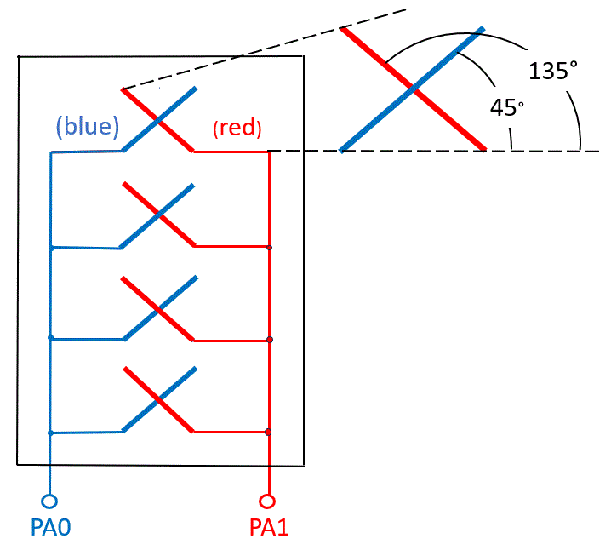
Figure 11: An array of two cross-polarized antennas (2T2R configuration)
Each physical antenna has individual RF chain (also known as antenna port). The first antenna PA0 (corresponds to the antenna port AP0) consists of radiating elements with a polarization of +45 degrees, the second antenna PA1 (corresponds to the antenna port AP1) consist of radiating elements with a polarization of +135 degrees. This antenna array can be used for 2xMIMO technology. More complex antenna array is a combination of subarrays. One subarray includes only antennas with a polarization of +45 degrees and +135 degrees.
From the above it is clear that the waves emitted by antenna arrays with cross-polarized antennas are slant polarized where each wave is rotated 45 degrees from the horizontal, mirrored, so the first is at +45 degrees and the other is at +135 degrees, as shown in Figure 12.
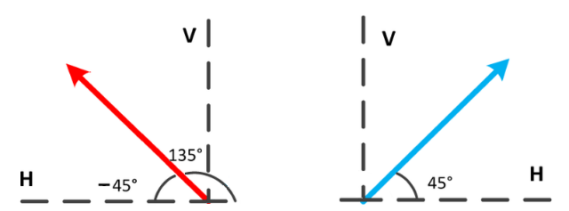
Figure 12: slant 45° dual‐pol mode
Each of these two waves is characterized by its field strength at the measurement point E(45) and E(135). In the case of the simplest antenna array, the field strength E(45) is created by antenna PA0, and the field strength E(135) by antenna PA1.
In the case of array that consists of four antennas (4T/4R), see Figure 13, each antenna PA0, PA1, PA2 and PA3 individually produce field strengths E₀(45), E₁(45), E₂(135) and E₃(135) respectively.
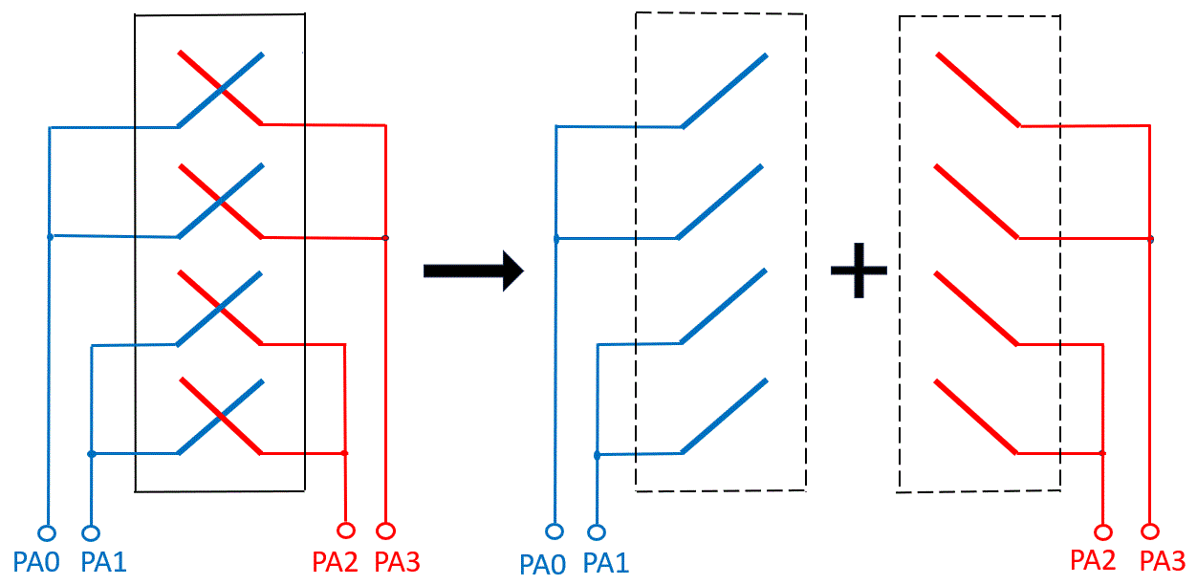
Figure 13: An array of four cross-polarized antennas (4T4R configuration)
In this case, the field strength E(45) is the result of adding the field strengths E₀(45) and E₁(45) according to equation (6) (because vectors $\vec{Е_{0}(45)}$ and $\vec{Е_{1}(45)}$ are parallel), and the field strength E(135) is the result of adding the field strengths E₂(135) and E₃(135) according to the same equation. According to this equation, the resulting field strengths E(45) and E(135) depend on the correlation coefficient between the signals transmitted by antennas PA0 and PA1 and between PA2 and PA3 respectively. This dependence is described in detail in Section A2.1. The same method would also apply for the array that consists of eight antennas (8T8R),
  - Measuring field strength of cross-polarized waves
As follows from Section 0, in the case of cross-polarized fields, two field strengths E(45) and E(135) must be measured. In principle, this is easy to do using a linearly polarized measuring antenna and a conventional spectrum analyser. Since this is not always convenient in practice, instead of measuring two individual field strengths, the vertical component E(V) of the resulting field strength of the two waves is measured (using a measuring antenna with vertical polarization).
This section will analyse how this vertical component E(V) depends on the individual field strengths E(45) and E(135). Figure 14 shows the vertical and horizontal projections of these field strength vectors.
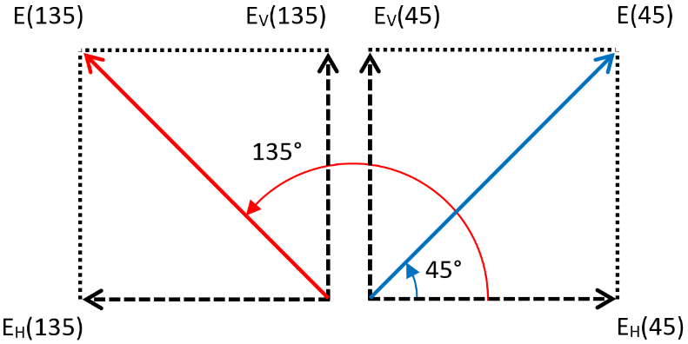
Figure 14: Decomposition of two perpendicular field strength vectors, E(45) and E(135), into vertical and horizontal components
Let us consider the result of the case when the fields strengths E(45) and E(135) are equal (let's denote them as E). The vertical and horizontal components of individual field strengths E(45) and E(135) are:
 | EV45=EH(45)=E(45)sin45° | (12a)
 | EV135=EH(135)=E(135)sin45° | (12b)
For the two parallel vertical components the sum E(V) depends on correlation coefficient R according to equation (6). For the two antiparallel horizontal components the sum E(H) also depends on correlation coefficient R according to equation (7).
If correlation coefficient R = 1, i.e. perfectly correlated vertical components, then according to equation (6) the sum E(V) is
 | EV=E×sin45°+E×sin45°=2E×sin45° | (13)
From this expression it is easy to get that the sum E(V) is higher by 3 dB:
 | 20logEVE=20log2Esin45°E=20log2sin45°=3 dB | (14)
If correlation coefficient R = 0, i.e. the vertical components are completely uncorrelated, then according to equation (6) the sum E(V) is equal to individual field strength (with a polarization of 45 degrees or 135 degrees):
 | EV=(E×sin45°)2+(E×sin45°)2=E2sin245°=E | (15)
Thus, depending on the degree of correlation (coefficient R), the field strength of vertical component is equal or 3 dB higher than the field strength of individual field strength (with a polarization of +45 degrees or +135 degrees). Therefore, if the maximum value of the total field strength of cross-polarized waves is required to measure, then measurements should be done for the vertical component of this field.
For the two horizontal components E_{H}(45) and E_{H}(135) the sum E(H) depends on correlation coefficient R according to equation (7). If correlation coefficient R = 1, i.e. perfectly correlated horizonal components, then according to equation (7) the sum E(H) is equal to 0:
 | EH=E×sin45°-E×sin45°=0 | (16)
If correlation coefficient R = 0, i.e. the horizontal components are completely uncorrelated, , then according to equation (7) the sum E(H) is equal to individual field strength (with a polarization of +45 degrees or +135 degrees):
 | EH=(E×sin45°)2+(E×sin45°)2=E2sin245°=E | (17)
In general for MIMO systems it can be assumed that signals between individual antennas are uncorrelated, and all antennas create fields with equal average field strengths. Therefore, it can be concluded that measuring with vertical polarized antenna the average values of the resulting field strength in the vertical plane is equal to the average value of the individual field strength in the +45 degrees or +135 degrees planes. The same result is obtained when measuring with horizontally polarized antenna.
  - Determination the field strength of UMTS from measurement results of power of primary common pilot channel (P-CPICH)
The power of primary common pilot channel is defined by the factor r between the power of the P-CPICH and the maximal power of the cell. Factor r is expressed in % and is usually between 5% and 15% of the total cell transmit power. Commonly, the CPICH power is 10% of the typical total transmit power of 43 dBm.
Knowing the factor r and the measured value of the P-CPICH, it is possible to determine the total UMTS level for full traffic:
 | Ptot=PCPICH*100/r | (18)
Using the logarithmic scale and coefficient r=10% the equation can be written as follow
 | PtotdBm=PCPICHdBm+10log10010=PCPICHdBm+10 dB | (19)
Using this value, the resulting field strength is calculated.
  - Determination of the field strength of LTE MIMO from measurement results of ference signal received power (RSRP)
For LTE dedicated reference signals RS are assigned for all the antenna ports individually. Therefore, using a dedicated decoding equipment (usually a radio scanner) the reference signal received power (RSRP) is measured for each physical antenna. RSRP is power only of one reference signal which allocates one sub-carrier. Extrapolation of RSRP to the power corresponding to full traffic situation is carried out according to the formula:
 | PtotidBm=RSRPidBm+10logn-PB(dB) | (20)
Where:
- Ptoti is the total LTE signal received power level produced by i^{th} transmitting antenna extrapolated to a full traffic situation;
- n is the number of subcarriers in the relevant LTE signal;
- PB is reference signal power boosting value.

Considering that MIMO streams are completely uncorrelated with each other the total level of the LTE 2xMIMO signal under a full traffic situation could be calculated as:
 | PtotdBm=10log⁡(10RSRP010+10RSRP110)+10logn-PBdB | (21)

For 4xMIMO the RSRP-0, RSRP-1, RSRP-2 and RSRP-3 are measured (see Figure 15) and using these values and equation (1) the total field strength is calculated.
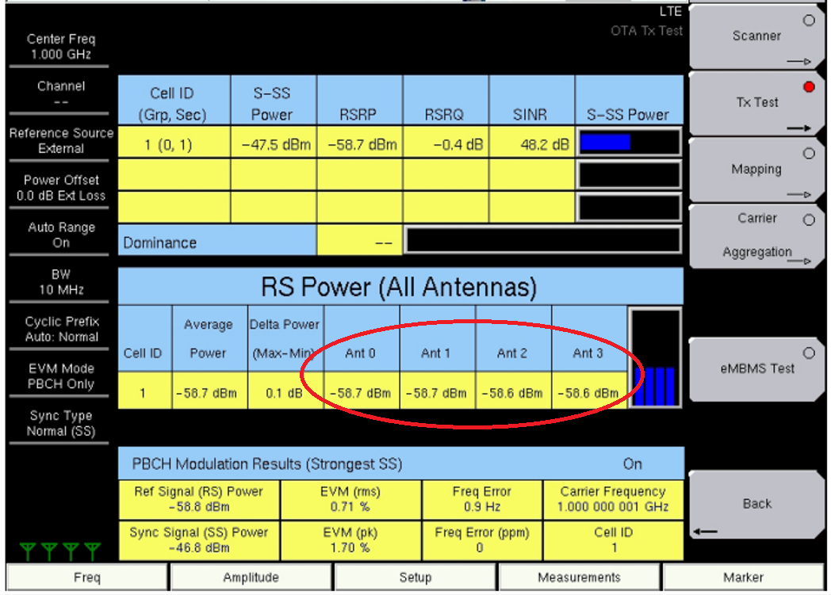
Figure 15: RSRP measurement with dedicated equipment
Same as in the case of 2xMIMO the total level of the LTE 4xMIMO signal under a full traffic situation could be calculated as:
 | PtotdBm=10log⁡(10RSRP010+10RSRP110+10RSRP210+10RSRP310)+10logn-PBdB | (22)
Since P_{tot} is the total signal received power level extrapolated to a full traffic situation then the resulting filed strength is maximum (peak) value.
  - Crest factor and Peak-to-Average power ratio
To calculate the field strength mean values, you need to know the crest factor (CF). Crest factor is the difference in decibels between the peak and average levels of a signal. The signal level can be understood as both the amplitude and power of the signal. Moreover, in the first case, the difference is between the peak and root-mean-square amplitude values, and in the second, between the peak and average power values. Of course, in both cases the CF value will be the same. CF for power is often called as peak-to-average power ratio (PAPR).
In principle, the signal levels generated by mobile networks are random variables and therefore their CF is naturally statistical in nature. The CF is not just one value but varies with time. Therefore, theoretical calculation or modelling of the CF for any systems usually comes down to obtaining a complementary cumulative distribution function (CDF). This function shows the probability of a CF exceeding certain values. For OFDM and similar technologies, the crest factor value is usually taken for a probability of 10⁻⁶ (0.001%).
For technologies that use OFDM or CDMA, the theoretical crest factor CF lies in the range of 10-13 dB [4].

- List of references and relevant documentation
- ERC Recommendation 74-02: „Method of measuring the field strength at fixed points in the frequency range 29.7-960 MHz”
- HCM Agreement: http://www.hcm-agreement.eu/
- Recommendation ITU-R SM.1708: “Field-strength measurements along a route with geographical coordinate registrations”
- https://en.wikipedia.org/wiki/Crest_factor

